Antambolo - Municipality d’Antambolo

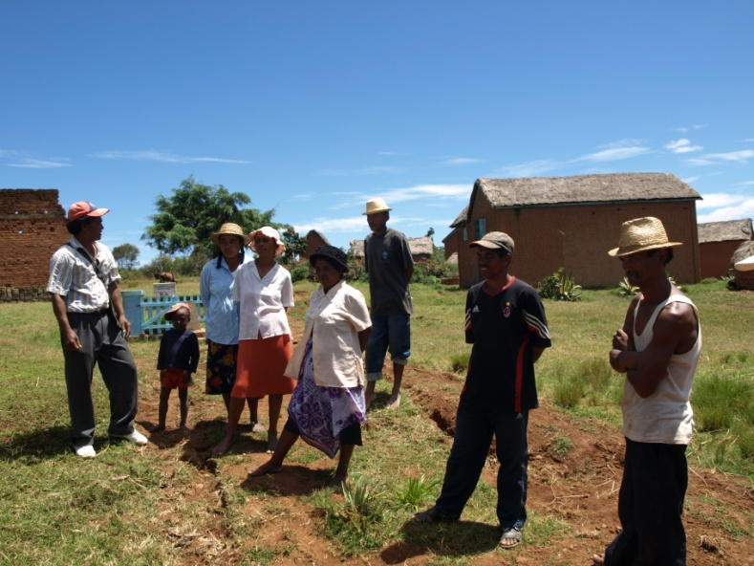
Membres of water user committee

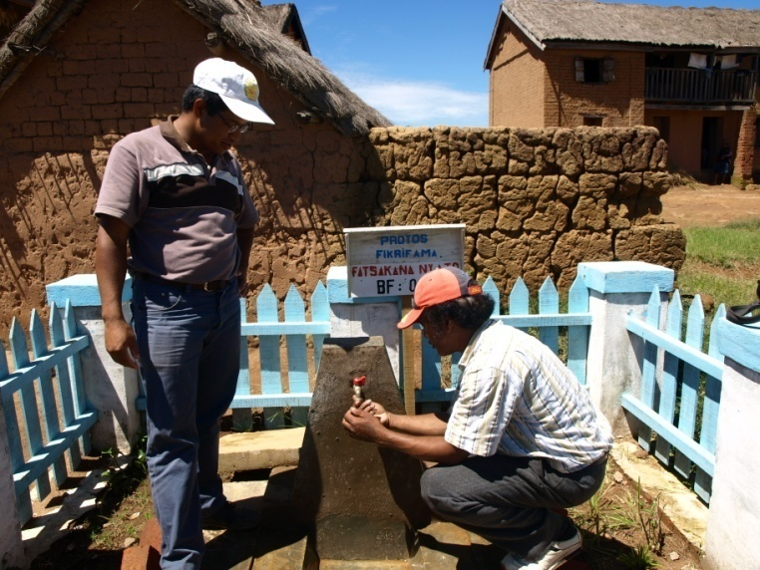
Installation of public tap

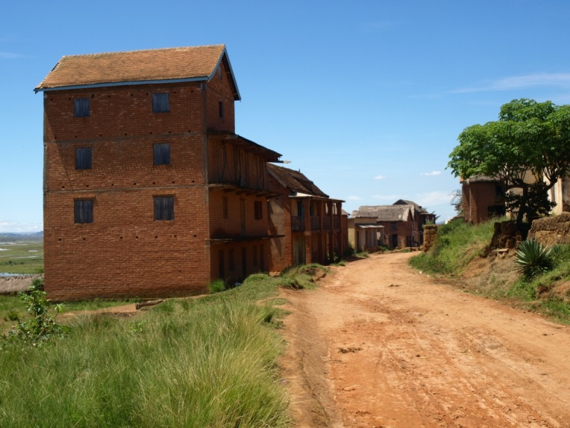
Antambolo Village

Ambololondrano, Antsahondra and Miarinarivo – Municipality of Antambolo

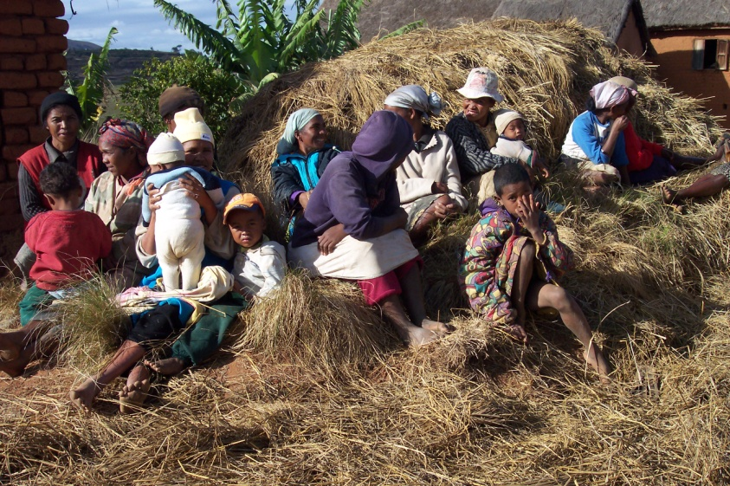
Meeting before starting the community work

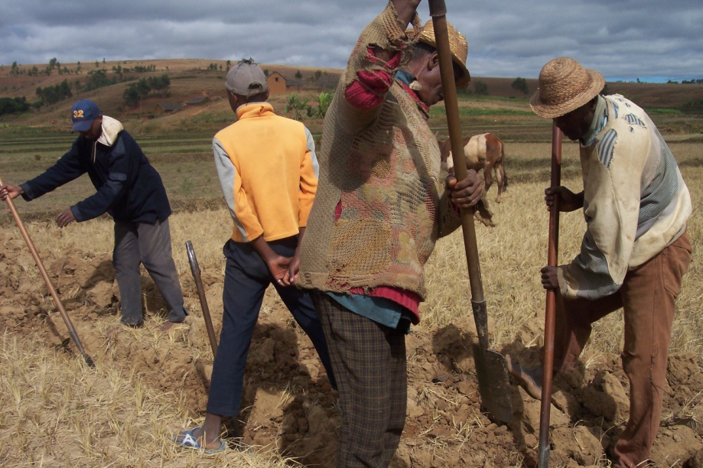
Digging trenches by community

