FINAL REPORT
WATER PROJECT: NUEVA AMERICA

Submitted by Etta Projects

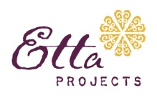

- INTRODUCTION

This report summarizes the activities and outcomes of the water project, implemented in the community Nueva America in the Municipality of Santa Rosa del Sara by the nonprofit organization Etta Projects.

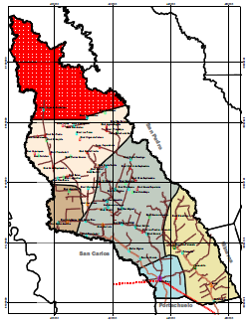
Nueva America is a community that is located approximately 2.5 hours from the city of Montero and 58 kilometers from the Municipality of Santa Rosa, passing by the villages: La Planchada, San Luis, Monte Rico and 4 de Marzo.

This community also is accessible through the main road that leads to the Municipality of San Juan of Yapacani by passing through the communities Enconada and Ayacucho and crossing the river Palacios. Even though this alternative route is longer, because it is 70% asphalt, it is the preferred method.

This project was financed by Blue Planet/Peer Water Exchange, the government Autonomy Municipal de Santa Rosa del Sara and by the community of Nueva America.

  - BACKGROUND

Approximately 40 families currently reside in Nueva America, with a population of approximately 200 habitants (please note, not all families reside in the village year-round). The demand to implement a water project in the village Nueva America came directly from the beneficiaries as well as from the local municipality, who formally submitted a proposal on behalf of the village.

Water Source

Prior to the implementation of the project, the community of Nueva America received their water from shallow water wells and the river. According to a needs assessment 5.88% of the families received their water from a shallow water well at their home. These wells are approximately 7 meters deep. 82.35% received their water from a well located at the village school. This well at the school is approximately 10 meters deep. The rest of the families received their water from a creek that runs along an edge of the village. This zone around Nueva America is mainly agriculture which contributes to the contamination of the water sources. After testing the water, we learned that none of the prior sources of water was acceptable for human consumption.

Hygiene

Much of the contamination found in the village of Nueva America is caused by the domestic animals that circulate freely around the community. In regards to the garbage, approximately 20% of the community burn their garbage, while the remaining villagers throw things out in the open air. Recycling is not practiced. The rain contributes to the spread of contamination caused by the garbage. Poor personal and household hygiene contributes to the high incidence of illness. Many families defecate in the open air or in shallow pit latrines.

1.2 PROJECT BENEFICIARIES

During the planning stages of the project, approximately 40 families lived in the village Nueva America. During the process of planning and implementation, various families left the village looking for better living conditions. In the end, 72.5% of the total number of the families at the start of the project lived in the village at the time of the implementation and therefore benefited from the water system

In summary, the benefiting families included:
- 29 families directly benefitted, resulting in 20 installed water meters and faucets (many families live on the same piece of property and therefore share a water faucet).
- 5 families that participated in the workshops and advocated in favor of the water system currently maintain a piece of property in the village, but reside in another location much of the time. Most of these families plan on moving to the village and claim that securing water will allow them to reside in Nueva America full-time. These five families paid to be connected to the water system so their households are ready when they maintain full-time residency.
- In total, 34 families benefitted from the project with a total population of 118 habitants. Of those, 23.47% are children less than 12 years old, 27.62% are adolescents between 13 and 20 years old, 33.33% are adults between 21 and 48 years old and 11.43% are 49 years old or older.
- Of this population, 56.12% are men and 43.88% are women.

This project is designed for sustainability over the next 20 years, with a 3% annual population growth.

- COMMUNITY TRAINING

Community organization and the development of local skills in an important component of the success and sustainability of the project. Etta Projects began to train community members at the beginning of the project cycle with the intention of preparing the community to sustain and manage the water system independent of the project by the end of the project cycle.

  - Activities
- Community Needs Assessment
- Coordinating project details alongside the community the local municipality
- Signing agreements among the Municipality, Plastiforte, Nueva America and Etta Projects
- Selection of Water Committee
- Community meetings to plan, organize and evaluate the project
- Community training: families, children, water committee members
- Water system implementation

  - Accomplishments may not need this if nothing under it

    - Partnership Agreements

The project developed the following partnership agreements:

- Municipality of Santa Rosa

The local municipality agreed to contribute 45% of the total cost of the water system. In addition to the economic contribution, the municipality developed all legal contracts associated with this projects, including: official blueprints of the community and mapping of the water distribution system.

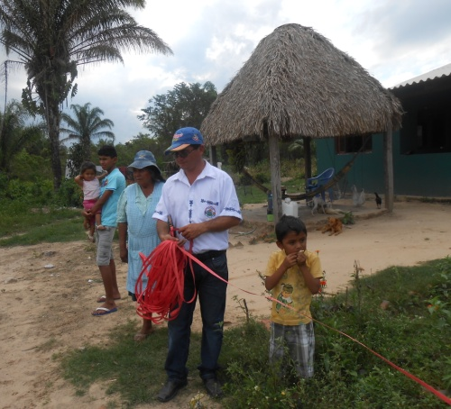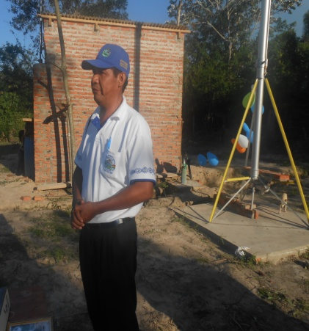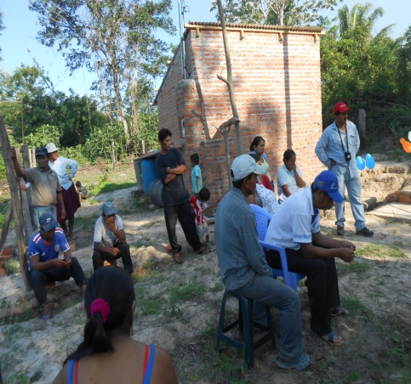
The photos show activities with active participation of municipal representatives

- Bolivian Water Company- Plastiforte

Plasiforte signed a contract agreeing to, upon payment, supply the materials for the distribution system as well as provide training to the local water committee of the implementation, use and maintenance of the water system. Technicians from Plastiforte were also responsible for supervising the installation of the system. They have also agreed to provide ongoing support if any challenges or breakdowns occur.
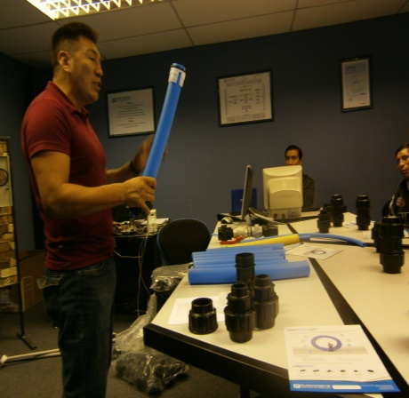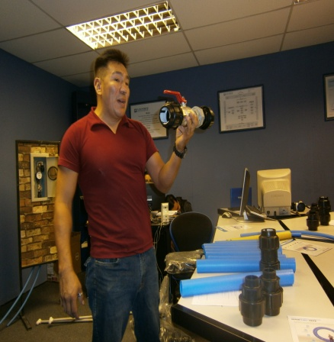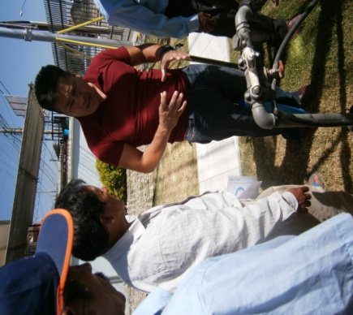
Facilitator of Plastiforte training members of the water committee in the city of Cochabamba

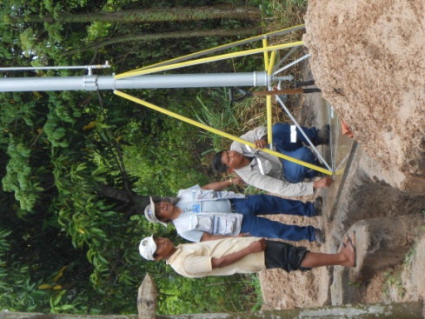. 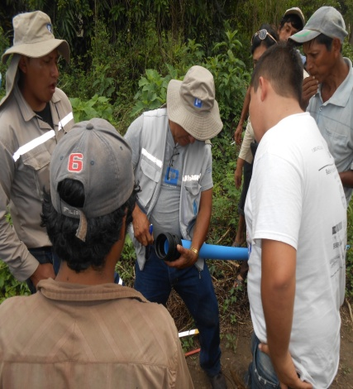 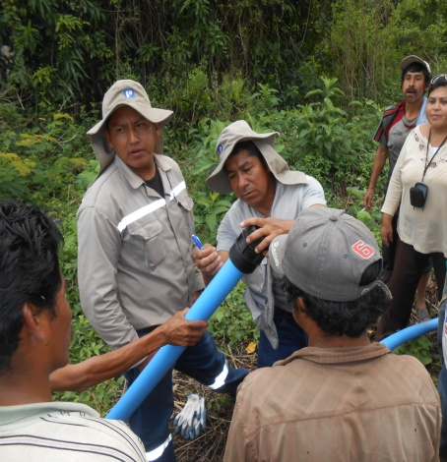
Representatives from Plastiforte training and supervising the implementation of the water system in the village Nueva America.

- Rural Electrical Cooperative (CRE)
The CRE agreed to install a monophasic water meter that will support the hydro-pneumatic water tower. They installed the monophasic water meter on the water tower with no charge to the village. The CRE installed two light posts as well.

“….Generally we do not do this type of work free of charge. It is outside the norms of our organization. On this occasion, we did not want to leave this community without water. Water is life. It is because of this, we accepted the request to do this work without cost. As a cooperative, we have a social obligation to serve these villages.” Robert Vaca, Manager of CRE.”

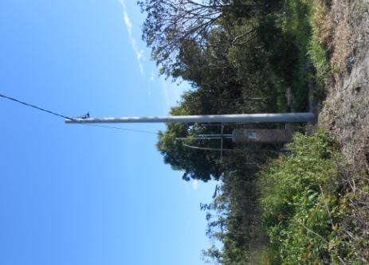

WORK REALIZED BY THE CRE IN THE VILLAGE NUEVA AMERICA

- Community Nueva America

The community of Nueva America organized many community meetings in preparation of the project. Villagers agreed to play an active role in the implementation of the water system. They formed a local water committee who accepted the responsibilities to assist in the installation and maintenance of the system. The community also agreed to participate in community hygiene promotion and water workshops. Last families also agreed to make a financial contribution to the system by paying for their household water faucets and domestic water meters. The children that attend the village school also attended a number of workshops and participated in interactive activities.
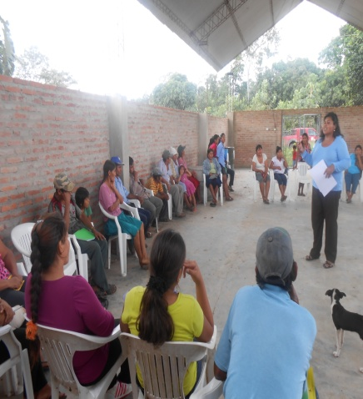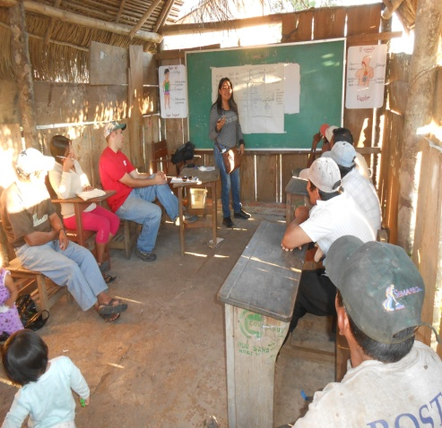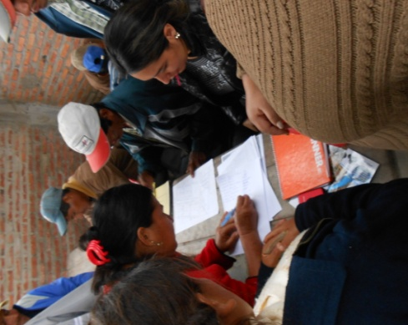
COMMUNITY MEETINGS AND SIGNING AN AGREEMENT WITH ALL FAMILIES
IN NUEVA AMERICA

    - Community Activities
The community joined forces to dig the trenches for the water distribution system. Each family was assigned a specific area and number of meters of the distribution system. Every family that benefited from the water project participated in the work. They also made a decision to construct a small room next to the water tower that will be used as the office of the water committee. The water committee members organized and led the work, and motivated all families to complete their contribution.

“… As community members, we enjoyed doing this work and participating in the workshops. Everything we learned will stay right here in our village. Many people in this village never thought we were going to have water. Some families even left our village saying that it’s necessary to have water to live in a community. Now that we have water, it’s certain that they will return….”
Natividad Marin, community member of Nueva America
,
This community demonstrated a lot of interest in the implementation of the project. They organized work groups to complete the different phase of the project. Women played a large role in the workload as well.
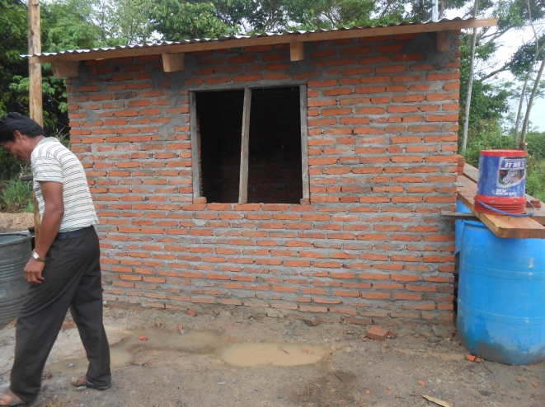
The community members had the responsibility of digging the trenches, transporting the tubes and water system accessories, supporting the installation of the hydro-pneumatic water tower, and installing the water distribution system. Each family also learned how to install their personal water connection and hook up their water meter. The water committee also verified the inventory of materials brought by Plastiforte. They also worked with the local municipality to elaborate the blueprints and community maps used to mark the water distribution system. Committee members went house-to-house verifying that every water faucet and water meter were correctly functioning.
Water Committee Office built by community members
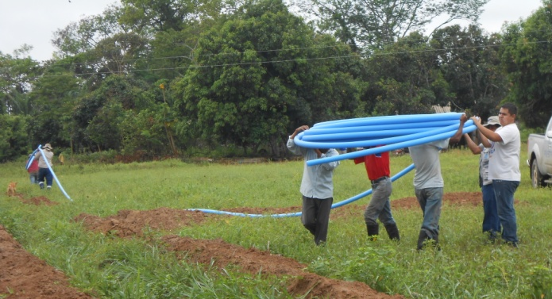
Each family was responsible for contributing the cost of their water meter and faucet. All families paid this contribution in-full and on-time.
Community members transporting tubing used in the water distribution system

At the start of the project some family members felt overwhelmed by the work or were not eager to participate actively in the project. The water committee members made routine visits to all the families and encouraged people to take advantage of this opportunity and contribute to the system.

By the end of the project, three families did not participate in the project. Below is a brief description of the three families that did not participate in the program:

- Family Vicente Catari, Their home is located on the outskirts of the village and is isolated from the other homes. The Catari family currently has a water well that is 50 meters deep. The family does not live at their home year-round; they spend half the time in the town Los Andes. It would have been extremely costly to run the distribution system to their home.
- Family Francisco Cespedez, This family did not connect to the water system because they did not want to pay for the consumption of water. They spend almost all day working outside of their home and claim to only spend the evenings at home. They currently retrieve their water from a shallow water well.
- Family Bautista Mateo. This family does not currently reside in the village. They only recently bought property in the village, and only spend a few days there each month. This family consumes water from the school faucet. The community agreed to let them pay a small fee to get their water from the school faucet when they reside in the village. They live directly in front of the school.
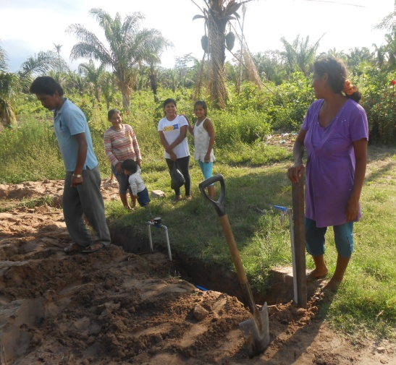
Participation of Women

The women actively participated in the project. Two women currently sit on the community water committee. In addition, dozens of women participated in the labor- carrying materials, digging trenches for the water distribution system and other activities to support the implementation of the system. Women also brought a lot of dialogue to the training workshops regarding water usage, personal hygiene and hygiene in the home.
Doña Sabina, supporting the implementation of the domestic faucets

    - Structure and Functions of the Community Water Committee
At the start of the project the community elected villagers to serve on the community water committee. These individuals are in charge of the administration, operation, and maintenance of the water system

The water committee members include the following individuals:
Members of the wáter committee alongside EP staff

Name | Position
Bruno Mamalli Ortega | President
Sabina Aguirre | Treasurer
Paola Aguirre | Vocal
Elibrando Ribera | Plumber
Eusebio Pérez | Secretary

The committee became legalized by the municipality, and therefore have realized their responsibilities in coordination and with support of the Municipality of Santa Rosa del Sara. At the start of the project, Etta Projects trained the community on the importance of forming a water committee along with the roles and responsibilities of water committee members.

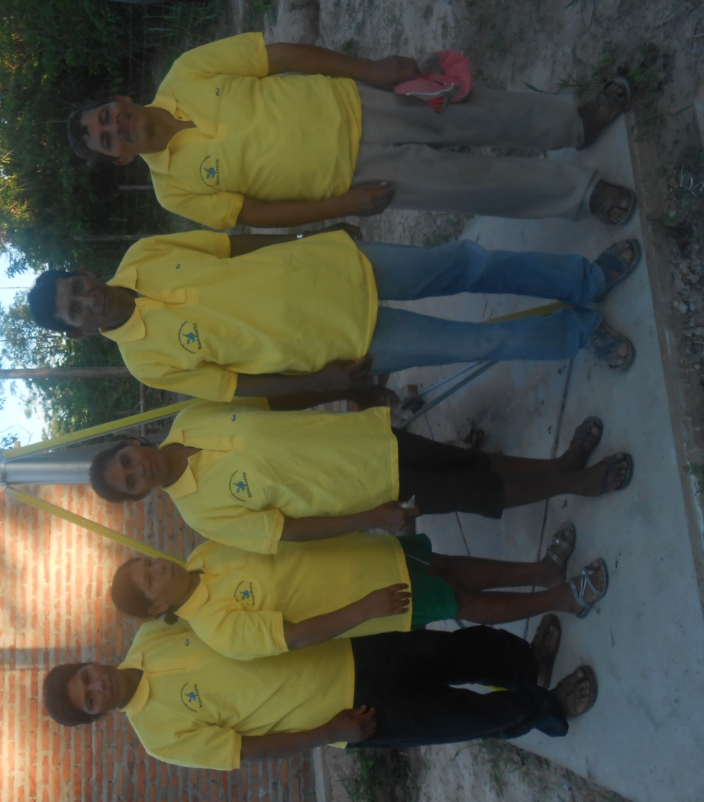
From left to right: Eusebio, Paula, Sabina, Bruno y Elibrando, Members of water com.

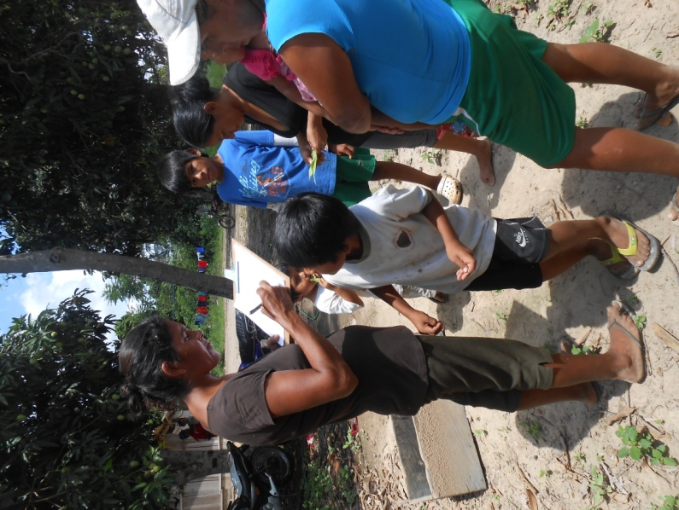
The water committee members were instrumental in the organization and communication between the project and the village. They helped plan meeting, make house visits, collect family contributions and coordinate work schedules.

Sabina (treasurer) y Paola (vocal), organizing a meeting

2.2.4 Training the Local Water Committee

The following describes the training received by the water committee members:

- Training by Plastiforte and Etta Projects in the city of Cochbamba

“… I am very happy about the training. The water tower is very interesting, and the materials and tubing have a great guarantee. They seem like they are really high-quality. I think this system is going to last for many, many years. Now we have to go home and teach everything we learned to the rest of Nueva America.”
Sr. Clemente Ribera, Plumber of Water Committee

The technicians from Plastiforte provided hands-on training to water committee members. The training took place at Plastiforte’s headquarters in Cochabamba, about a 10-hour commute from Nueva America. Members learned how to install and maintain the water equipment. They had the opportunity to test the durability of the equipment, practice the installation, ask questions and learn the science behind how it functions. The technicians later traveled to Nueva America during the installation process to offer additional supervision and guidance.

The training with the technicians included the following themes:

- Components of the Water System: Members learned how to identify each component of the water system; including the parts of the water distribution system, accessories, water tower, water pump and household connections.
- Plumbing: During this section, committee members learned how to connect different sections of the water system and how to install water meters and faucets. They also learned how to turn off service.
- Operation and Maintenance. Members learned about the necessary tools needed to maintain the water system. During this section they created a calendar of system maintenance and assigned specific responsibilities to the committee members. Included was both corrective and preventative maintenance.

The training was offered by both technicians from Plastiforte and project staff from Etta Projects. All five members of the water committee participated in the training. Low levels of reading and writing created some challenges during the training, especially when learning to calculate tariffs and write receipts. 4 of the 5 members of the committee do not have an education past the 6th grade. Some responsibilities had to be delegated according to the skills of the committee members.

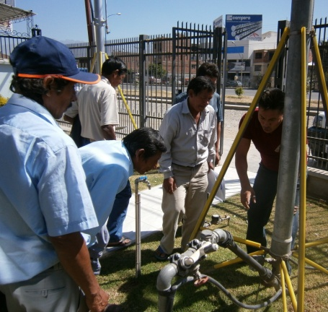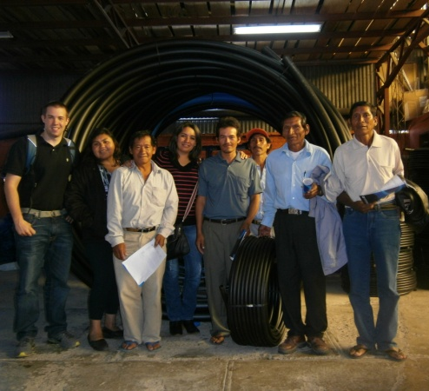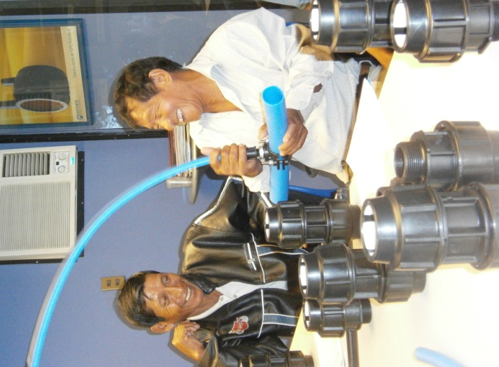
Pictures: Members of the water committee participating in the training in Cochabamba.

“I enjoyed our time in Cochabamba. I learned a lot about plumbing. We got to practice everything which made it easier to learn about the system and the water tower. I loved our trip to the beautiful city.”
Sr. Nicolas Mamalli, member of the water committee

- Training on Water System Administration

“…We have learned a lot. I didn’t know anything about water systems. Now I know how to read water meters. Each month I am charge of going with the community plumber to read every family’s water meters. Later I do the calculations so we can charge each family according to how much water they use every month. I thought it was going to be really hard, but it’s pretty easy to do.”
Sra. Sabina, Treasurer

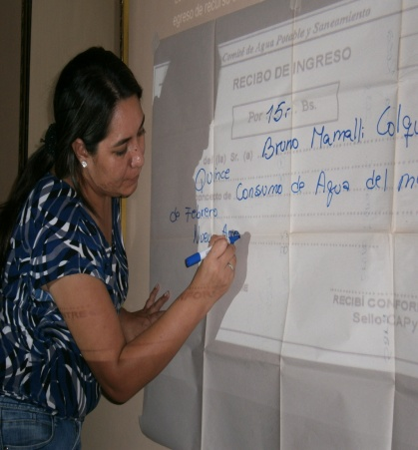
Members of the water committee learning system administration.
The main themes of the system training included:
- Community Organization
- Roles and Functions of System Administration
- Administration of Tariffs and Fees
- Income, Expenses, Expense Book, Inventory, etc.
- Operation and Maintenance of the System
- Approval of Internal Rules & Norms
- Balancing the Accounts
- Social Control
100% of the water committee members attended the system administration training workshops.
2.2.5 Technical Training to committee members by Plastiforte in Nueva America
The water committee members as well as other community members received additional training in their village prior and during the system implementation by technicians from Plastiforte. This was a good opportunity to review the lessons learned from their training sessions in Cochabamba.
Training in Nueva America included the following themes:
- Components of the Water System
- Water Distribution System and Tubing
- System Accessories
- Location and Design of the Water Distribution System
- System Plumbing

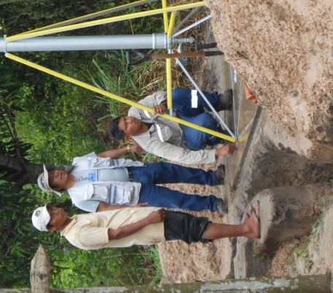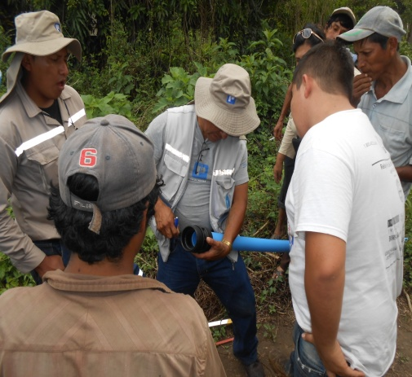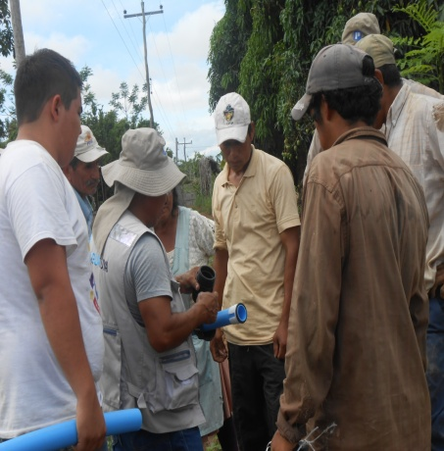
Members of the Water Committee Receiving Technical Training during Installation.

2.2.6 Maintenance and Frequency.
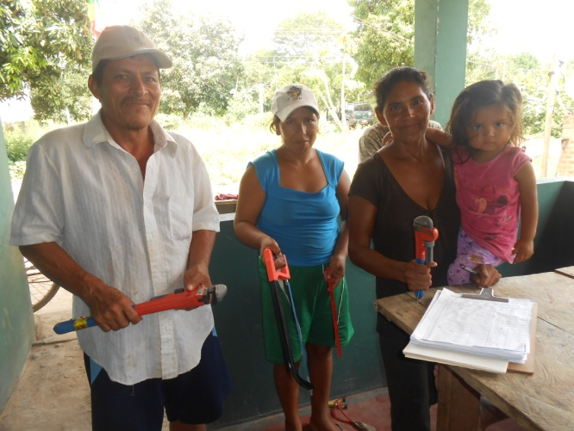
The water system began to function on October 20, 2013. The water committee scheduled a meeting to discuss and evaluate the maintenance of the system every three months. This activity will be led by the community plumber.

Included in the project budget was the donation of all the necessary tools to complete the necessary maintenance of the system. These tools are managed by the committee.
Members of the water committee with their tools

Etta Projects will continue to offer support to the water committee to monitor their capacity to complete their role and responsibilities.

2.2.7 Administration of the Water System

2.2.7.1 General Organization & Maintenance Partnerships

This organization is supported by the following institutions:

- Municipality of Santa Rosa del Sara, The municipality has the role of advising the committee members on the organizational aspects by giving them skills that support the sustainability of the system. The municipality agrees to provide technicians that will assist the village with system maintenance. The municipality has no right to intervene in the management or have control of the funds collected from water usage.

- Department of Santa Cruz, the “Gobierno Autónomo Departamental de Santa Cruz”, with support from the program PROASU/JICA, has the obligation to support the local municipality in its function as well as offer technical trainings, provide water testing & analysis and provide maintenance on the water well.

- Ministry of Education, The Ministry of Education, on behalf of the Department of Education of Santa Rosa, allowed both Etta Projects staff as well as members of the water committee to enter the classrooms to offer small workshops that taught students important lessons around water, hygiene, sanitation and the environment.

2.2.7.2 Tariffs and Financial Control

The community worked together to establish a tariff system to manage the finances collected from water usage. This system was voted on by the community. The tariff system has a basic rate set at 15 Bs monthly ($2.17 USD) for the usage of 7 m3 or 7,000 liters of water. Every cubic meter used above 7 has an additional rate of 3 Bs ($0.43USD). The community also voted that if a person is using the water for commercial use they will be charged 10 Bs ($1.45 USD) for every additional cubic meter.

Aligned with the recommendations of the Ministry of Water, Etta Projects encouraged the community to set the basic tariff rate at 15 Bs for every 5 m3 instead of every 7 m3. The community voted and chose to go against our recommendations. Etta Projects continues to urge the community to change the tariff rate in order to increase the future sustainability of the system. The change of rate will not affect most families, as the vast majority use less than 5 m3 per month.

The local water committee opened a savings account in order to maintain a better control of the community funds. Funds acquired from the consumption of water each month will be used principally to maintain the system, purchase new materials and pay the electricity bill generated by the water system. All funds remaining will be deposited into the account.

The committee members created by-laws forbidding using the community water funds for personal loans to families. This rule was created to avoid misuse of the funds or the termination of services due to the lack of resources.

The community also decided to collect monthly tariffs by the 5th of every month. Families are given up to two months of late payments. If payment is not made by the 5th of the third month, the plumber is instructed to immediately cut off their water service. The motive is that no family maintains a high amount of late fees and contributing to the lack of sustainability of the system.

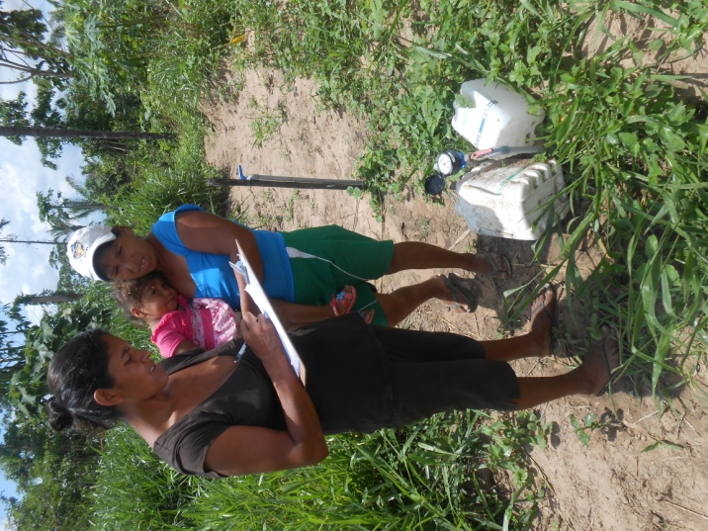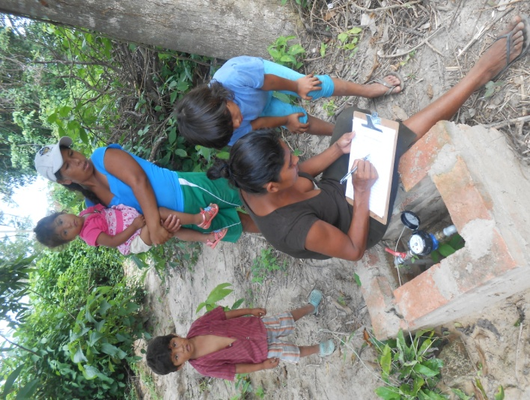

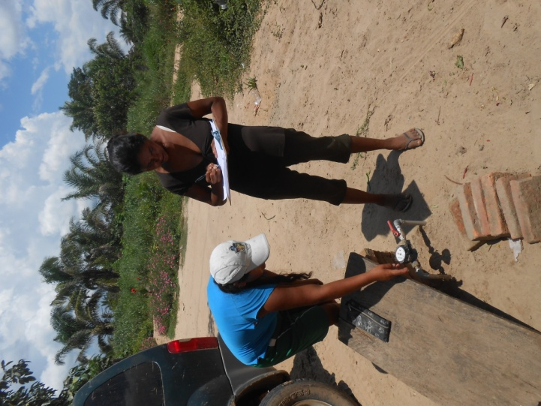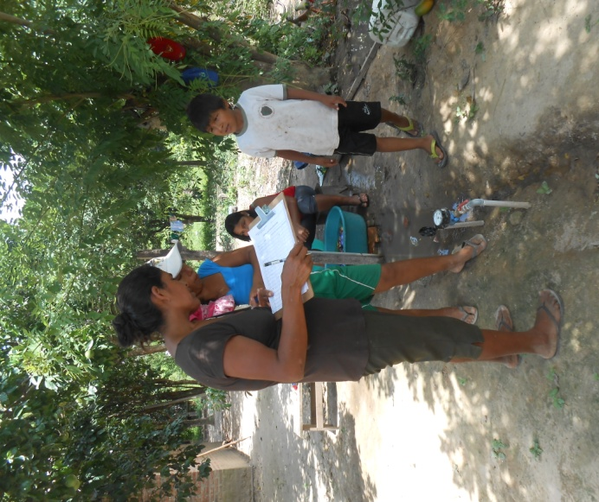
Doña Sabina (treasurer) and Doña Paula (Vocal), realizing the meter readings

To date, the community had completed 3 meter readings. The results are displayed on the following chart:
FIRST SEMESTER: MONTHLY WATER CONSUMPTION (m3)

 | Meter Reading : Nov 25th |  |  |  | Meter Reading : Dec 20th |  |  |  | Meter Reading: Jan 21st
Beneficiary | Prior Reading | Current Reading | # of m3 | Paid | Prior Reading | Current Reading | # of m3 | Paid | Prior Reading | Current Reading | # of m3 | Paid
Sabina Aguirre | 0 | 9 | 9 | 21.00 | 9 | 16 | 7 | 15.00 | 16 | 24 | 8 | 18.00
Elibrando Ribera | 0 | 4 | 4 | 15.00 | 4 | 6 | 2 | 15.00 | 6 | 8 | 2 | 15.00
Fermin Aguirre | 0 | 2 | 2 | 15.00 | 2 | 4 | 2 | 15.00 | 4 | 7 | 3 | 15.00
Deisy Flores | 0 | 0.5 | 0.5 | 15.00 | 0.5 | 0.5 | 0 | 15.00 | 0.5 | 0.5 | 0 | 15.00
Ismael Flores | 0 | 3 | 3 | 15.00 | 3 | 7 | 4 | 15.00 | 7 | 11 | 4 | 15.00
Eusebio Perez | 0 | 0.5 | 0.5 | 15.00 | 0.5 | 0.5 | 0 | 15.00 | 0.5 | 0.5 | 0 | 15.00
Bruno Mamalli | 0 | 12 | 12 | 30.00 | 12 | 24 | 12 | 30.00 | 24 | 39 | 15 | 39.00
Mario Condori | 0 | 0.5 | 0.5 | 15.00 | 0.5 | 1 | 0.5 | 15.00 | 1 | 2 | 1 | 15.00
Maribel Rojas | 0 | 1 | 1 | 15.00 | 1 | 3 | 2 | 15.00 | 3 | 5 | 2 | 15.00
Natividad Marin | 0 | 3 | 3 | 15.00 | 3 | 5 | 2 | 15.00 | 5 | 8 | 3 | 15.00
Agapito Vargas | 0 | 5 | 5 | 15.00 | 5 | 9 | 4 | 15.00 | 9 | 15 | 6 | 15.00
Samuel Socompi | 0 | 2 | 2 | 15.00 | 2 | 9 | 7 | 15.00 | 9 | 13 | 4 | 15.00
Justina Zarate | 0 | 6 | 6 | 15.00 | 6 | 11 | 5 | 15.00 | 11 | 16 | 5 | 15.00
Marina Soliz | 0 | 3 | 3 | 15.00 | 3 | 5 | 2 | 15.00 | 5 | 11 | 6 | 15.00
Elio Mamalli | 0 | 0 | 0 | 5.00 | 0 | 0 | 0 | 5.00 | 0 | 0 | 0 | 5.00
Dionicio Peca | 0 | 6 | 6 | 15.00 | 6 | 11 | 5 | 15.00 | 11 | 21 | 10 | 24.00
Santusa Leon | 0 | 0 | 0 | 5.00 | 0 | 0 | 0 | 5.00 | 0 | 0 | 0 | 5.00
Escuela | 0 | 5 | 5 | 5.00 | 5 | 7 | 2 | 15.00 | 7 | 7 | 0 | 15.00
Cede Comunal | 0 | 0.5 | 0.5 | 15.00 | 0.5 | 0.5 | 0 | 15.00 | 0.5 | 0.5 | 0 | 15.00
Iglesia | 0 | 0.5 | 0.5 | 15.00 | 0.5 | 1 | 0.5 | 15.00 | 1 | 1 | 0 | 15.00
TOTAL |  |  | 63.5 | 291.00 |  |  | 57 | 295.00 |  |  | 69 | 316.00
Total Paid |  |  |  | 266.00 |  |  |  | 270.00 |  |  |  | 222.00
Total Owed |  |  |  | 25.00 |  |  |  | 25.00 |  |  |  | 94.00

Analysis of Payment of Tariffs
Approximately one month after the water system was installed, the water committee logged the water consumption of each family. The first reading of the meters took place on November 25. In total 63.5 m3 (or 63,500 liters) of water. The second reading took place on December 20. In total, 57 m3 (57,000 liters) of water was consumed. The final reading to date took place on January 21. They learned that in total on the third month the community consumed 69 m3 (or 69,000 liters) of water.

This information is displayed on the following chart:

After one month of water consumption, the water committee charged a total of 291 Bs ($42.17 USD) for the total consumption of 63.5 m3. 17 of the 20 beneficiaries paid their bill on time, resulting in an income of 266 Bs ($38.55). In other words, 91.41% of the total income was collected on time. The remaining 3 beneficiaries owed a total of 25 Bs ($3.62 USD) or 8.59% of the total amount billed out after one month of use. After month two, the committee billed out a total of 295 Bs ($42.75 USD) for the 57 m3 of water consumption. Again 17 of the 20 families paid their bill on time. In December, the water committee collected a total of 270 Bs ($39.13 USD) or 91.53 % of the total amount billed. On the third month (the month of January, 2014), the water committee charged the community a total of 316 Bs ($45.80 USD) for the 69 m3 of water usage. 14 out of the 20 members paid their bill on time. In total, the committee collected 222 Bs ($32.17 USD), or 70.25% of the total amount charged to the families. A total of 94 Bs ($13.62 USD) is still owed (or 29.75% of the total amount billed in January). The committee allowed the three families with consistent late bill until February 5, 2014 before shutting off their water.

During the first trimester, 16% of the beneficiaries had late payments, while 84% paid their bills on-time and in-full. This demonstrates that the majority of the community members are able to pay their water bills and have created a habit of contributing to the system.

The project staff interviewed members of the water committee to learn more about the reaction of families regarding their water bills. They shared that no family has complained at the rates established by the community, and in general families feel they are paying a fair price for water consumption. They also expressed satisfaction in the water meters, indicating that they are valuable tools to control water usage in a fair and equitable way.

“…All families pay their bills with no complaints. They understand that the more you use, the more you pay. No one thinks it’s unfair. We all understand why it’s important to contribute if we want the (water) system to last. The water meters make everything very fair.”
Bruno Mamalli, President of Water Committee

Total Earning From the Water System
To date, the project has established a steady gross of income. At the end of month 1, the water committee billed out 291 Bs ($42.71 USD). This month the community was charged by the local electrical cooperative (CRE) a total of 11 Bs ($1.59 USD) for electricity, equivalent to 3.78% of the total funding billed. 280 Bs (or $40.58 USD) remained in the account to be used for maintenance and repairs. During month 2, the committee billed out 295 Bs ($42.75 USD), and the system assumed 18.5 Bs ($2.06 USD) in electrical charges. This resulted in an additional 276.50 Bs ($39.20) in the account for repairs and maintenance. On the final month of the trimester, the committee billed out 316 Bs ($45.80 USD) and was charged 21.20 Bs ($3.07 USD) in electrical fees from the CRE, leaving 294.80 Bs ($42.72 USD) remaining for repairs and maintenance. In general, we learned that approximately 6% of the earnings each month will be spent on electricity to power the system, while 94% can be reserved for the sustainability of the system. As long as proper care is consistently being performed on the system so that equipment and parts last according to their projects warranty, the system should be sustainability.

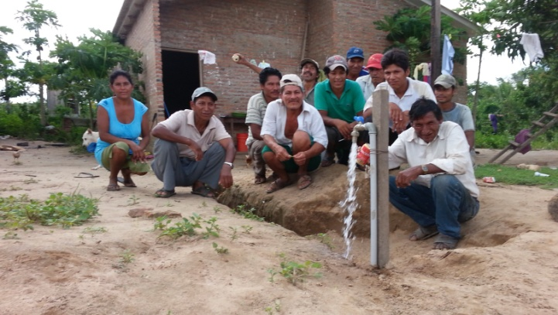
“… The water committee has held its first quarterly meeting. We reviewed the income and expenses assumed by the committee to date. When I told the members how much we spent on electricity from the water system, they thought I was joking. We all worried that the electricity bill was going to be more expensive.”
Nicolas Mamalli, OTB of Nueva Amaerica, with wáter committee members and villagers celebrating wáter in Nueva America
Sr. Nicolas Mamalli, community leader of Nueva America
Financial Sustainability of the System
Based on the financial results of the system thus far, we anticipate that after the water committee pays its fixed monthly expenses (i.e. the electricity bill and normal maintenance), the committee should have an annual balance of approximately 2325.20 Bs ($337 USD). Please note, this amount will continue to increase as the community population grows.
The chart below compares the annual income generated from the system (represented in blue) to the spending on the replacement of various system parts, including the electrical bulbs (shown in purple), the water pump (shown in green), and the pressure switch (shown in red). According to our findings, if the system continues to generate income at the same rate, the amount of revenue should allow for Nueva America to replace the necessary parts to sustain the water system for years to come.
*Please note, the water tower has a guaranty of 20 years and the PVC tubing has a guaranty of 50 years.

- The Hydropneaumatic Water Tower

  - Description of the Water System
This water project utilized a Hydropneumatic Tower. The Hydropneumatic Tower is a specific category of technology that pressurizes the water in order to directly inject it to the distribution network. The hydropneumatic system essentially replaces expensive elevated tanks that are traditionally used in water systems with perforated wells. The water is extracted and is pressurized in the hydropneumatic tower before it is distributed to the households.
The pressure vessel contains water in a pressurized air space to provide the necessary pressure to distribute the water. With water demand, water flows from the vessel; increasing the air space while decreasing the air pressure. This lower pressure signals the pump to start. The pump meets the demand with the excess volume backing up in the pressure vessel. This decreases the air space and increases the pressure once again. When the upper level is reached, the pump shuts off. These systems are ideal for a rural water system that has a concentrated service area, as in the case of Nueva America.

The Hydropneumatic Tower was connected to a water distribution system made from PVC tubing that distributes the water to each of the 20 households. The water distribution was approximately 1000 meters long.

  - Summary of Financial Contributions towards the water system

The water system was funded in the following ways:
- ETTA PROJECTS, with financial support from Blue Planet
Etta Projects was responsible for coordination among the various institutions that provided services and materials towards the system.
Etta Projects paid for the following goods and services:
Business | Description | COST
LA GOTA | Installation of the water pump, testing of the water pump | $1,628.13
DISTRIBUTOR SAN RAFAEL | Water Pump Pedrollo 1 HP | $800.00
PLASTIFORTE | Training, Supervision of the water system, installation of the hydropneumatic tower, accessories of the installation and a % of the transportation | $4,212.56

- MUNICIPALITY OF SANTA ROSA DEL SARA
The municipality offered the following financial contribution to the water system in Nueva America:
Business | Description | COST
PLASTIFORTE | tubing, water distribution system, accessories | $5,350.64

- Community NUEVA AMERICA
In addition to supporting the manual labor, villagers of Nueva America paid the cost of their water meter and the domestic connection.
Business | Description | COST
PLASTIFORTE | Water meters and domestic connections | $1,660.35

3.3 Community Satisfaction

Etta Projects conducted satisfaction interviews with 77% of the participating families. We learned that 100% of the families interviewed were satisfied with the system. According to the results, families identified the following aspects of the system as positive aspects of the foundation (in order from most common to less common): water pressure, water tower, water meters, and tubing in distribution system. Many families commented that they believed this system is better than the water systems in the neighboring communities, which more commonly use an elevated tank, claiming that the water tower provides better water pressure.

  - Water Quality

Water Source in Nueva America
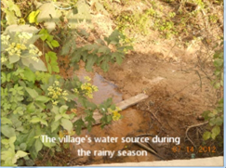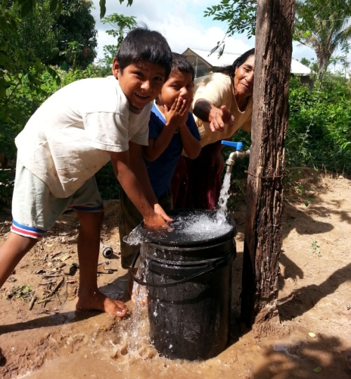
BEFORE AFTER

The state government drilled a 120-meter well. The water was tested prior to the project and proved to be safe for human consumption. An approval stamp was placed on the well by the state government. We learned that of the 17 families that participated in the survey: 100% said the water was clean and safe for drinking. 100% said that the water had a good flavor; however one community member mentioned that she believed one side of the village had a “better” flavor than the other. 100% of the families interviewed said the water did not carry any foul odors.

  - Problem Resolution

During the first three months after the implementation of the system, Etta Projects made monthly visits to Nueva America to speak with community members regarding any issues or problems with the water system and learn how problems were resolved. 82% of the families mentioned two occasions when the rain interrupted electrical service. On the first occasion the power went out for approximately 30 minutes. On the second occasion the community lost power for approximately 2.5 hours. During the second shortage that lasted a significant more time, members of the water committee notified representatives of the electrical cooperative, who communicated that the shortage had been programmed to allow maintenance on the electrical system in the area. Generally these shortages are programmed and they notify communities that are impacted via the radio. Of course, we cannot overlook that one disadvantage of a system that uses a hydropneumatic water tower (vs. a water tank) is that the community does not have access to water when the electric system is interrupted.

“The water service has been interrupted briefly on two occasions due to power outages. The water committee advised us to keep a bucket of water in our home just in case there is another power outage. Power outages do not occur very often here. At times they last a few seconds, but rarely do they last longer than that”
Doña Deisy Flores”
- PROMOTION OF HEALTH & HYGIENE

The health and hygiene promotion component of this project targeted three specific groups: families, children and water committee members.

The project held 6 workshops with adults as well as with children at the village school. While activities were changed to be age-appropriate for each group, the workshop topics included:
- How are we living in our community?
- Taking care of our water
- Hand washing
- Prevention of common Illnesses in Our Community
- My hygiene
- What to do with my garbage?
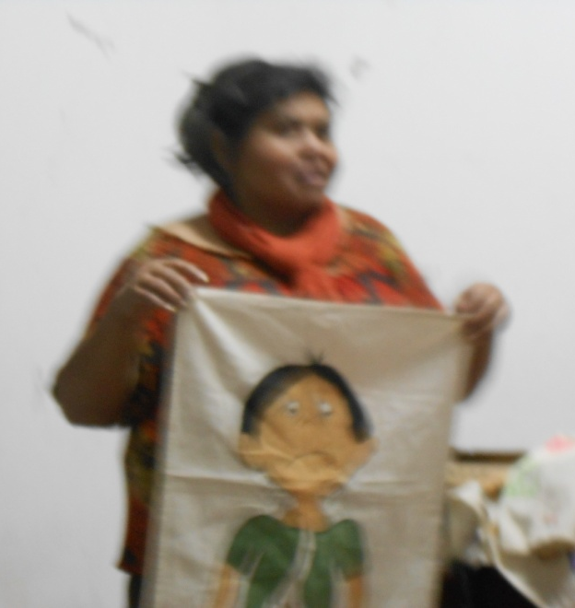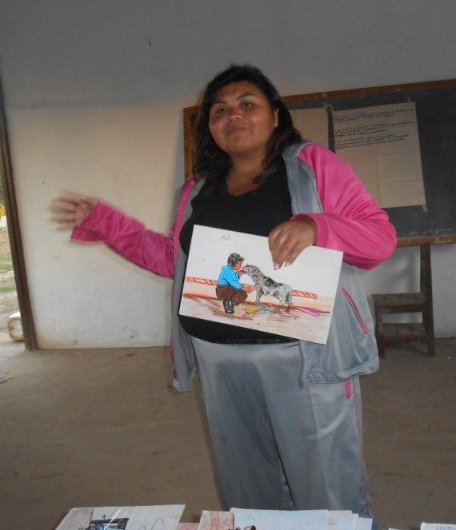

Each family was required to send a minimum of one person to attend each workshop. In most cases, more than one family member attended. Overall families enjoyed the workshops. The project distributed satisfaction surveys to each participant at the end of the training program to learn participants’ opinion regarding the environment of the workshop, the quality of the materials as well as the quality of the facilitator. The categories were rated as “bad”, “average” or “good”.
- In regards to the environment we learned that 36.84% rated the environment “average” and 63.15% rated the environment “good”. 0% rated the environment “bad”.
- In regards to the materials, we learned that 37% of the participants rated the materials “average” and 63% rated the materials “good”. 0% rated the materials “bad”.
- In regards to the facilitator, 100% of the participants rated the facilitator “good” indicating that she had a high level of knowledge regarding the project themes and maintained a positive relationship with the community members.

Participants also rated the content of the workshops. 84.21% interviewed responded that the content of the workshops was “good”, while 15.79% rated the content “average”. 100% of the participants responded that the workshops were useful in the everyday life of the community members. 78.95% responded “good” in the area that the workshops were active and dynamic, while 21.05% rated that area “average”. 57.89% of the participants responded that the workshops met their expectations. 42.11% rated “average” in this category. The following chart summarizes these results:

“…I enjoyed the workshops. They taught us important things about staying healthy. It’s really important for the children in our community. “
Jhoselin Ribera

The children’s workshops maintained 100% of the students at the small school in Nueva America attended each of the 6 workshops. Participants included 38.5% girls and 61.5% boys.

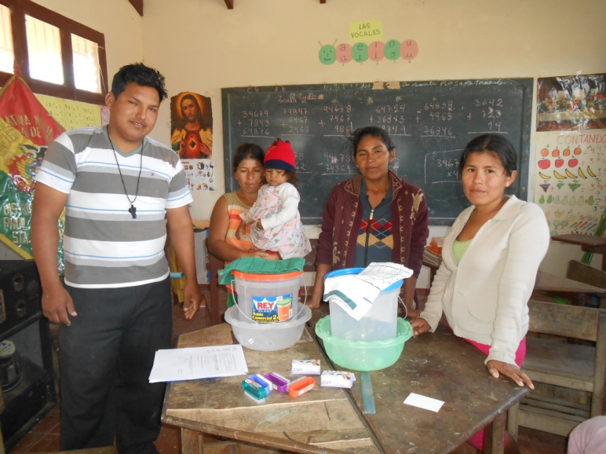
The project also turned in a school “hygiene corner”, providing all the materials for the students to practice healthy behavior. Hygiene corners included materials such as: toilet paper, tooth brushes, tooth paste, towels, buckets, nail clippers, mirrors, brooms, and other hygiene materials. In addition, the school developed a calendar to maintain their school grounds clean. They rotated the chores among the students.
Members of wáter committee turned in materials to teacher to begin a hygiene corner.

In addition to the community and student workshops, the facilitator also made house visits and worked individually with families to review the content of the workshops and make real changes in each home.
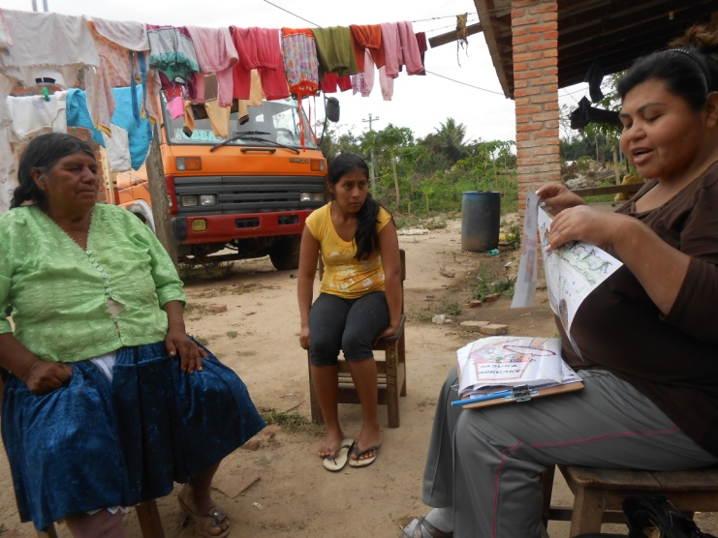
Maria Edilda, project facilitator, making house visits
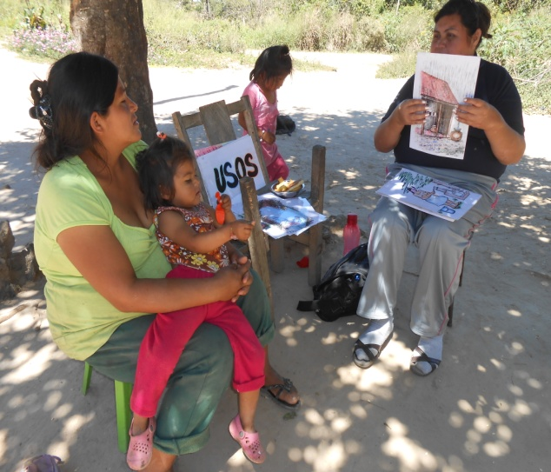

- Plan for continuing work on this project?
Unfortunately, due to the postponed installation of the water system due to rain and electrical modifications, there was not sufficient time to gather long-term information regarding the impact and sustainability of the project, particularly how it relates to education, health and income generation.
Data collection regarding the sustainability of the water system will continue for the next five years. Etta Projects will continually check that water is available throughout the day and reaches all households. We will also monitor if new households are able to connect to the system.
In order to increase the sustainability of the project, Etta Projects aims to offer ongoing support and training to the water committee and local families. In order to effectively accomplish this, Etta Projects will continue to make bi-monthly visits to Nueva America throughout 2014, and include Nueva America in group trainings with other communities utilizing this system.

