KATOSI WOMEN DEVELOPMENT TRUST
KWDT constructed and distributed 27 bio sand water filters. 18 out of the 27 filters have been installed and are functioning, while 9 have been applied for and delivered waiting for installation. Six of the bio sand water filters were distributed to schools while the rest have been taken and applied for by households.
The list below indicated the bio-sand filter beneficiaries and applicants whose bio sand filters will be installed after the Christmas holidays.
 | DATE CONSTRUCTED | BENEFICIARY | GROUP/SCHOOL | VILLAGE | F | M | # of USERS
1 | 1/5/2013 | Nsonga Primary School | ManyiGamulimi | Nsonga | 245 | 267 | 512
2 | 1/5/2013 | Kojja Secondary School | Katosi | Nsanja | 423 | 250 | 673
3 | 1/5/2013 | Katente CU Primary School | Manyigamulimi | Katente | 198 | 235 | 433
4 | 1/5/2013 | Kajjule Betty | Katosi | Nsanja | 7 | 5 | 12
5 | 1/5/2013 | NamwanjeResty | Katosi | Buakijja | 3 | 2 | 5
6 | 1/5/2013 | Nabwami Gertrude | Katosi | Katosi | 4 | 1 | 5
7 | 17/04/2013 | Namukasa Rose | Kalengera | Kalengera | 1 | 7 | 8
8 | 18/04/2013 | BabiryeAidah | Katosi | Katosi | 3 | 2 | 5
9 | 18/04/2013 | Kulabakoreginana | katosi | Kalengera | 4 | 1 | 5
10 | 22/04/2013 | NalongoNaggujja | Kulubi | kulubbi | 2 | 2 | 4
11 | 22/04/2013 | NakawundeSikola | Kulubbi | kulubbi | 3 | 2 | 5
12 | 22/04/2013 | NamagandaMastula | Katosi | Katosi central | 2 | 3 | 5
13 | 23/04/2013 | Kamukama Patricia | kulubbi | kulubbi | 4 | 1 | 5
14 | 23/04/2013 | Nakalema Dorothy | Katosi | katosi | 3 | 5 | 8
15 | 24/04/2013 | Nsanja Primary School | Katosi | Nsanja | 300 | 312 | 612
16 | 24/04/2013 | Kateregga Lydia | Katosi | Kalengera | 5 | 0 | 5
17 | 29/04/2013 | Kiyoola Church of Uganda | KiyoolaManyiGamulimi | Kiyoola | 100 | 110 | 210
18 | 29/04/2013 | St. BalikuddembeTtabba | Mpatta | Ttaba | 284 | 205 | 489
19 | 30/04/2013 | LuleJackline | Nakisunga
 | DISTRUBUTED AND YET TO BE INSTALLED
20 | 30/04/2013 | Esther Owor | Nakisunga
21 | 1/5/2013 | KalyangoJesca | Nakisunga
22 | 1/5/2013 | NakamatteAgness | Bukwaya
23 | 2/5/2013 | Nabusayi Joyce | Bukwaya
24 | 2/5/2013 | Kyobe Justine | Muwumuza
25 | 17/07/2013 | Nakafu Margaret | Muwumuza
26 | 17/07/2013 | NalwogaResty | BasookaKwavula
27 | 17/07/2013 | Ndagire Joyce | BasookaKwavula
 |  | TOTAL |  |  | 1591 | 1410 | 3001
Sensitization and awareness on use of Bio sand filters
KWDT with the GWWI team leaders, Betty, Rose and Mastula carry out awareness on the of use bio sand water filter. This has been done through, coordination committee meetings, group meetings, exhibitions and community dialogues. The community members have been sensitized about the importance of using the facility, what the beneficiary stand to lose in monetary terms.
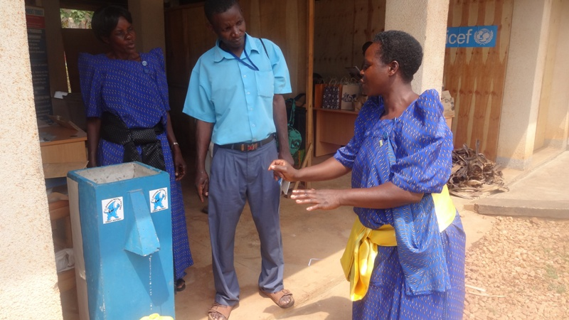
KWDT was identified as a key player in the promotion of access to clean and safe drinking by Appropriate Technology Center (ATC) an arm of the Ministry of Water and Environment to take part in the 2nd National Water and Sanitation Technology exhibition which took place on the 18th December 2013. During this exhibition, KWDT shared experiences with various people on the use of the bio sand which attracted a lot of attention.
Kajjule Betty a GWWI team member and Nakalema Dorothy a tank mason explaining to a visitor during the exhibition.
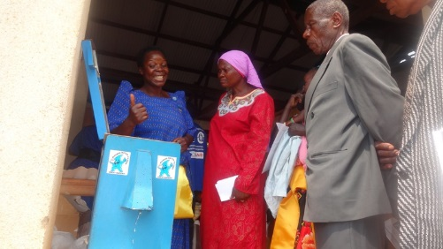
Kajjule Betty emphasizing the procedure in operation and maintenance of a bio-sand water filter

