THE STORY OF FERMIN AGUIRRE ORTIZ
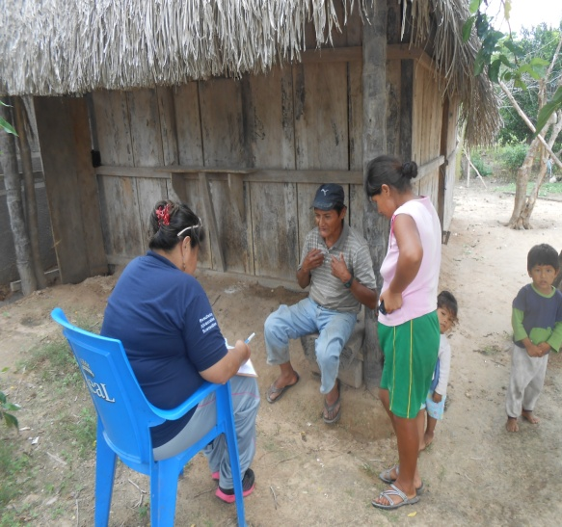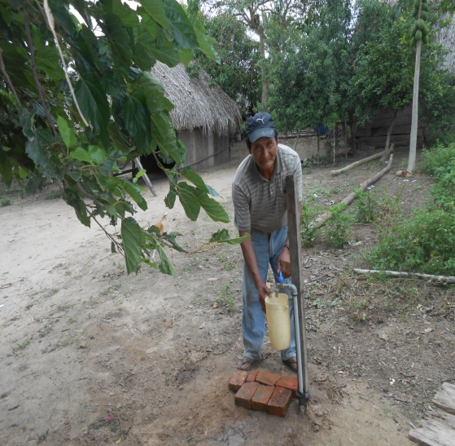
Nueva América 31/10/2013
Fermín Aguirre Ortiz is one of the many happy members of Nueva América, who recently benefited from the new water system. He is 63 years old and has been a part of this community for the past 22 years. This past year his wife Juana Flores passed away from complications due to arthritis. He now lives with their 12 year old granddaughter that he and his wife have raised. Fermin is a dedicated to his work with agriculture.
Fermin said, “ I have great joy and feel very happy and peaceful now because I have clean, safe water and can now bathe with ease. I don’t have to use the tube now, which had dirty and contaminated water”.
Fermin participated in all of the sanitation workshops and actively worked to help with the installation of the water system.
Here is a glimpse of Fermin’s involvement through pictures.
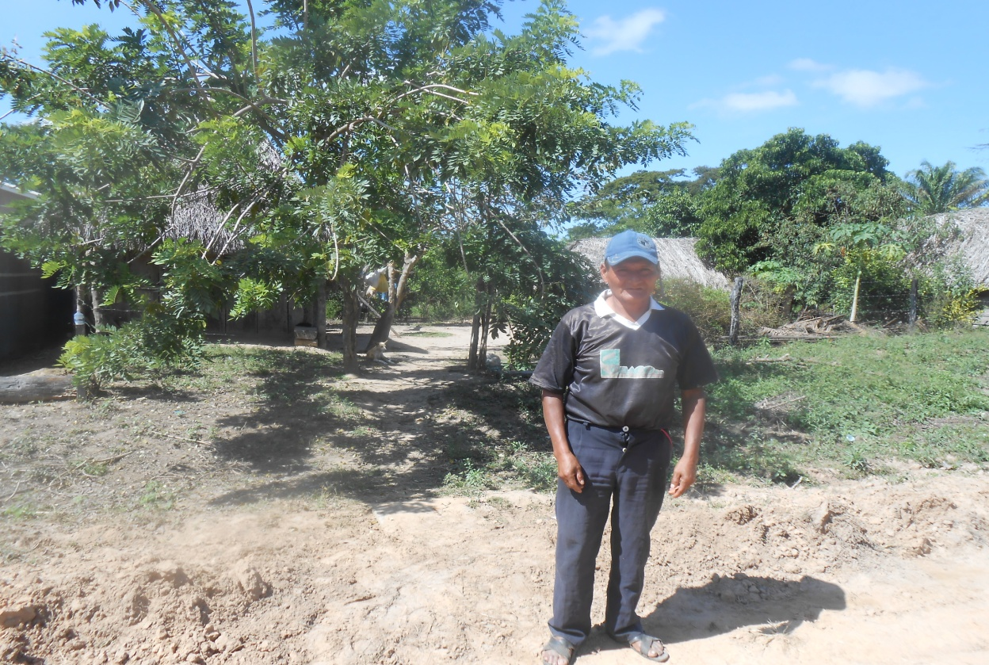
Fermin posing for the camera when Etta went out for baseline monitoring with Pennye Nixon
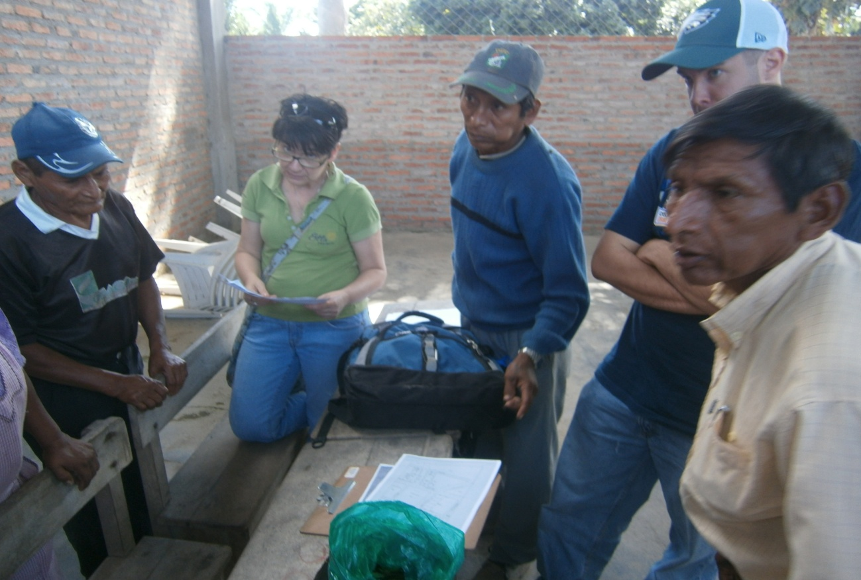
Fermín participating in the meetings for coordinating activities for 2013, Nueva América with Pennye. 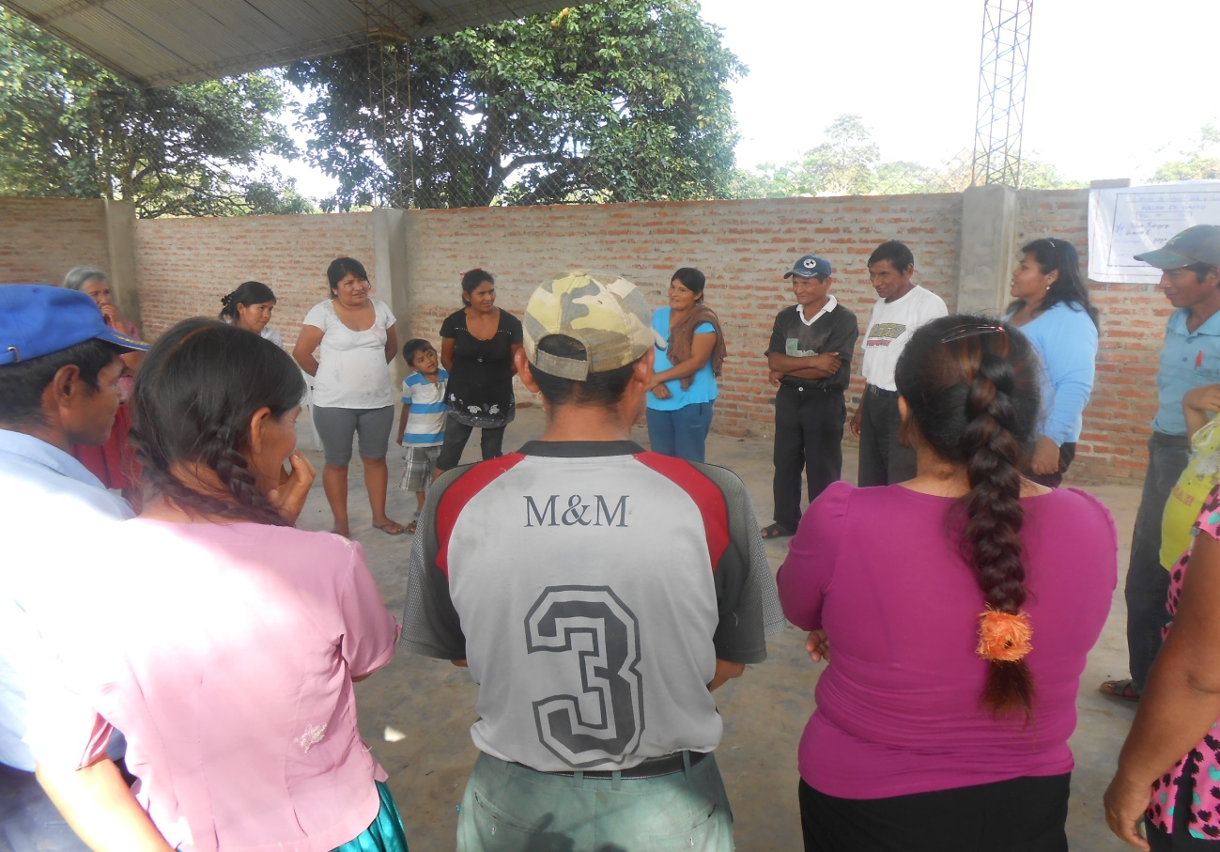
Fermin participating in the first workshop “Sources of water suppy and water care”. June 2013.
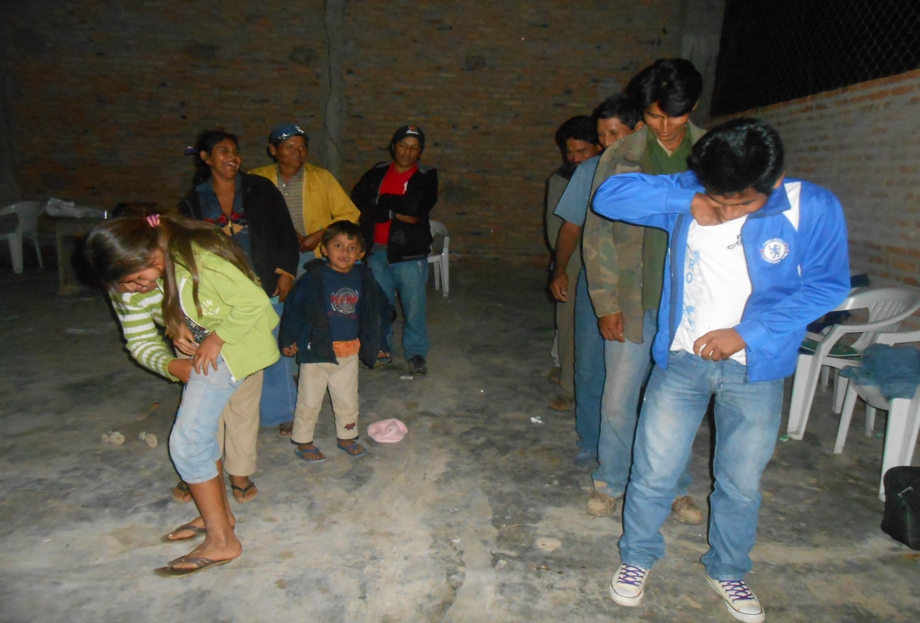
Fermín participating in the second workshop, the importance of sanitation and water care- July 2013.
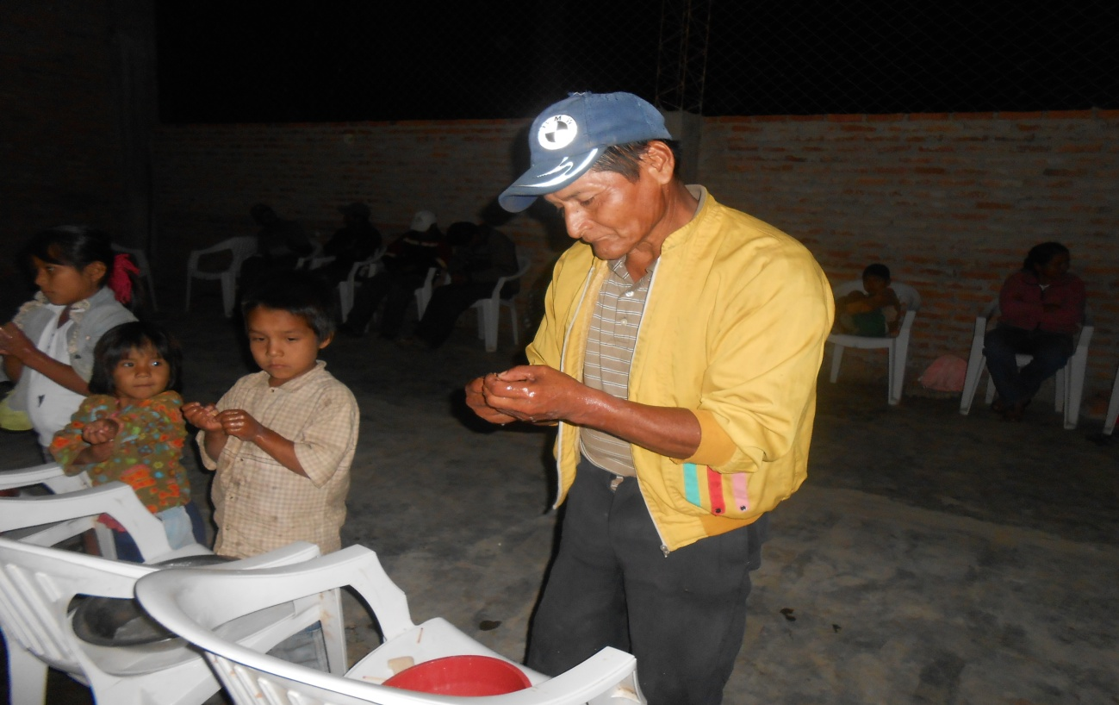
Fermín participating in the third workshop “The importance of handwashing” –July 2013.
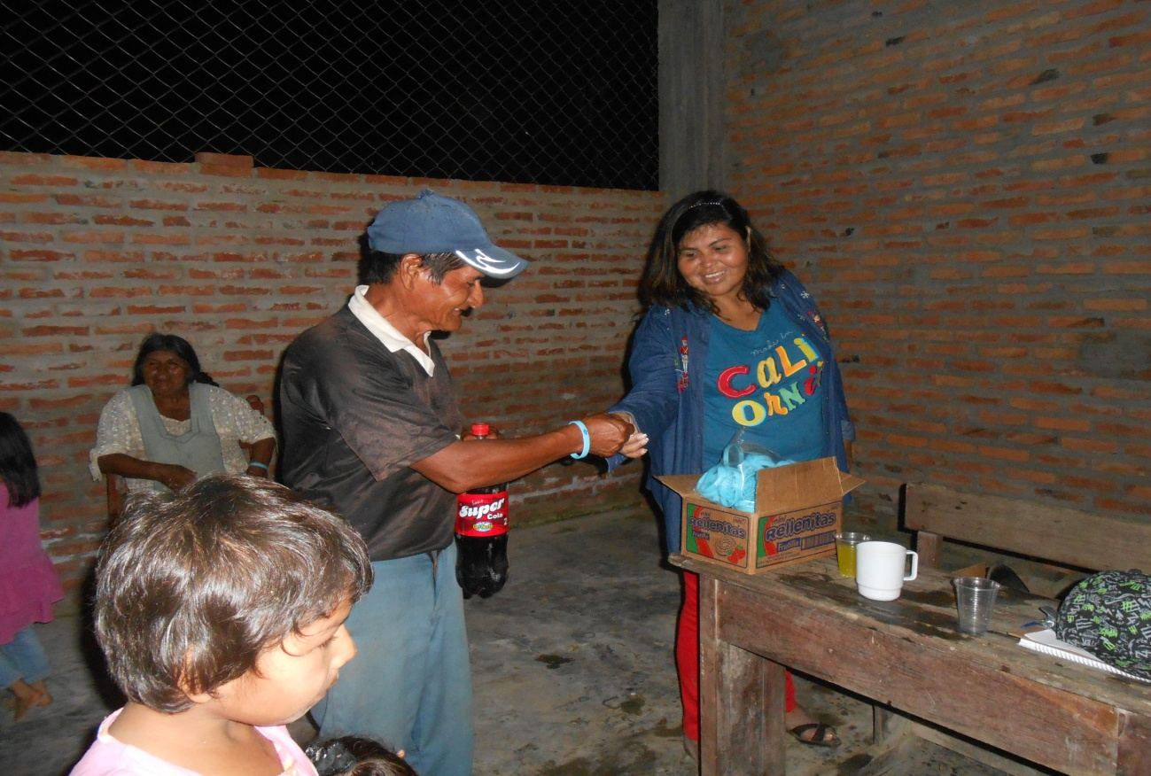
Fermín participating in the sanitaition workshops ,”Personal and food hygiene”-July 2013. IN this Photo he is recieving a prize.
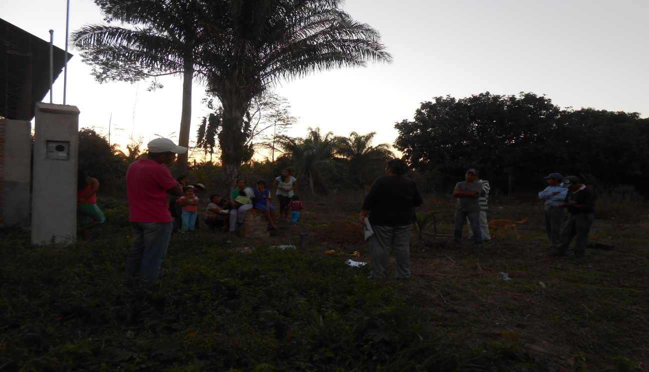
Fermín participating in sanitation workshops,” Sanitary Management of Trash”- August 2013.

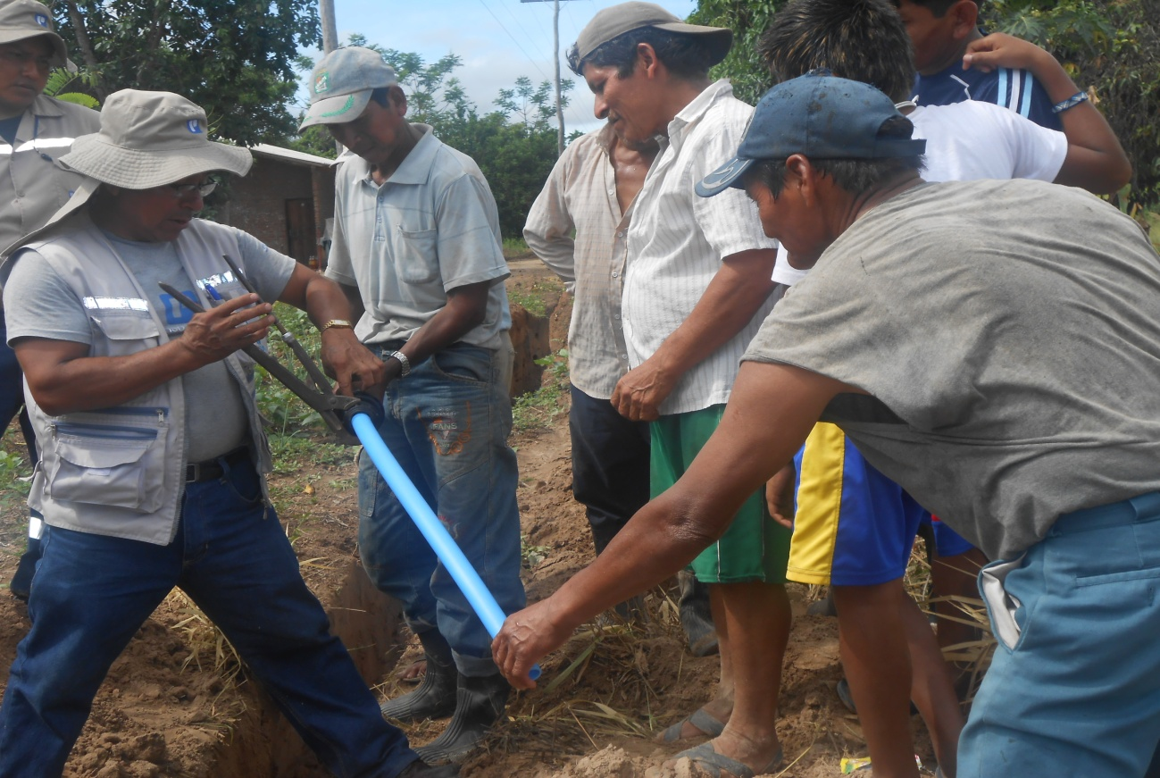
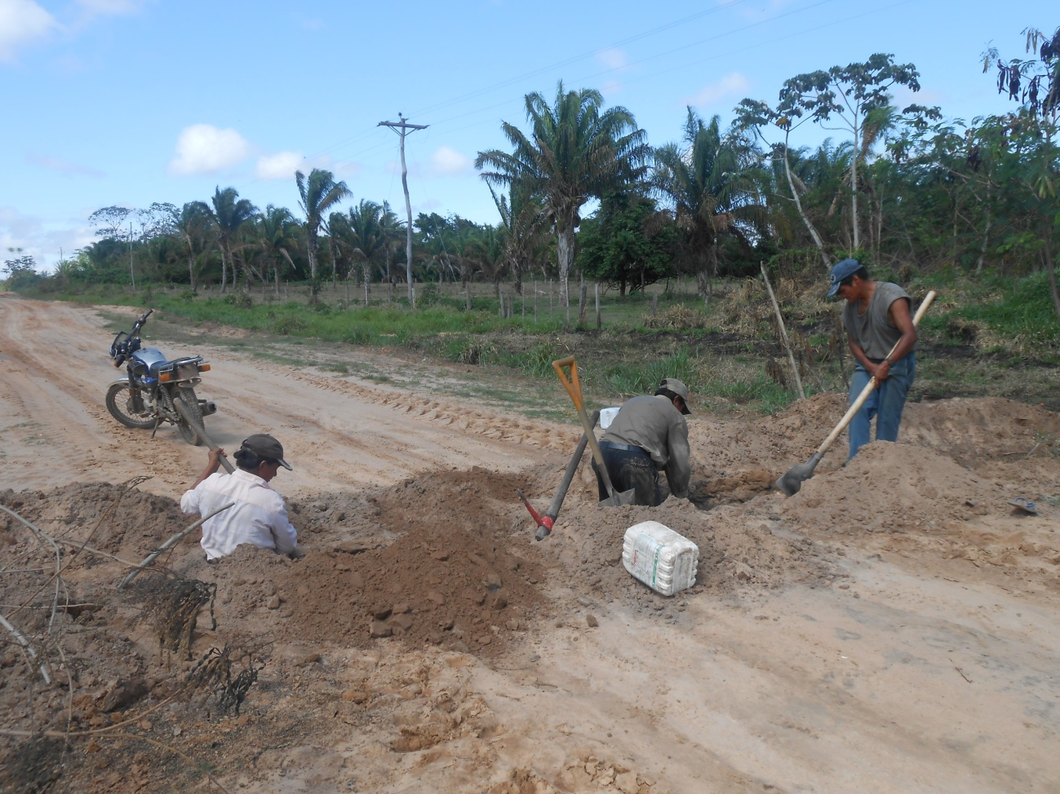
Fermín helping install the poratble water system- October 2013.
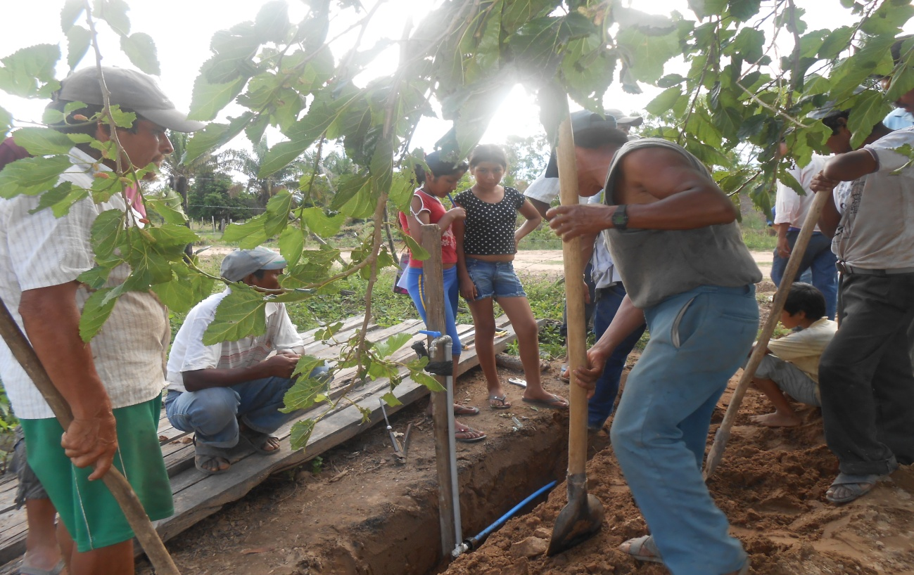
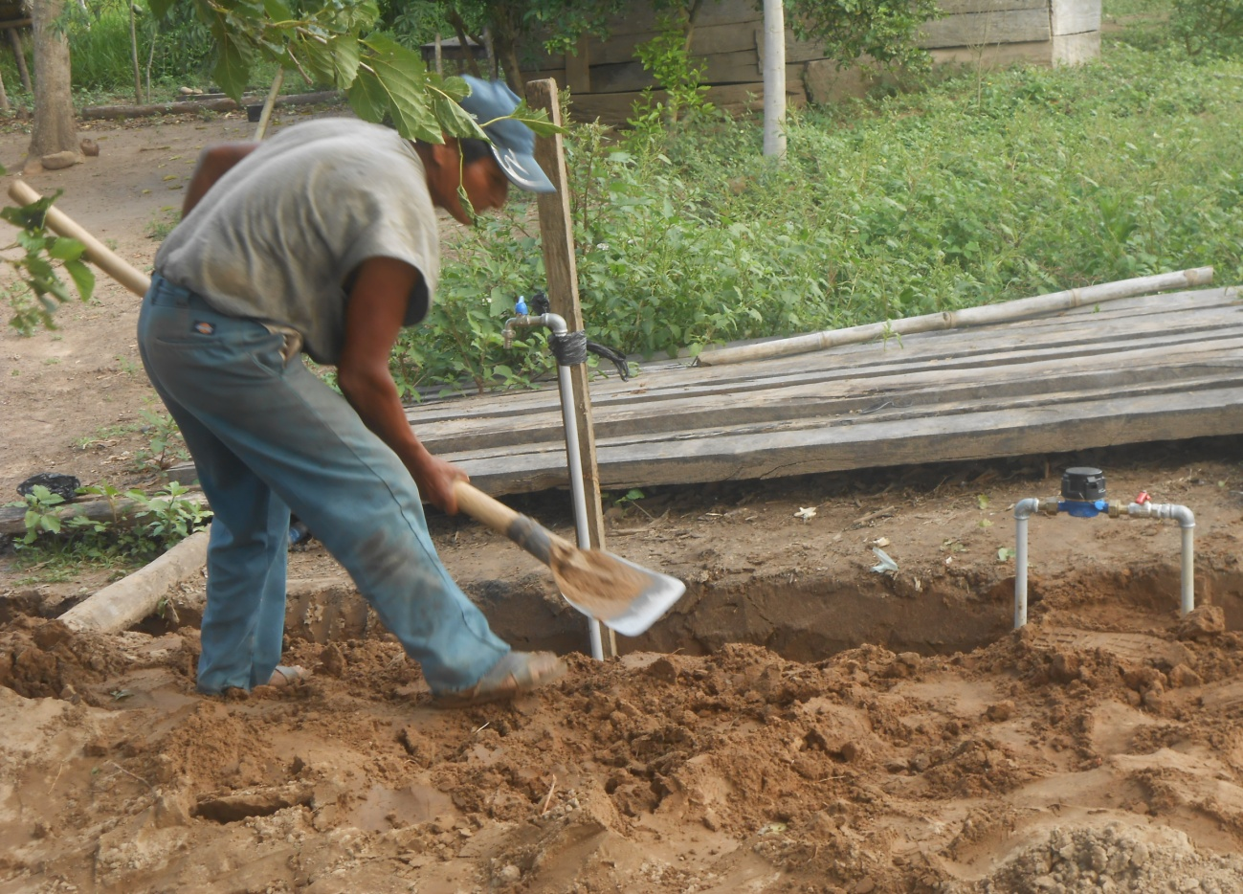
Fermín covering the escavation after placing the meter and tap- October 2013

