Performance curve of Pump
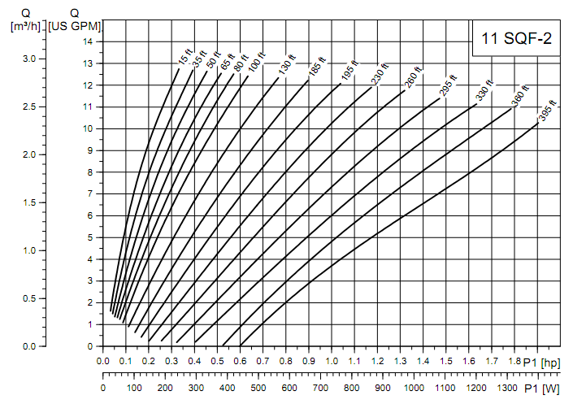
Source: Grundfos Product Guide-SP-TL-014

