PROJECT WELL REPORT ON THE 24 NEW DUGWELLS CONSTRUCTED IN 2007: GAIGHATA

Project Well, PW, (California, USA, 2001) with the help of local NGO, Aqua Welfare Society (near Kolkata, West Bengal) has developed a self-supporting community-based mitigation program to provide arsenic-safe water to the villagers of the districts of North 24 Parganas of West Bengal, India. PW has provided 48 dugwells in eight villages in the the Deganga and Habra 1 Block where the population drinking arsenic contaminated water >50µg/L are 87,334 and 66,685 respectively. In 2007, 24 more dugwells have been constructed mostly in the Block called Gaighata of N 24 Parganas where the number of people drinking water containing arsenic >50 µg/L is106,552.

To provide arsenic safe drinking water to the rural areas inexpensive, easily adaptable method is used by excavating a special type of concrete shallow dugwells that differ in design from the traditional dugwells. The program to implement dugwells has been formulated scientifically keeping two major contaminants in view: arsenic and pathogenic bacteria. Such dugwells are constructed at carefully selected sites. The diameter of a dugwell is 3.3 feet (one meter) and the depth is kept less than 30 feet.

Considering real value from data tracking, on an average, from each dugwell 30 people can be provided with arsenic-safe-chlorinated-water throughout their entire life (at some places the number of consumers exceeds 50 persons) at the expense of less than US$30 (INR1200) per person. And through village meetings and health meetings they also acquire knowledge on health effects of drinking arsenic contaminated water and develop proper personal hygiene & sanitation practices producing a healthy environment.

To make this scheme sustainable the user community of each well is trained in well maintenance, including disinfecting and periodic sampling of water for monitoring of arsenic and bacterial concentrations. The method involves only indigenous raw material and labor. There is no requirement of importing any equipment. To remove the slight chlorine odor and organic odor cheap earthen filters that are manufactured locally are distributed among the users enhancing the pottery trade in the villages.

In 2007, the Blue Planet Run/Peer Water Exchange has funded 20 dugwells and four more were funded by Mosaique and Eco-band Valoris of Quebec, Canada (3) and Kallol Club of New Jersey (1). The pictures of all the dugwells constructed in the month of May and June of 2007 are displayed below.

Dugwell ID | PW68/JLS1
Land donated by | Manik Mondol
Village | Narikala
Panchayat | Jaleswar / Gaighata
District | N 24 Parganas
Location :Latitude | 22.94178 E
Location :Longitude | 88.72678 N
Constructed | June 2007
Arsenic level | 4 PPB
Date of Report | 19th November 2007
Bacteria:TC / FC | 395 / 0
Date of Report | 21st December 2007
Physical qlty of water | Clear water, no odor, normal taste
Beneficiary families | 4
Beneficiary members | 22
Remarks | As of January 2008
Sponsored by | Blue Planet Run (1)
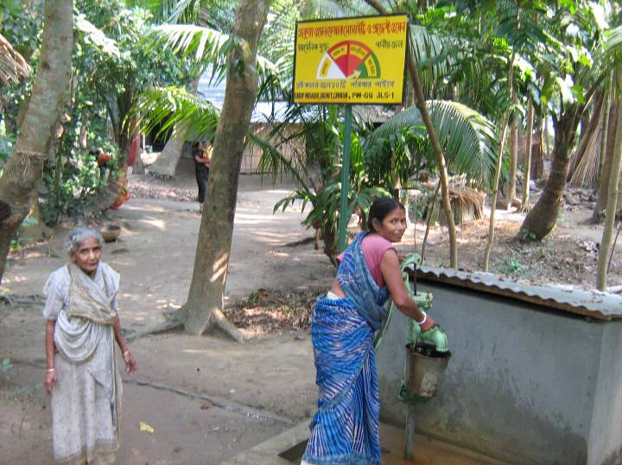
PW68/JLS1

Dugwell ID | PW66/RMN2
Land donated by | Porimol Mondol/Pipley milk Co-op
Village | Pipley
Panchayat | Ramnagar/ Gaighata
District | N 24 Parganas
Location :Latitude | 22.94418 N
Location :Longitude | 88.88788 E
Constructed | June 2007
Arsenic level | 6 PPB
Date of Report | 19th November 2007
Bacteria:TC/FC | Bottle broke during sample transfer. The water being treated.
Date of Report | Bacteria test is pending
Physical qlty of water | Clear water, no odor, normal
Beneficiary families | 8
Beneficiary members | 40
Remarks | As of January 2008
Sponsored by | Blue Planet Run (2)
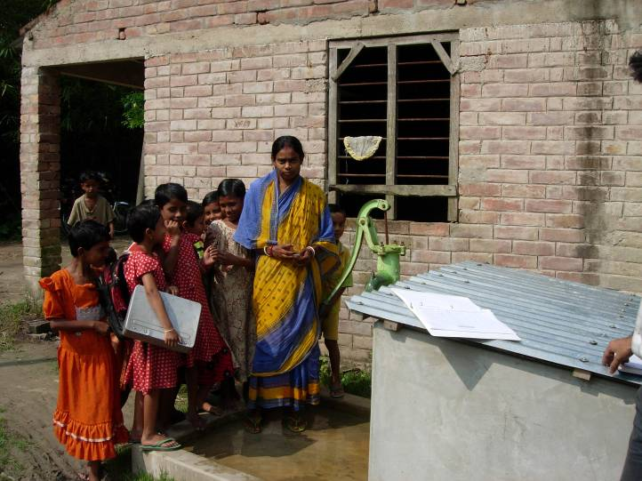
PW66/RMN2

Dugwell ID | PW52/RMN3
Land donated by | Madan Mohan Mondol
Village | Pipley
Panchayat | Ramnagar/ Gaighata
District | N 24 Parganas
Location :Latitude | 22.9463 N
Location :Longitude | 88.88097 E
Constructed | June 2007
Arsenic level | 14 PPB
Date of Report | 19th November 2007
Bacteria:TC / FC | 135 / 0
Date of Report | 21st December 2007
Physical qlty of water | Clear water, no odor, normal
Beneficiary families | 12
Beneficiary members | 49
Remarks | As of January 2008
Sponsored by | Blue Planet Run (3)

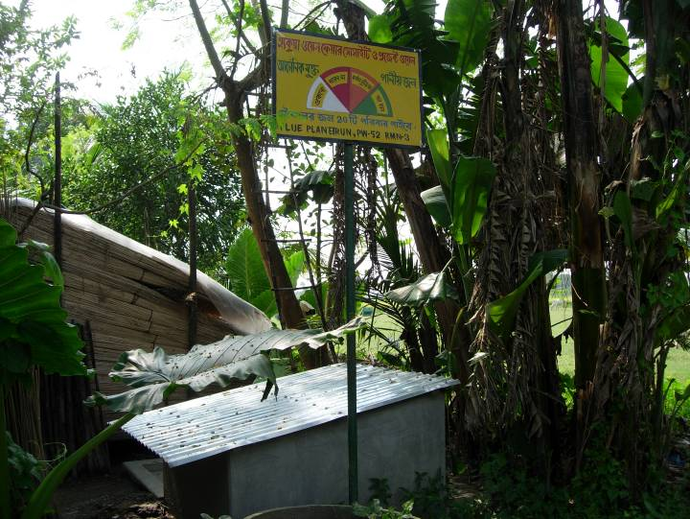
PW52/RMN3

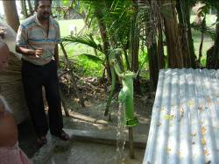

Dugwell ID | PW51/SML2
Land donated by | Bishnupada Das
Village | Das Para
Panchayat/Block | Simulpur/ Gaighata
District | N 24 Parganas
Location :Latitude | 22.9328 N
Location :Longitude | 88.83318 E
Constructed | June 2007
Arsenic level | ??
Date of Report
Bacteria:TC/FC | 1640 / 200
Date of Report | 11/17/07
Physical qlty of water | Clear water, no odor, normal taste
Beneficiary families | 4
Beneficiary members | 14
Remarks | Water is being treated and re-test for Bacteria. As of January 2008.
Sponsored by | Blue Planet Run (4)

PW51/SML2

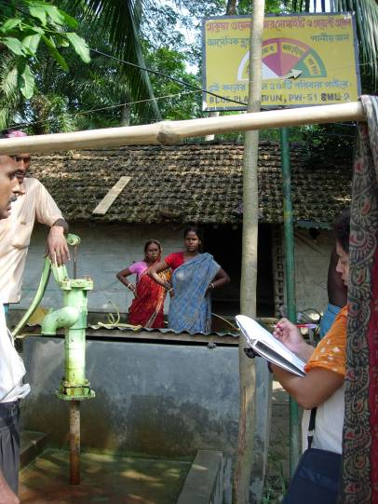

Dugwell ID | PW54/SU2
Land donated by | Satana Das
Village | Purba Bishnupur
Panchayat | Sutia/ Gaighata
District | N 24 Parganas
Location :Latitude | 22.9036 N
Location :Longitude | 88.78818 E
Constructed | June 2007
Arsenic level | 4 PPB
Date of Report | 19th November 2007
Bacteria:TC/FC | 375 / 0
Date of Report | 11/17/07
Physical qlty of water | Clear water, no odor, normal taste
Beneficiary families | 4
Beneficiary members | 12
Remarks | As of January 2008
Sponsored by | Blue Planet Run (5)
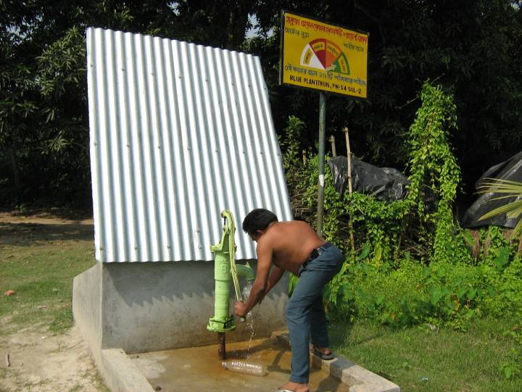
PW54/SU2

PW57/SU5
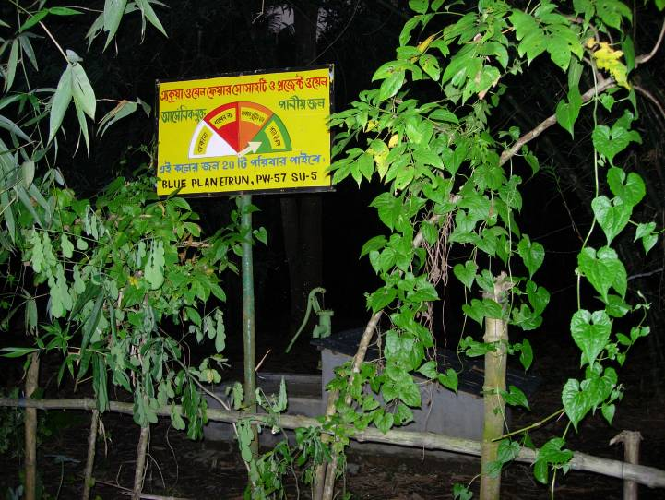
Dugwell ID | PW57/SU5
Land donated by | Samir Kumar Mondol
Village | Baldarghat
Panchayat | Sutia / Gaighata
District | N 24 Parganas
Location :Latitude | 22.90087 N
Location :Longitude | 88.80294 E
Constructed | June 2007
Arsenic level | 17
Date of Report
Bacteria:TC/FC | 1620 / 50
Date of Report | 11/17/07
Physical qlty of water | Clear water, no odor, normal taste
Beneficiary families | 4
Beneficiary members | 22
Remarks | Water being treated Re-test for bacteria. As of January 2008
Sponsored by | Blue Planet Run (6)

Dugwell ID | PW60/SU8
Land donated by | Topon Das
Village | Gajna
Panchayat / Block | Sutia / Gaighata
District | N 24 Parganas
Location :Latitude | 22.90549 E
Location :Longitude | 88.79761 N
Constructed | June 2007
Arsenic level | ??
Date of Report
Bacteria:TC/FC | 230 / 22
Date of Report | 11/17/07
Physical qlty of water | Clear water, no odor, normal taste
Beneficiary families | 3
Beneficiary members | 11
Remarks | Water being treated Re-test for bacteria.
Sponsored by | Blue Planet Run (7)
PW60/SU8
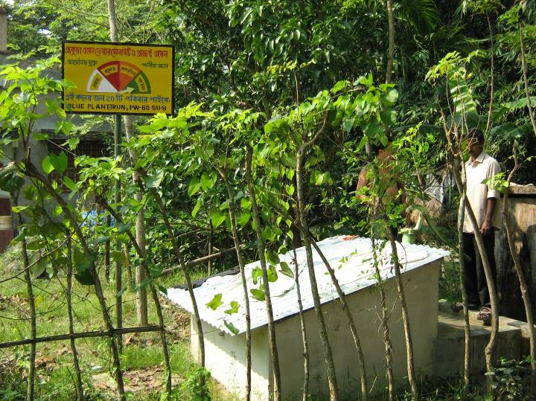

Dugwell ID | PW61/SU9
Land donated by | Dilip Das
Village | Gajna
Panchayat / Block | Sutia / Gaighata
District | N 24 Parganas
Location :Latitude | 22.90077 E
Location :Longitude | 88.80336 N
Constructed | June 2007
Arsenic level | 2 PPB
Date of Report | 19th November 2007
Bacteria:TC/FC | 510 / 0
Date of Report | 11/17/07
Physical qlty of water | Clear water, no odor, normal taste
Beneficiary families | 12
Beneficiary members | 47
Remarks | As of January 2008
Sponsored by | Blue Planet Run (8)
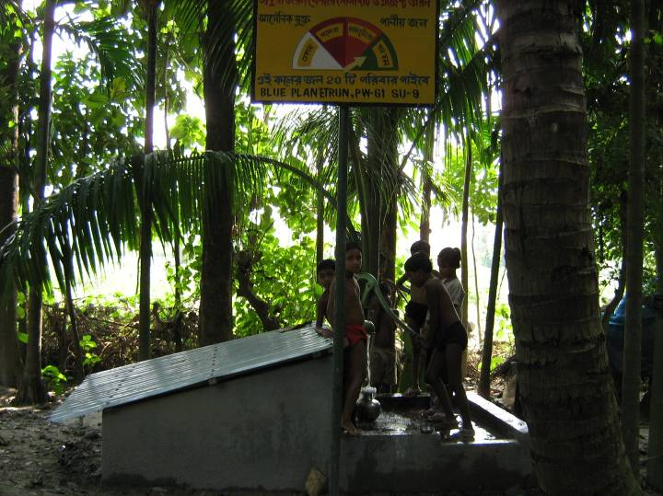
PW61/SU9

Dugwell ID | PW62/SU10
Land donated by | Manoj Sarkar
Village | Teghoria
Panchayat/Block | Sutia / Gaighata
District | N 24 Parganas
Location :Latitude | 22.90077 E
Location :Longitude | 88.80336 N
Constructed | June 2007
Arsenic level | 10 PPB
Date of Report
Bacteria:TC/FC | 415 / 0
Date of Report | 11/17/07
Physical qlty of water | Clear water, no odor, normal taste
Beneficiary families | 4
Beneficiary members | 26
Remarks | As of January 2008
Sponsored by | Blue Planet Run (9)

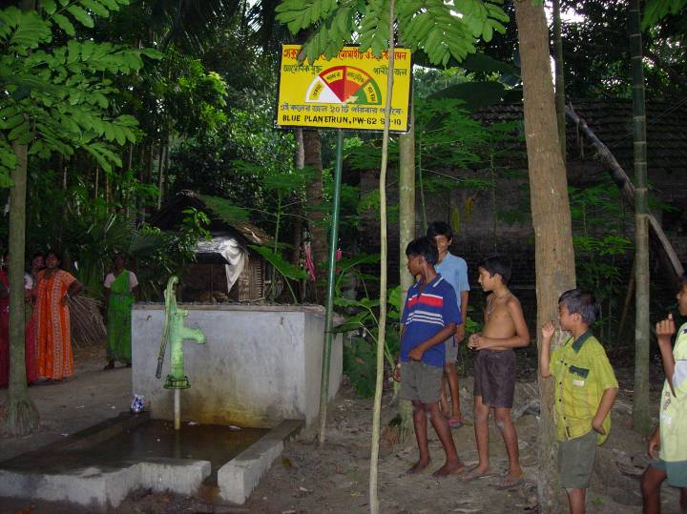
Dugwell ID | PW63/SU11
Land donated by | Partho Majumdar
Village | Faredkati
Panchayat/Block | Sutia / Gaighata
District | N 24 Parganas
Location :Latitude | 22.91144 E
Location :Longitude | 88.79035 N
Constructed | June 2007
Arsenic level | 16 PPB
Date of Report
Bacteria:TC/FC | Pending sample collection on Dec 13
Date of Report
Physical qlty of water | Slightly turbid
Beneficiary families | 13
Beneficiary members | 52
Remarks | As of January 2008
Sponsored by | Blue Planet Run (10)
PW62/SU10

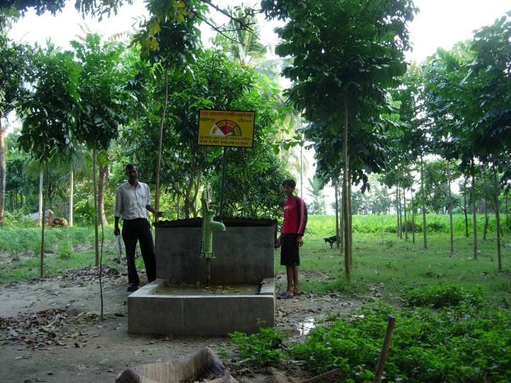
PW63/SU11

Dugwell ID | PW64/SU12
Land donated by | Gajna Milk Coperative
Village | Gajna
Panchayat/Block | Sutia / Gaighata
District | N 24 Parganas
Location :Latitude | 22.90644 E
Location :Longitude | 88.80965 N
Constructed | June 2007
Arsenic level | 20 PPB
Date of Report | 19th November 2007
Bacteria:TC/FC | 810 / 186
Date of Report
Physical qlty of water | Clear water, no odor, normal taste
Beneficiary families | 1
Beneficiary members | 4
Remarks | Water being treated. Re-test for bacteria. As of January 2008.
Sponsored by | Blue Planet Run (11)
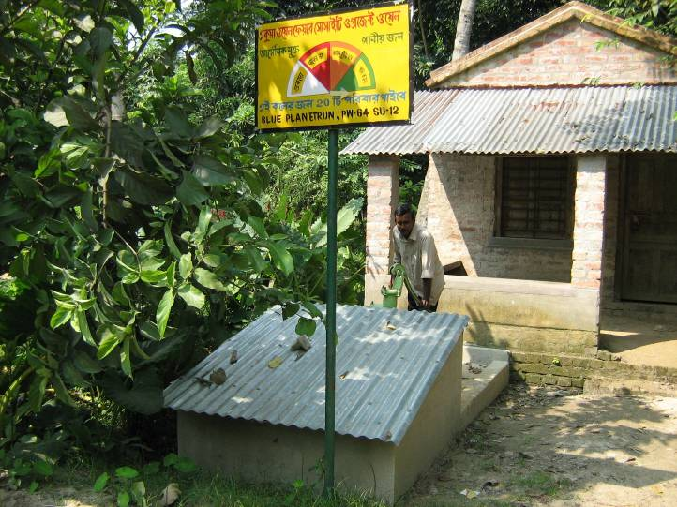
PW64/SU12

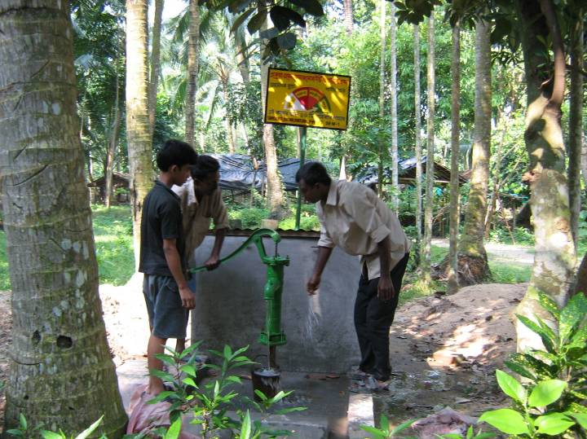
Dugwell ID | PW67/DRM1
Land donated by | Joydeb Mukherjee
Village | Bamonpara
Panchayat/Block | Dharampur / Gaighata
District | N 24 Parganas
Location :Latitude | 22.90283 E
Location :Longitude | 88.69646 N
Constructed | June 2007
Arsenic level | 39.2 Re-test required.
Date of Report
Bacteria:TC/FC | Bottle broke during sample transfer.
Date of Report
Physical qlty of water | Clear water, no odor, normal taste
Beneficiary families | 0
Beneficiary members | 0
Remarks | Need Health Meetings
Sponsored by | Blue Planet Run (12)
PW67/DRM1

Dugwell ID | PW69/JLS2
Land donated by | Sujit Das
Village | Narikala
Panchayat/Block | Jaleswar / Gaighata
District | N 24 Parganas
Location :Latitude | 22.93710 E
Location :Longitude | 88.72120 N
Constructed | June 2007
Arsenic level | 14 PPB
Date of Report | 19th November 2007
Bacteria:TC/FC | 80 / 0
Date of Report | 21st December 2007
Physical qlty of water | Reddish color due to iron and taste is normal
Beneficiary families | 0
Beneficiary members | 0
Remarks | Under R&D observation, introduce mawka filter
Sponsored by | Mosaique & Eco-Band Valoris, Sagney, Canada (1)
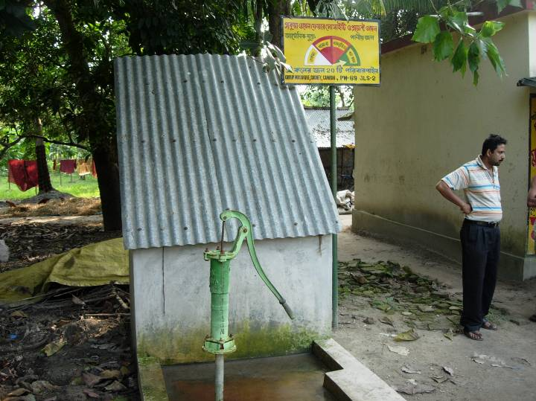
PW69/JLS2

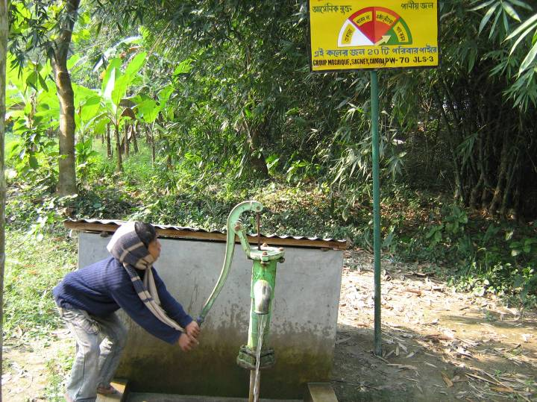
PW70/JLS3
Dugwell ID | PW70/JLS3
Land donated by | Adher Dey
Village | Narikala
Panchayat/Block | Jaleswar / Gaighata
District | N 24 Parganas
Location :Latitude | 22.93958 E
Location :Longitude | 88.72306 N
Constructed | June 2007
Arsenic level | ??
Date of Report
Bacteria:TC/FC | 640 / 0
Date of Report | 21st December 2007
Physical qlty of water | Clear water, no odor, normal taste
Beneficiary families | 0
Beneficiary members | 0
Remarks | As of January 2008
Sponsored by | Mosaique & Eco-Band Valoris,  Sagney, Canada (2)

Dugwell ID | PW71/JLS4
Land donated by | Sanjib Dutta
Village | Narikala
Panchayat/Block | Jaleswar / Gaighata
District | N 24 Parganas
Location :Latitude | 22.93814 E
Location :Longitude | 88.72214 N
Constructed | June 2007
Arsenic level | ??
Date of Report
Bacteria:TC/FC | 975 / 0
Date of Report | 21st December 2007
Physical qlty of water | Reddish color due to iron and taste is normal
Beneficiary families | 6
Beneficiary members | 26
Remarks | As of January 2008
Sponsored by | Mosaique & Eco-Band Valoris, Sagney, Canada (3)
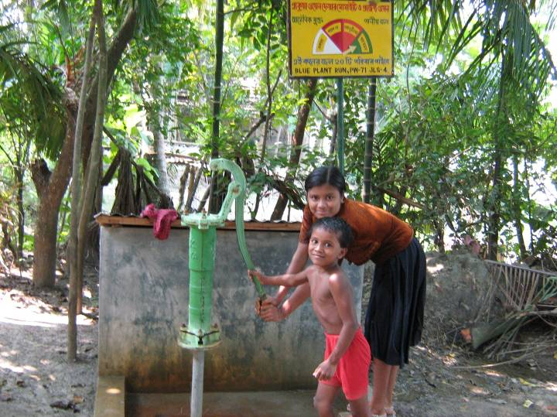
PW71/JLS4

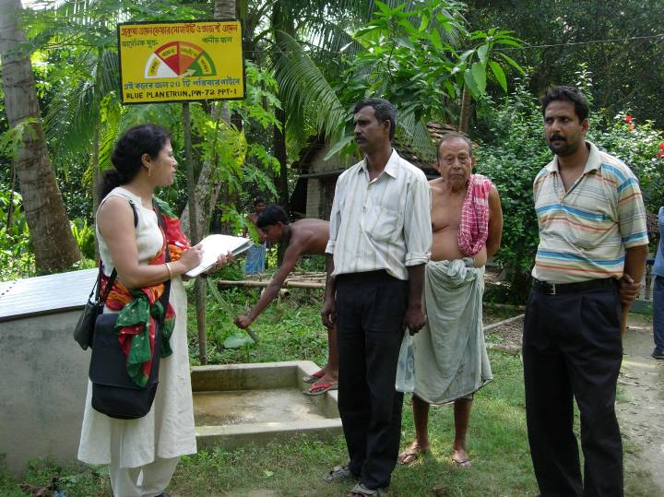
Dugwell ID | PW72/PPT1
Land donated by | Swapon Ghosh
Village | Ghoshpara
Panchayat/Block | Pachpota / Gaighata
District | N 24 Parganas
Location :Latitude | 22.91445 E
Location :Longitude | 88.84618 N
Constructed | June 2007
Arsenic level | 24 PPB
Date of Report | 19th November 2007
Bacteria:TC/FC | 260 / 22
Date of Report | 17 November 2007
Physical qlty of water | Clear, no odor, normal taste
Beneficiary families | 4
Beneficiary members | 21
Remarks | Water is treated. As of January 2008
Sponsored by | Kallol Club of New Jersey
PW72/PPT1

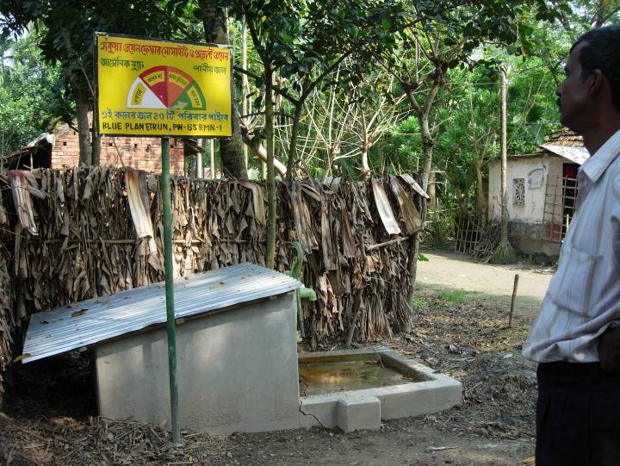
Dugwell ID | PW65/RMN1
Land donated by | Kartik Dey
Village | Pipley Dakshin Para
Panchayat/Block | Ramnagar/ Gaighata
District | N 24 Parganas
Location :Latitude | 22.93873 N
Location :Longitude | 88.88818 E
Constructed | June 2007
Arsenic level | 23
Date of Report | 19th November 2007
Bacteria:TC/FC | 654 / 18
Date of Report | 21st December 2007
Physical qlty of water | R&D observation
Beneficiary families | 0
Beneficiary members | 0
Remarks | Water is treated As of January 2008
Sponsored by | Blue Planet Run (13)
PW65/RMN1

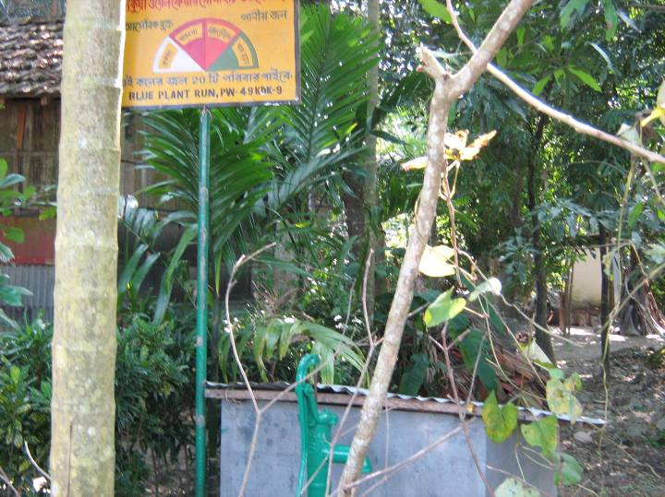
Dugwell ID | PW49/KDK9
Land donated by | Ajit Baroi
Village | North Kamdebkati
Panchayat/Block | Deganga / N 24 Parganas
District | N 24 Parganas
Location :Latitude | 22.81758 E
Location :Longitude | 88.73366N
Constructed | June 2007
Arsenic level | 20
Date of Report | 19th November 2007
Bacteria:TC/FC | 300 / 0
Date of Report | 21st December 2007
Physical qlty of water | Slightly turbid
Beneficiary families | 4
Beneficiary members | 17
Remarks | As of January 2008
Sponsored by | Blue Planet Run (14)
PW49/KDK9

Dugwell ID | PW50/SML1
Land donated by | Raghunath Paramanick
Village | Korapara
Panchayat/Block | Simulpur / Gaighata
District | N 24 Parganas
Location :Latitude | 22.92951 E
Location :Longitude | 88.82650 N
Constructed | June 2007
Arsenic level | 8 PPB
Date of Report | 19th November 2007
Bacteria:TC/FC | 250 / 0
Date of Report | 11/17/07
Physical qlty of water | Clear water, no odor, salty taste
Beneficiary families | 6
Beneficiary members | 38
Remarks | As of January 2008
Sponsored by | Blue Planet Run (15)

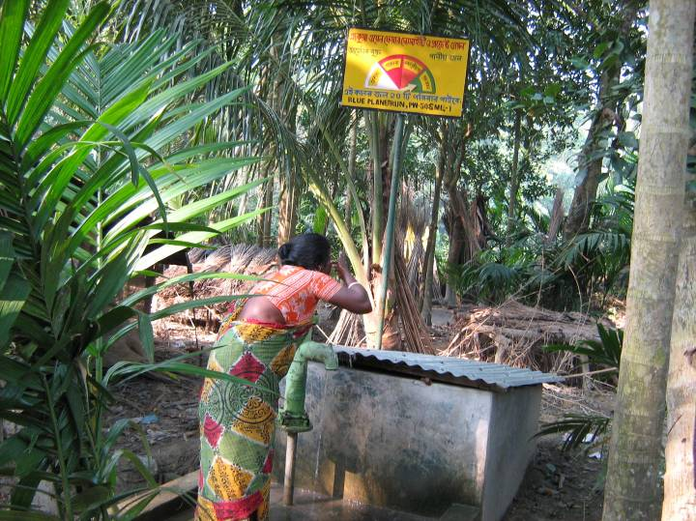
PW50/SML1

Dugwell ID | PW53/SU1
Land donated by | Anuradha Ball
Village | Nagbari
Panchayat/Block | Sutia / Gaighata
District | N 24 Parganas
Location :Latitude | 22.91803 E
Location :Longitude | 88.80999 N
Constructed | June 2007
Arsenic level | 24 PPB
Date of Report | 19th November 2007
Bacteria:TC/FC | 1855 / 34
Date of Report | 11/17/07
Physical qlty of water | Clear water, slight chlorine odor, taste normal
Beneficiary families | 10
Beneficiary members | 42
Remarks | Water is being treated. As of January 2008.
Sponsored by | Blue Planet Run (16)
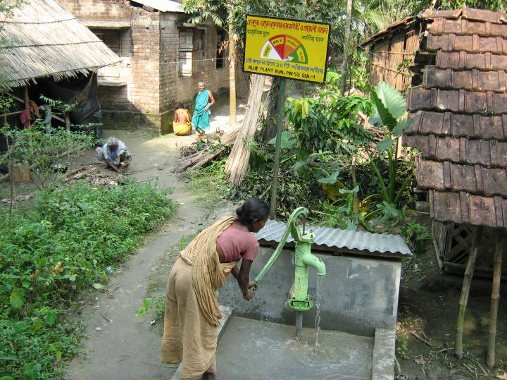
PW53/SU1

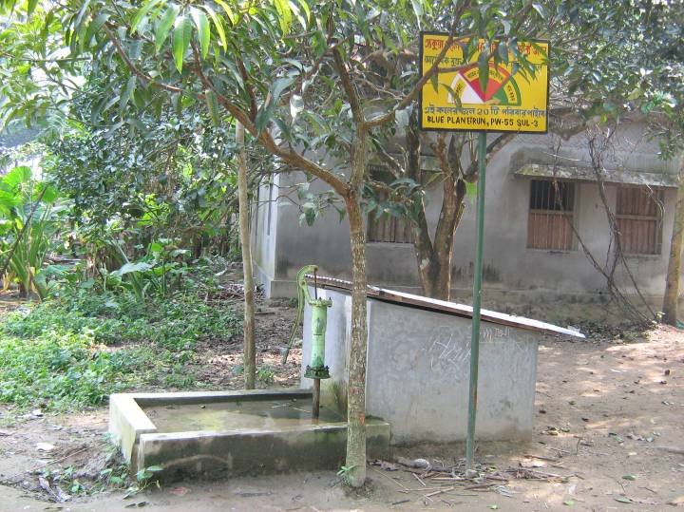
Dugwell ID | PW55/SU3
Land donated by | Haran Das
Village | Purba Bishnupur
Panchayat/Block | Sutia / Gaighata
District | N 24 Parganas
Location :Latitude | 22.90877 E
Location :Longitude | 88.79141 N
Constructed | June 2007
Arsenic level | 3 PPB
Date of Report | 19th November 2007
Bacteria:TC/FC | 990 / 13
Date of Report | 11/17/07
Physical qlty of water | Clear water, slight chlorine odor, taste normal
Beneficiary families | 12
Beneficiary members | 56
Remarks | Re-test for bacteria after 2 mnths if req.
Sponsored by | Blue Planet Run (17)

PW55/SU3

Dugwell ID | PW56/SU4
Land donated by | Anondo Mondol
Village | Thkurtala
Panchayat/Block | Sutia / Gaighata
District | N 24 Parganas
Location :Latitude | 22.90985 E
Location :Longitude | 88.78936 N
Constructed | June 2007
Arsenic level | 6 PPB
Date of Report | 19th November 2007
Bacteria:TC/FC | 222 / 0
Date of Report | 21st December 2007
Physical qlty of water | Normal
Beneficiary families | 2
Beneficiary members | 5
Remarks | As of January 2008
Sponsored by | Blue Planet Run (18)
PW56/SU4

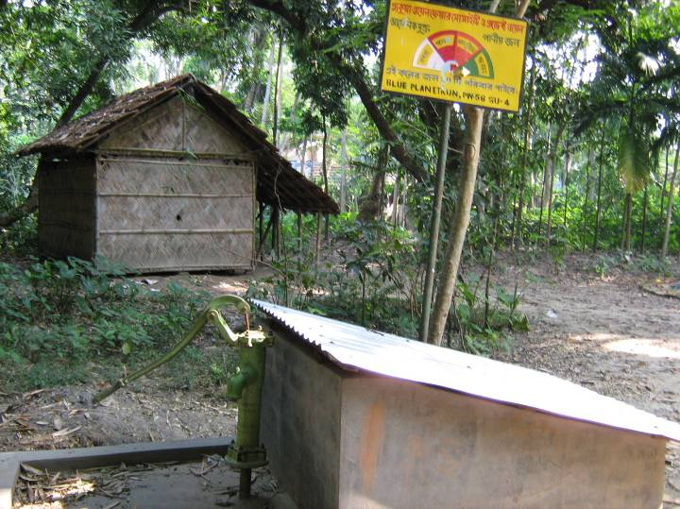

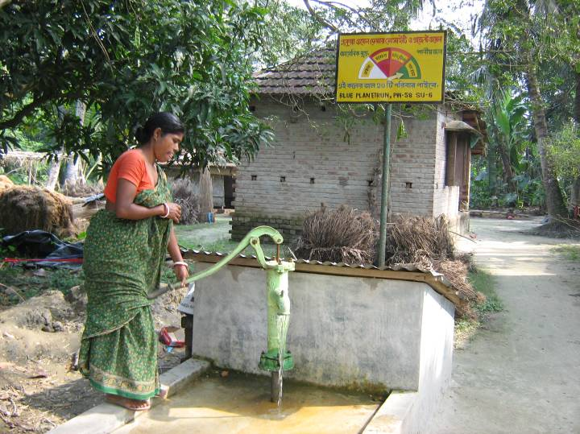
Dugwell ID | PW58/SU6
Land donated by | Shyamal Das
Village | Foridkati
Panchayat/Block | Sutia / Gaighata
District | N 24 Parganas
Location :Latitude | 22.90872 E
Location :Longitude | 88.78815 N
Constructed | June 2007
Arsenic level | 4 PPB
Date of Report | 19th November 2007
Bacteria:TC/FC | 0 / 0
Date of Report | 11/17/07
Physical qlty of water | Clear water, no odor, normal taste
Beneficiary families | 0
Beneficiary members | 0
Remarks | Need health meeting. As of Jan 08
Sponsored by | Blue Planet Run (19)
PW58/SU6

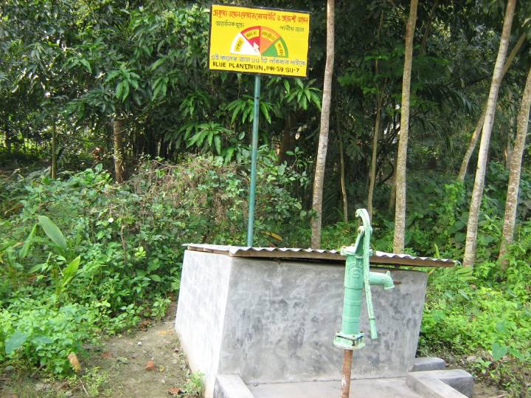
Dugwell ID | PW59/SU7
Land donated by | Sankar Mondol
Village | Charaktala
Panchayat/Block | Sutia / Gaighata
District | N 24 Parganas
Location :Latitude | 22.90507 E
Location :Longitude | 88.78609 N
Constructed | June 2007
Arsenic level | ??
Date of Report
Bacteria:TC/FC | 2550 / 0
Date of Report | 21st December, 2007
Physical qlty of water | Flooded severely.
Beneficiary families | 0
Beneficiary members | 0
Remarks | Need health meeting. As of Jan 08
Sponsored by | Blue Planet Run (20)
PW59/SU7

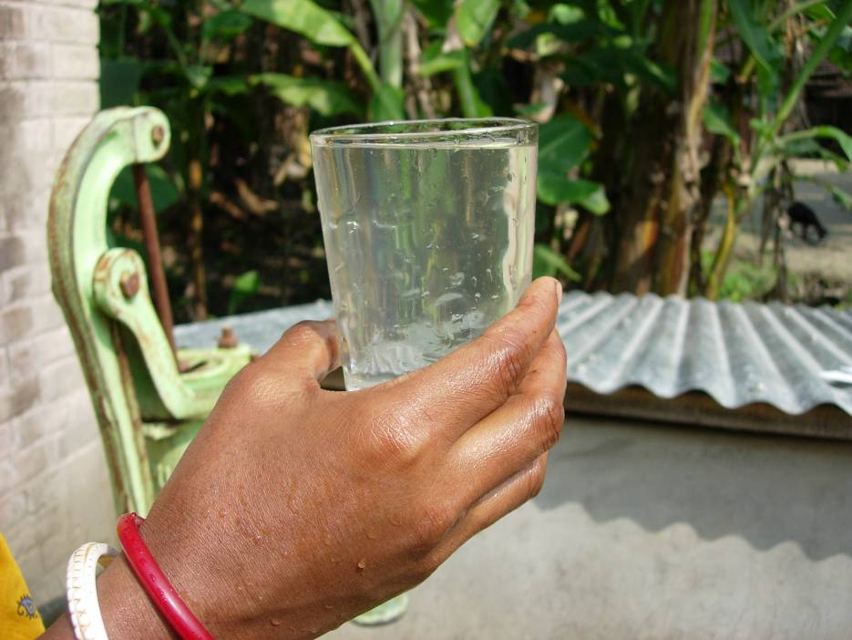

Water sample of dugwell # PW66/RNM2

Date of photo taken: 7 November 2007
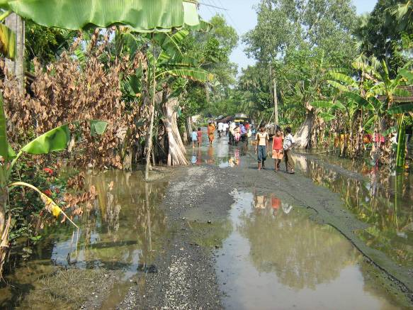
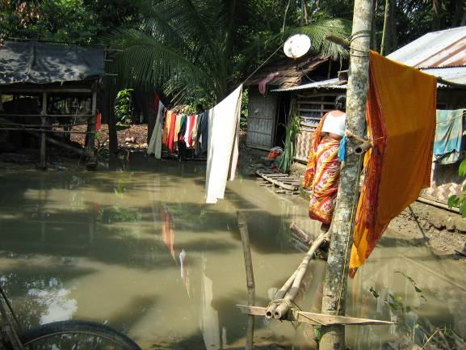

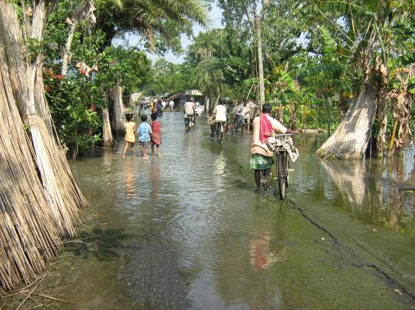

In 2007 Gaighata was affected by heavy rainfall that delayed the operation of most of the dugwells. It also delayed in water analysis. Until the bacterial tests are completed villagers are advised not to drink water without boiling. They are advised to use for cooking. But some villagers do not wish to wait for the bacteria tests if the taste of water is good. On the other hand inspite of water being potable with FC count ‘zero’ as in PW58 and PW62 the villagers are not using the water to drink nor to cook. Educating the people through health meetings (‘shastho shawbha’) is the next step in this years dugwell program.

Please contact mmhsmith@berkeley.edu if there is any questions or comments.
For more information and published articles visit <http://www.projectwellusa.org>.

