Germania House made out of mud and branches ( Bajareque)
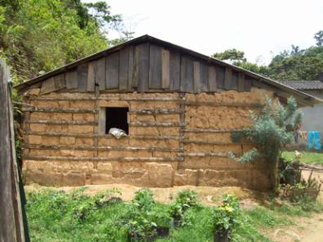

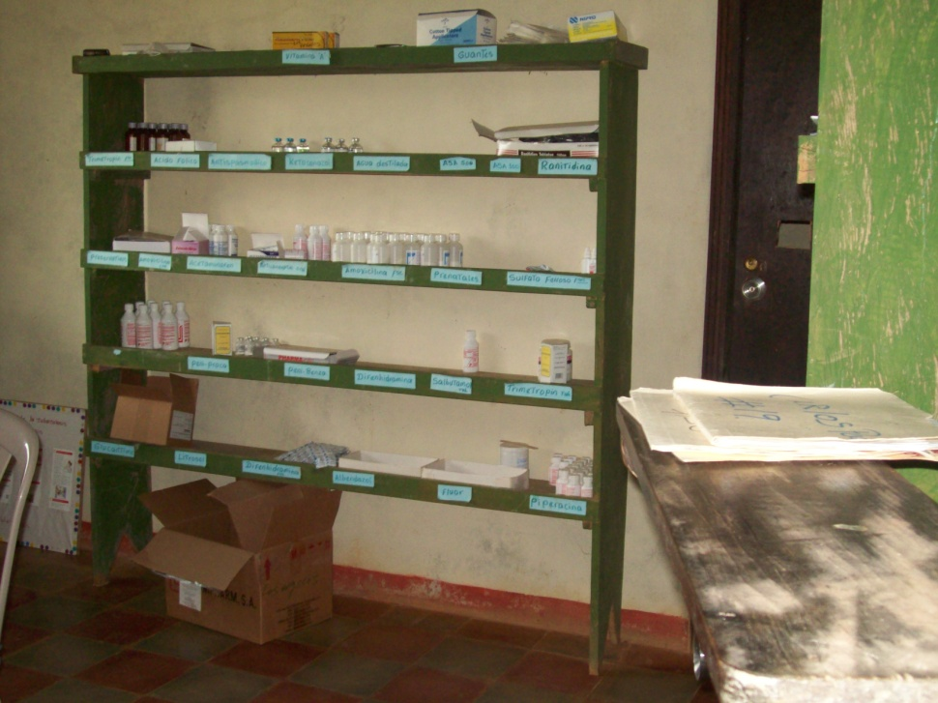
Health Center in Los Angeles: only medicine supply available are the ones in the shelf.

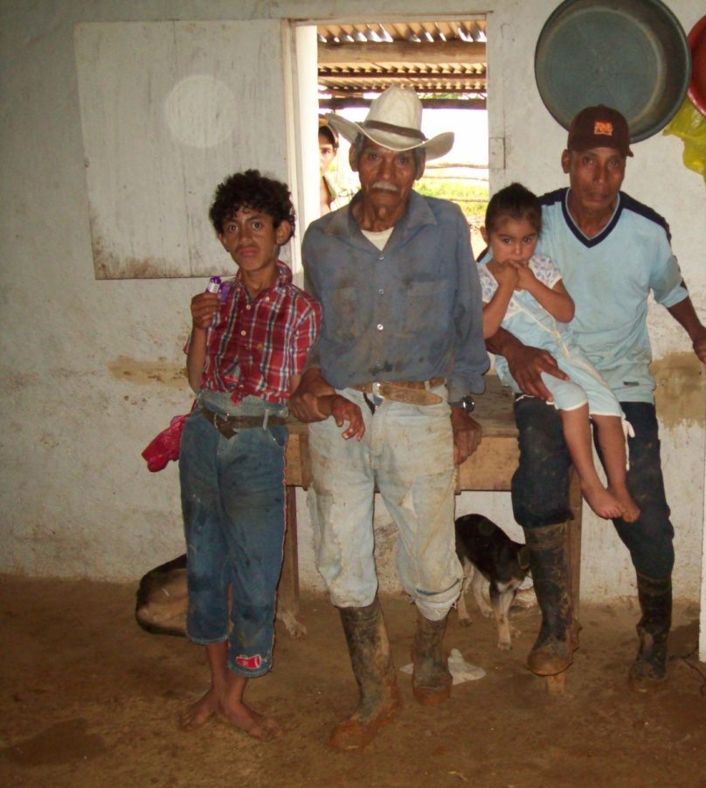

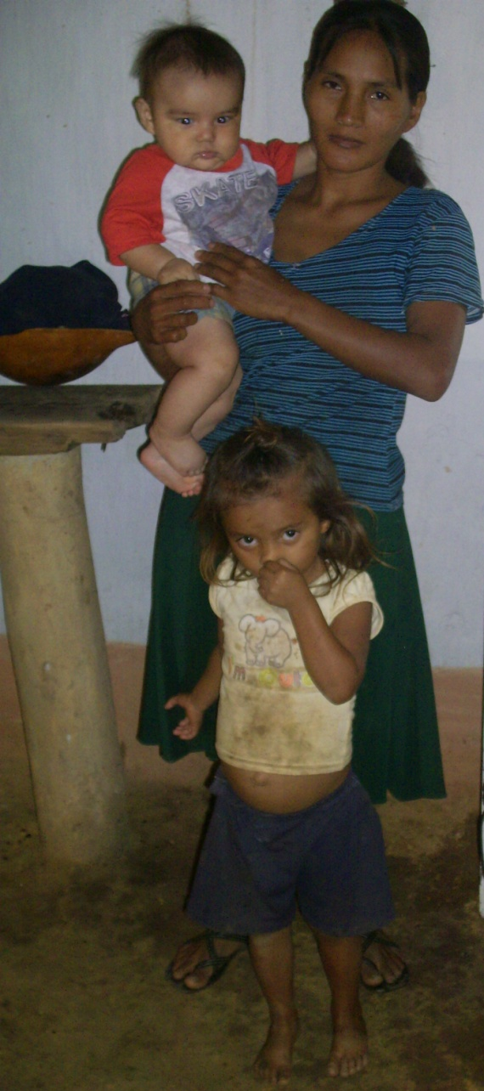
Los Angeles single mother of two

