

The Global Rainwater Harvesting Collective (GRWHC)
In Collaboration with
Norwegian Church Aid Afganistan Programme

ROOFTOP RAINWATER HARVESTING ( RWH) FOR DRINKING WATER AND SANITATION IN 2 RURAL SCHOOLS

submitted to
Blue Planet Run (BPR), USA

1. | Project Title: | Rooftop Rainwater Harvesting for Drinking Water and Sanitation in 2 Rural Schools in Ghazni Province, Jaghori District.
2. | Implementing Agency: | NCA in collaboration with Future Generations Afghanistan, GRSP (Ghazni Rural Support Program) and the Barefoot College  grynca@brain.net.pk  009379334986  Postal address:  NCA, pb 1518 Kabul Afghanistan  DHL address:  House 1071  Saraye Ghazni  District 3 Kabul City  Afganistan
3. | Project Area: | The project envisages covering a total of 2 rural schools in Jaghori District  of Ghazni province in the year 2005.  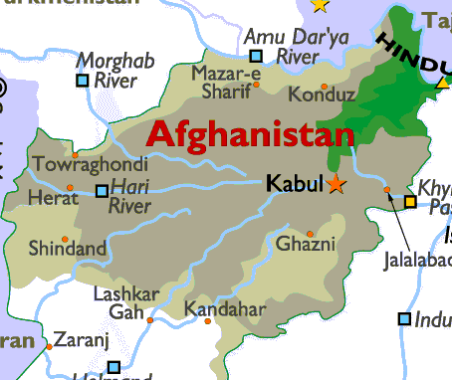  Jaghuri District, Ghazni province map  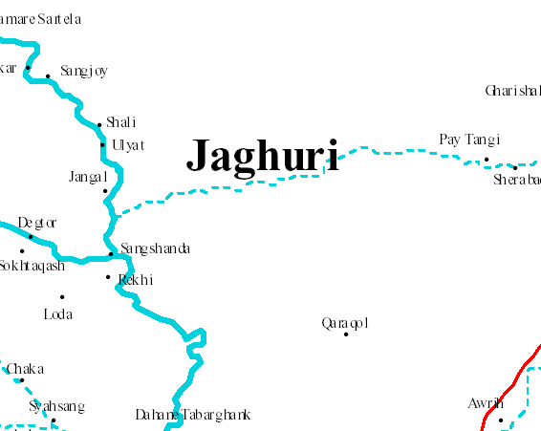
4. | Description: | The rooftop rain water harvesting structure will improve access of potable water for the school children especially during the dry season  - To provide safe drinking water for poor school children and other staff in areas where other sources of drinking water is unavailable or difficult accessible  - To link fresh water to sanitation to reduce the incidence of water borne diseases.  - To provide a community based and more long term solution to the problem of drinking water  Implementation Plan  In each above mentioned schools NCA will construct one underground stone masonry retaining wall storage tank covered with reinforced cement concrete slab. The size of the tank will be (5 X 4 X 3.5) m with storage capacity of 50,000 liters. Roof water can be collect in the storage tank through PVC pipes and one hand pump will be installed in storage tank for safe operation purposes. It will be implemented by one of NCA Partner working in that region with contribution of the Community and the 2 barefoot  water engineers trained in the Barefoot College, India, in the construction phase. RWH is a maintenance free system and constructed in local material at village level.

5. | Name of Schools: | Tabrghanak School  This school is located in Jaghori District of Ghazni province. The School constructed by GRSP one of NCA partner organization in the year 2003. At present 471 children (Boys and girls) are studying in this school. The roof of the school building is made from corrugated sheet, and the rain water from the roof top can easily be directed by PVC pipe guttering to underground storage tank.  Obborda School  This school is located in Jaghori District of Ghazni province. The School constructed by GRSP one of NCA partner organization in the year 2003. At present 549 children (Boys and girls) are studying in this school. The roof of the school building is made from corrugated Sheet and the rain water from the roof top can easily be directed by PVC pipe guttering to underground storage tank.  Both schools have water problems, and water and sanitation is difficult accessible.
6. | No. of Users: | 1020 School Children
7. | Unit Cost  Break-up:
  Construction of the 2 RWH Structure in schools- Excavation, water proofing, masonry, plastering, covering, shuttering, sedimentation, tank etc | $ 14,600
  Connection of roof to the Storage tank | $ 4,900
  Construction of two Toilets-digging of pits ventilation, doors sanitation pan etc | $ 2,500
  Monitoring and Supervision | $ 1,000
8. | Total Budget for 2 RWHs: | USD 23, 000
9. | Project Duration: | One Year

Overview of proposed Rainwater Harvesting sites- Afganistan

Location | Jagori District in Ghazni Province
Organisations; | Norwegian Church Aid and Future Generations
Type of RWH structure | a) Rectangular  underground construction of RWH tanks in local masonry work by local barefoot water engineers
Total RWH structures to be proposed | 2
Average capacity (litres) per structure | 50,000 Litres each structure
Approximate number of users per RWH tank | 500 School children
Availability of rainwater for drinking in school | We hope it will be about 4 months
Estimated cost of a RWH/tank | $ 11,500
Average cost per litre water | $ 0.19 cents
Employment generation at local level for local poor people | 20 people per site
No. of days | 35 days for 20 people per site
Rooftop area required in a school | 200 mt.²
Average rainfall required for collection in RWH | 300 mm
Expected Life of a RWH | 20 years
Maintenance required | Only cleaning before rains.

PICTURES OF THE 2 SCHOOLS

Tabarghanac School Building Picture
Tabarghanac School
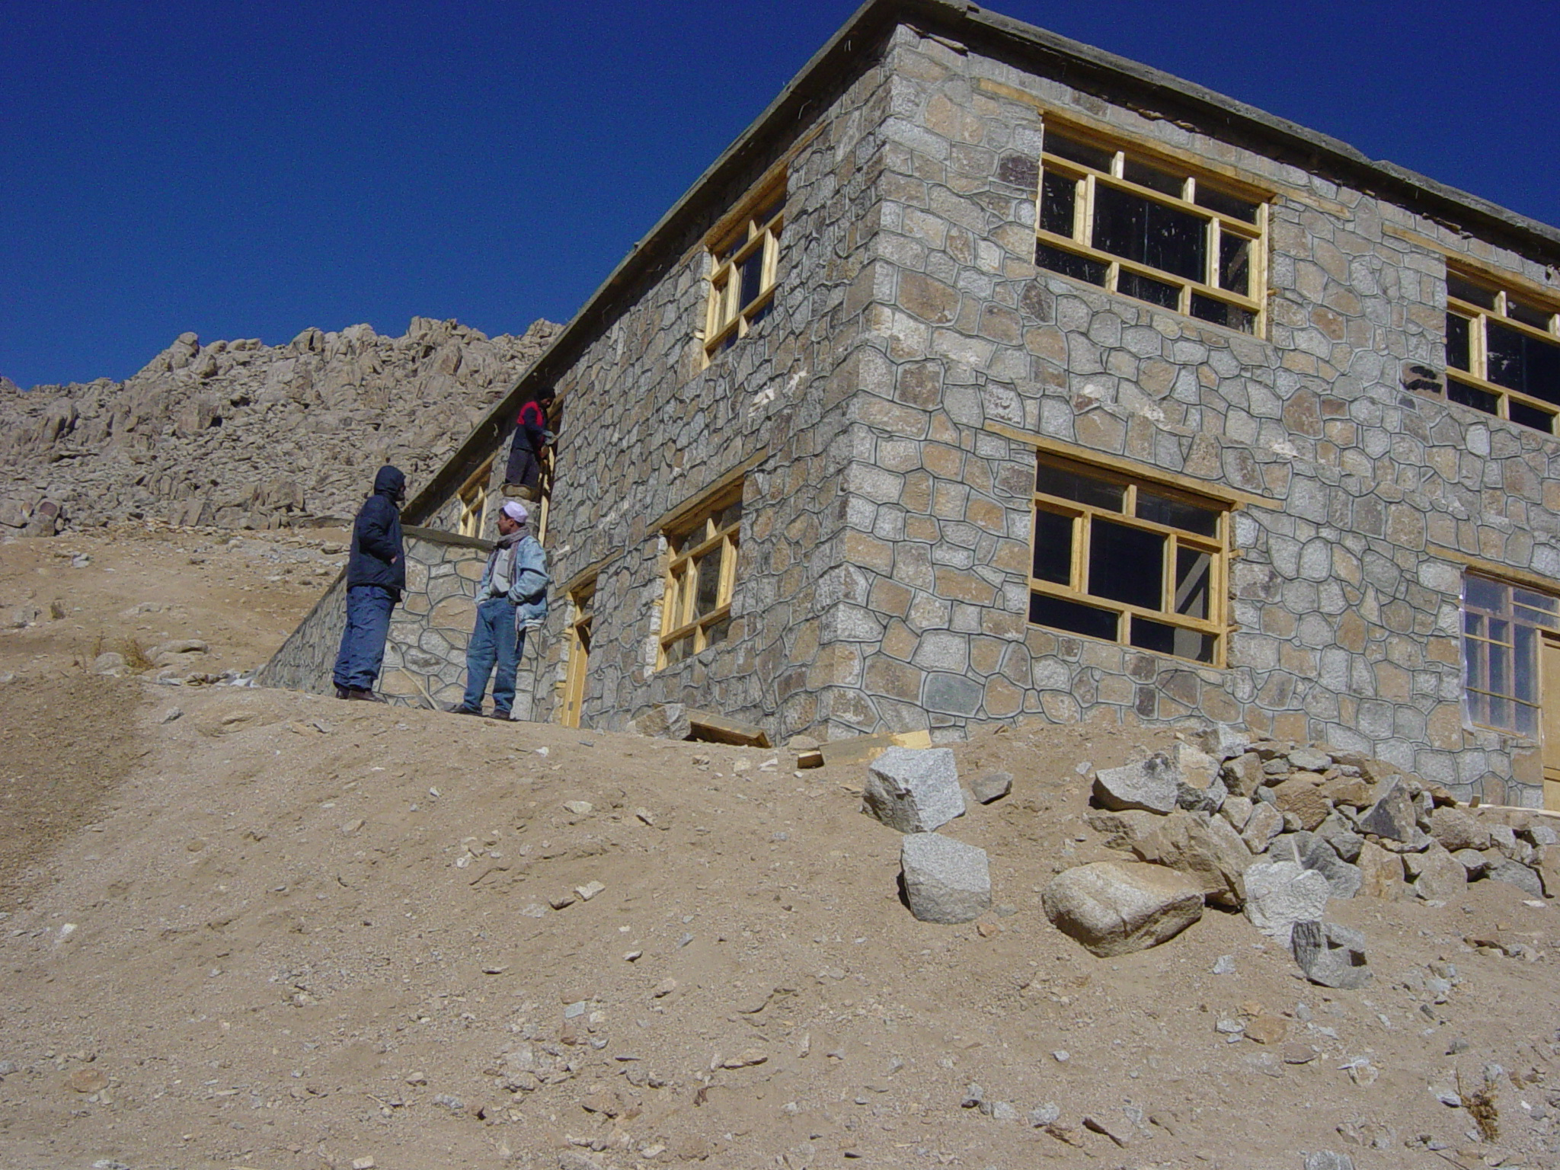

Tabarghanac School
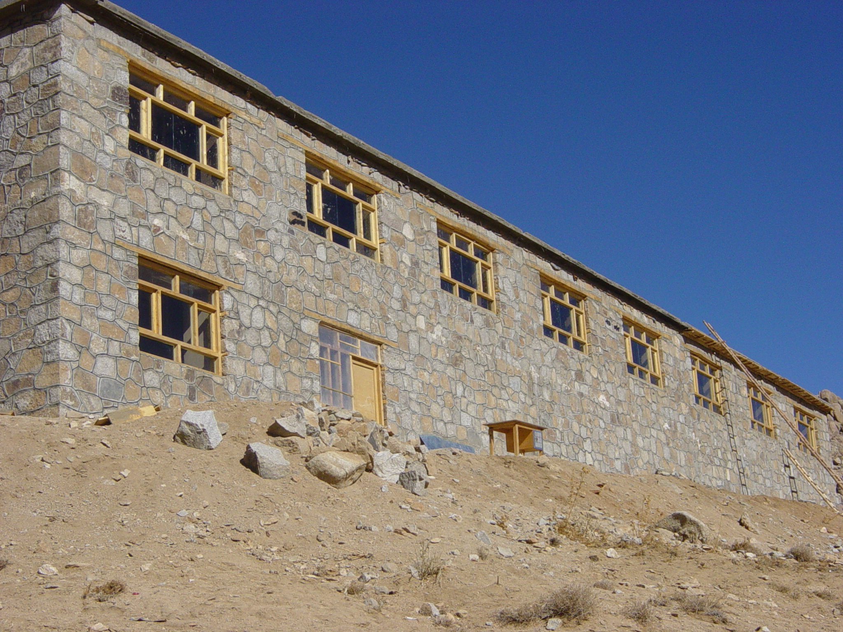

Obborda School Building Picture
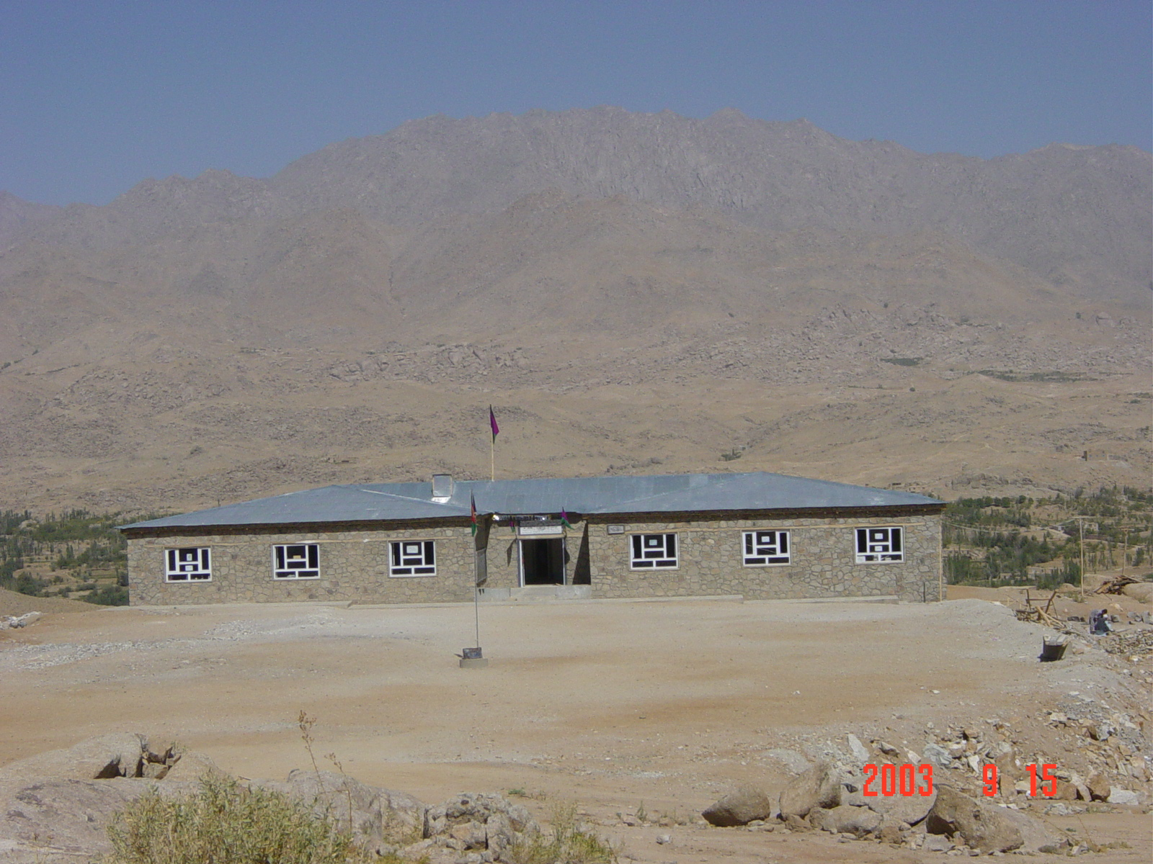
Obborda School
Obborda School


