I. Project Introduction

This project aims to provide a PV (Solar) powered electric water pumping systems and water distribution systems (where applicable) in three communities in Bolivia that currently do not have adequate access to potable water. Access to clean water has proved to greatly increase social, economic and health conditions in developing communities. Each of the communities visited in this feasibility study have limited access to potable water and unique challenges to mechanize their current system with a PV pump.

Four communities in the eastern/central region of Bolivia were identified by local government agencies and by Etta Projects as communities in need of improved potable water access. The community of Monte Rey uses a centralized hand pump installed on a borehole and women and children haul buckets of water to their homes
for consumption and washing. In the community of Guadalupe, families use inadequate hand dug wells to collect non-sanitary water. A borehole has been drilled in their community but has been capped. In the mountainous community of El Abra families rely on an artesian well which trickles water downhill to a community tap-stand. A tank and distribution system has already been installed but there is no means to pump water from the spring into a tank.

This feasibility study was conducted in November, 2012 by technicians from AlwaysON Solar and staff members of Etta Projects to assess the viability of mechanizing the water systems in each of these communities with a solar, photovoltaic (PV) pumping system. During the course of the feasibility study an assessment of the current potable water systems in each community was conducted. Demographic data for each community was collected and developmental, social and organizational conditions in the communities were assessed. Community members were interviewed to determine the water requirements and the willingness of the community to participate
in and take ownership of the projects (Appendix IX). Technical data was also collected to understand the physical characteristics of the wells and boreholes and the solar resource at each site. Research was conducted to determine the availability of local materials and components for a PV pumping project. In addition, team members examined the possibility of implementing in depth community based and organizational based capacity building programs to promote the sustainability of this and future PV technology transfer projects in Bolivia.

Bolivia: Country Profile
According to the latest Human Development Report of the United Nations Development Program, 59 per cent of the population of Bolivia live in conditions of poverty. However, many specialists maintain that this figure should be much higher as income and work are not considered when making this calculation. (PNUD 2002).

Bolivia, like many developing nations, is greatly affected by the lack of clean drinking water. Globally, contaminated water is the second greatest cause of infant mortality and an estimated 1.8 million children die each year as a result of illnesses linked to the consumption of polluted water. (PNUD 2002).

Statistics indicate that only 20 percent of the rural population in Bolivia has access to safe water and sanitation. Diarrhea causes 36% of deaths in Bolivia in children under the age of five. Bolivia is one of the least-developed countries in South America. Almost 70% of its people, many of whom are subsistence farmers, live in poverty. 23% of the Bolivian population lives on less than $1 per day; 42% live on less than $2 per day (PNUD 2002).

Solar Pumping Technology and Benefits
Solar electric pumping systems were chosen for this project for a number of reasons. Bolivia has a good solar resource and the system designs use proven and dependable technology to pump sufficient quantities of water without the use of expensive fuels or unreliable grid power.
Unlike many conventional pumping systems, the solar pump can operate unattended. The design is simple; when the sun is shining the pump is pumping water. There are very few moving parts which alleviates the need for continued costly maintenance. The system essentially contains three main components: The solar array, a controller, and the pump. The array consists of four to eight solar panels mounted on
a pole. The electricity generated by the solar panels passes first through the control box where it is regulated before energizing the pump. The pump may be a submersible
well type pump (which will be used in Monte Rey and Guadalupe) or a surface water
pump. See Appendix I for an illustration showing the components these two types of solar pump configurations.
The pumps that will be used are constructed with stainless steel parts and
have a warranties of 10 years. The pump can start pumping with as little as 30 volts of power and will increase the volume of water pumped as the voltage produced by the solar panels increases throughout the day. The pump also has the capability to run off of a.c. power from a portable generator in the event the sun is not shining or the control has malfunctioned. This gives the community the greatest flexibility. The pump is also capable of running off of the utility grid as well, if it ever reaches the village.
The solar panels come with a 25 year performance warranty. This exceeds the warranties provided on other possible fuel sources, like diesel or propane, which power generators. Maintenance on solar panels is minimal and involves nothing more than washing the dust off occasionally. Generators require regular maintenance with oil and air filter changes and require re-fueling for the entirety of their useful service life. The fuel and maintenance costs associated with generators increases overall operating expense and requires the community to purchase fuel with the little cash they have available. Solar panels produce electricity without any noise or without any pollution. Generators are noisy and cause atmospheric pollution due to the combustion of fossil fuels. The volatile price of fossil fuels can also add to the financial stress of a
community.
Using the electrical power grid to power a pump is often an economical and feasible way to pump water from wells. However, the villages where we will be installing the pumps do not currently have access to the electric grid. In all cases it is several miles away and would cost more to extend the lines than the installation of a solar system. In addition the electric grid is erratic and unreliable in many rural areas and cannot be depended upon for daily water pumping needs. Voltage sags and
spikes in the grid can cause costly damage to electric pumps and components. For this reason some communities choose PV water pumping systems even if the grid is available.
The solar pumping system will provide an adequate supply of clean drinking water to community members while eliminating the need for on-going fuel expenditures, maintenance and reliance upon an unreliable grid. Communities serviced by solar powered pumps will enjoy ownership of the system and direct control over its power and function. They will also be introduced to a technology that fosters a sustainable energy ethic along with local and global environmental consciousness.

III. Project Partners
Appendix II includes a complete list of project partners and contacts

Etta Projects is a 501c3 non profit organization created in 2003 to honor the life and humanitarian concerns of Etta Turner. Etta died November 25th, 2002, at the age of
16, in Bolivia. During her travel as a Rotary International exchange student, Etta and six Bolivians were killed when their bus driver fell asleep and drove off a cliff. Etta Projects was developed to carry on her legacy of inspiration and caring.

Etta Projects partners with Bolivian communities to implement sustainable solutions to the challenges of poverty, while educating and inspiring North Americans to act for positive change. Their work is to facilitate and help communities find the pathways to sustainable and realistic answers to have those needs met. They are a lean, practical organization whose donated dollars and energy go straight to improve health and support projects that provide clean water, nutritious food, education and income generation.

Etta Project’s projects are guided by the needs and interests of local community members. They believe the best way to address the circumstances of poverty is to provide a forum for communities to identify their own problems and set priorities. The projects focus on health, sanitation, clean water, leadership and education.

On the ground Etta Projects has a dedicated Bolivian staff that travels daily from their office in the city of Montero to remote villages throughout the Integrated North of the Department of Santa Cruz to facilitate training sessions, engage in interactive activities and empower local people to organize and sustain grassroots projects. Etta Projects’ talented fulltime staff includes a doctor, a teacher, an anthropologist, an engineer, and an agriculturist. Each project is led by a Project Coordinator responsible for organizing partners, planning activities and monitoring project impact. Etta Projects contracts specialists for specific technical needs and local people to support the sustainability of projects on the ground. They also receive the generous support of both U.S. and Bolivian volunteers and interns. Etta Project’s diverse Bolivian team is unified by their commitment to make a positive impact in rural villages.

Always On is Solar is a partnership between Puget Sound area (Washington State) Rotary clubs, the Northwest Solar Group, International NGOs and rural communities in developing countries. AlwaysOn Solar’s projects use solar energy to improve living conditions and promote clean, independent and sustainable power sources to meet community energy needs. Always On Solar is dedicated to the successful implementation of sustainable projects. In addition to technical support in project design and installation Always On Solar fosters community capacitation and education.

Always On Solar assists in the design of the system and facilitates fundraising within the applicant community, Rotary Clubs, and partnering organizations. Always On and Rotary volunteers work together with community members to implement the project. A team from Always On Solar provides the training needed to assure long term sustainability of the solar project.

Always On Solar provides technical expertise, designs and materials for solar energy projects such as: water pumping and purification, electricity for hospitals and medical centers, school lighting and power and other projects that enhance quality of life and benefit communities. To ensure project sustainability and promote the growth of jobs and a local solar industry, Always On Solar provides extensive technical training classes to local technicians, community members and school groups. Classes focus on electrical basics, the installation and maintenance of solar energy systems and small business development.

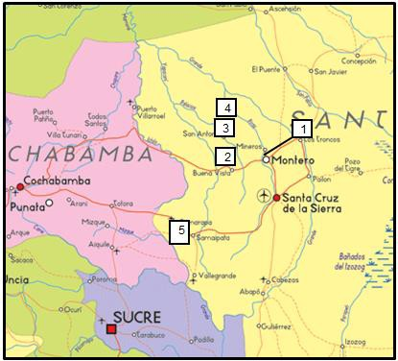
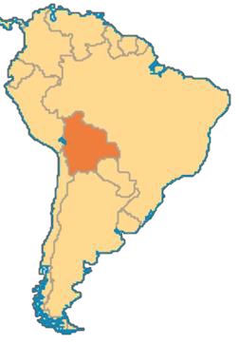
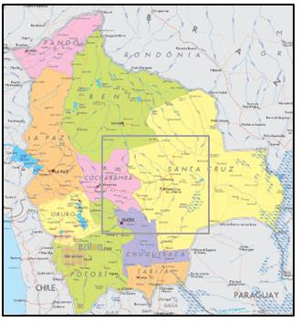
IV. Community Assessments

Community Locations

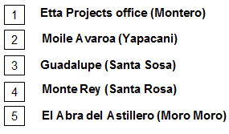

Monte Rey

Municipality: Santa Rosa

Community: Monte Rey

Community Contact: Dioniso Puma Martinez, Bismark Barreto

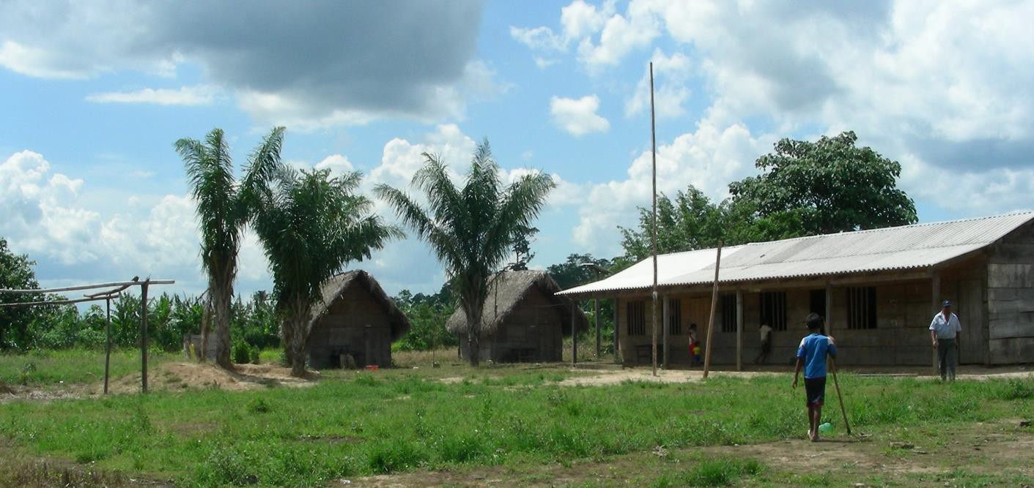

The school in the main plaza of Monte Rey

Current Conditions

Community Demographics

Distance from Montero | Aprox 5 hrs
# Families | 45
# Residents | 148
# Children in Escuela | 48
Projected annual rate of population  growth | 3%
Distance to health center | 7km to Guadalupe
Is ETTA currently working in community? | Pump installed in 2010
Community Organization / Groups | Women’s group
Distance to electric grid | 30+km
Anticipated date of grid electrification | ?

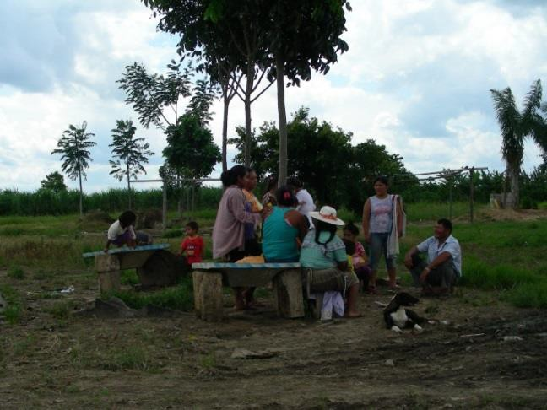

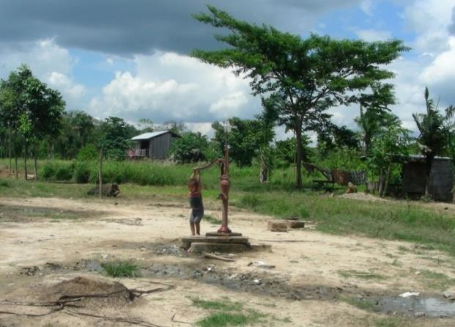
The washing area and adjacent hand pump in the center of Monte Rey
Monterey is an indigenous community located approximately 100km (4 hr drive) from Montero. There are 45 families and 30 houses. Residents’ primary language is Quechua but Spanish is also spoken. The community borders a forest reserve. The area is dominated by large soy farms and there is also a timber industry. General living conditions are poor. The community is only accessible by road in the dry season. The community was notified of our arrival and organized a meeting, attended primarily by women and children. They expressed interest in a solar pumping system and were willing to provide all the necessary labor for the installation of the pumping and distribution system. They were also willing to form a water committee and pay a monthly tariff for water use.

Current Water Situation

Until 2010, the residents shared a hand dug well located in the center of the community. A borehole was drilled in 2009 by H2O S.R.L and a handpump was installed by Etta Projects. Residents estimate that each family uses approximately 6 buckets (180L) of water each day which is carried to their homes. Additional water is used on days that they wash clothes. See Appendix IV for technical profile of bore hole and the results of a water quality test.

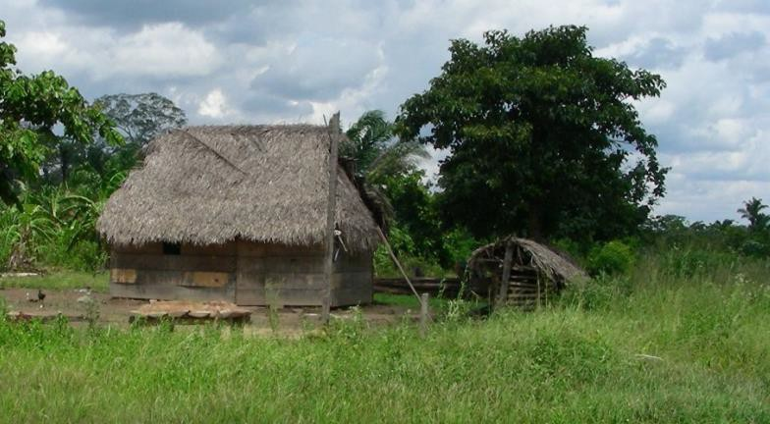
The water from this borehole is used for drinking and washing. It is not metered and used freely. Wash basins are set up near the pump where women bring clothes to wash.

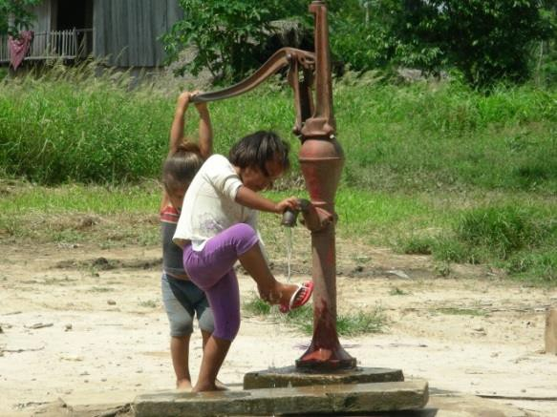

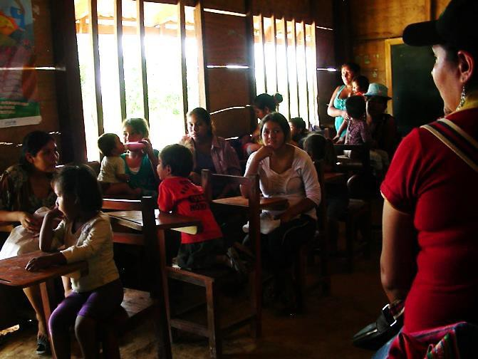

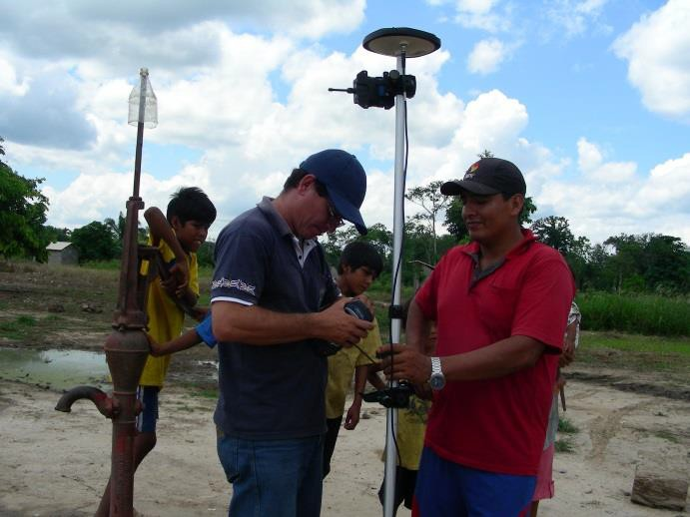
Feasibility study in Monte Rey…community meeting and data collection

Solar Pumping and Distribution Feasibility

Water Requirements

Using the minimum water requirement of 40 liters per day per person, Monte Rey’s 148 inhabitants would need approx. 6000 liters per day (1585 gallons per day). The system would provide water for domestic drinking, cooking, and laundry, but not for crop Irrigation or raising animals.

PV Array Location and Mounting

A PV array could be installed on a pole or ground mount in the area around the pump. There are future possible shading concerns with two trees that are approx. 30M north of the pump area. The community is willing to trim or remove these trees if there is a problem. There is plenty of room for a security fence around the area. There is little to no elevation gain in the community. See Appendix III: Bolivia Solar Resource for recommended tilt and orientation of solar array

Water Storage Tank

A water tower could be constructed inside or outside the fenced area to the south side of the PV array. If the tower is located inside the fenced in area enough room between the tower and PV array would be required to prevent shading. The tank(s) will be approximately 10000 liters in capacity to provide the community with1.7 days of usage. The water tower structure will be funded and built by the community members to specifications dictated by always on technicians or engineers,

Distribution system

An extensive distribution system would be installed so potable water will be available 6m in from each family’s property. It will be the family’s responsibility to fund and install the final section of distribution piping, meter and tap stand on their own property.

The distribution will contain up to 1000M of 2 or 3” poly pipe and will be installed under the supervision of Etta Projects. A diagram of the Monte Rey water distribution system can be viewed in Appendix IV.

Sustainability

Extensive community work would need to be conducted by Etta to develop a water committee and tariff structure to ensure that monthly payments made by consumers will be adequate for the ongoing and maintenance of the system and possible future replacement of components. Community water committee members and local government water officials would be trained in the function, operation, maintenance troubleshooting and repair of the PV water pumping system. Community members will be given all the tools and knowledge needed to install and maintain the system. The Municipality of Santa Rosa would be responsible for purchasing an extra pump which can be made available for purchase by the water committee of Monte Rey if / when needed.

Project Implementation

Assuming that the water tower has been constructed and the distribution system completely installed before the arrival of Always On team members, it is possible that the installation of the solar pump in Monte Rey will take two or three days. Given the driving time from Monte Rey to Montero (aprox 4 hrs) it may be advisable for team members to spend the nights in Monte Rey. This would mean camping in the school or health clinic in Guadalupe.

Monte Rey Water Distribution Pan

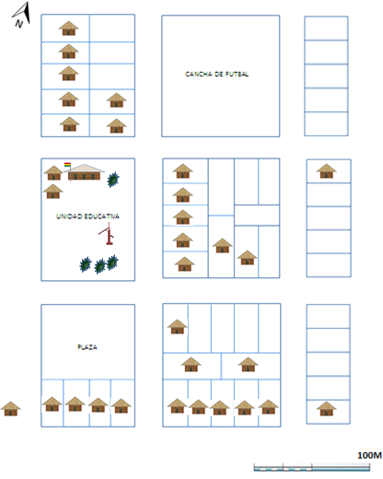
Current Proposed

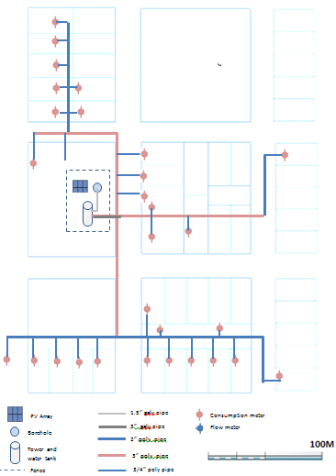

Technical Summery and Recommendations
See Appendix V for technical calculations for Pump and PV sizing

Monte Rey
Municipality: Santa Rosa Approx. Location 4-5 Hrs NW of Montero Number of Families 45
Number of inhabitants 148
Estimated Growth Rate 3%

Estimated Daily Water Requirements
(40L/day/person)
6000L

Are water quality test results available?
Yes

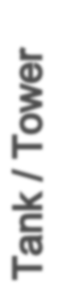
Diameter of borehole casing 4” PVC Borehole depth 94M Estimated productivity 3.8L/sec Static water level “Surgente” Dynamic water level 27.5M Recommended Pump Depth 40M Existing pump type Hand pump Type/size of pump to be installed
Is tank/tower existing No Size of Tank (proposed) 10,000L Height of Tank to inlet:
Distance from Borehole to tank
Tank Material
Tower material
Condition of existing infrastructure Elevation gain from borehole to tank Tank inlet pipe diameter
Tank outlet pipe diameter

Peak Sun Hours 3.3
Array Mounting Type Ground or pole
Distance from Array to Pump
Size of Array needed

.

Recommendations:

The following action items would be necessary for this project to be implemented:

Etta Project

• Create a budget for all materials needed for the distribution system
• Act as liaison between all project partners.
• Work with community members to develop a water committee which includes the necessary infrastructure to collect tariffs and manage ongoing maintenance and repair of system.
• Manage the construction of the water tower, distribution system and security fence. This includes purchasing of all components with grant funds. Water tower and distribution system must be complete before the solar pump installation
• Work with AlwaysOn Solar technicians to develop system operations and management protocol.
• Assist AlwaysOn technicians with the ordering and purchasing of system components
- Design and implement a hygiene education program in the community
- Design and implement a training program of the local water committee
• Assist with transportation, lodging, food and training
- Manage project funds, accounting and purchasing

AlwaysOn Solar

• Provide support with system design and engineering
• Specify and source all components and materials
• Coordinate purchasing of all PV, pumping, and water distribution related materials with grant funds
• Design a technical training program for users
• Oversee / manage installation of pump, controls, and PV array

Municipio de Santa Rosa

• Purchase one solar pump (extra) for the community
• Provide a representative to participate pump installation and training activities

Community of Monte Rey

• Provide labor and materials to construct a tower for the water tank. The tower must be constructed to pre-determined specifications.
• Provide labor for the installation of the water distribution system and pump
• Provide labor for the construction of a security fence around the borehole and PV
array.
• Establish a water committee to manage pumping system and tariff collection
• Each family must purchase and install local distribution materials (up to
6m….from main water line to tap stand location), water meter and tap stands for
their own homes

Guadalupe

Municipality: Santa Rosa

Community: Guadalupe

Community Contact: Ishmael

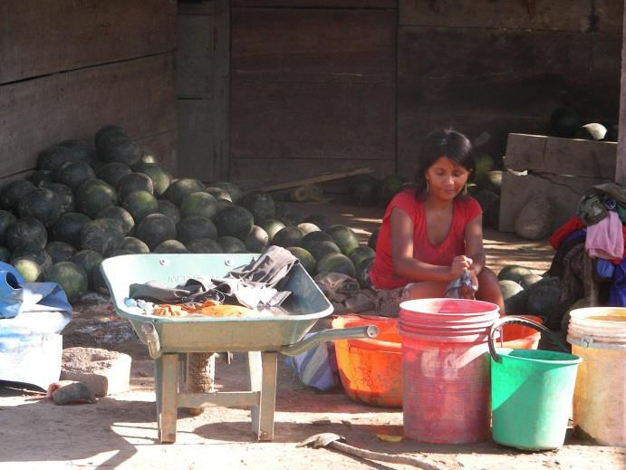

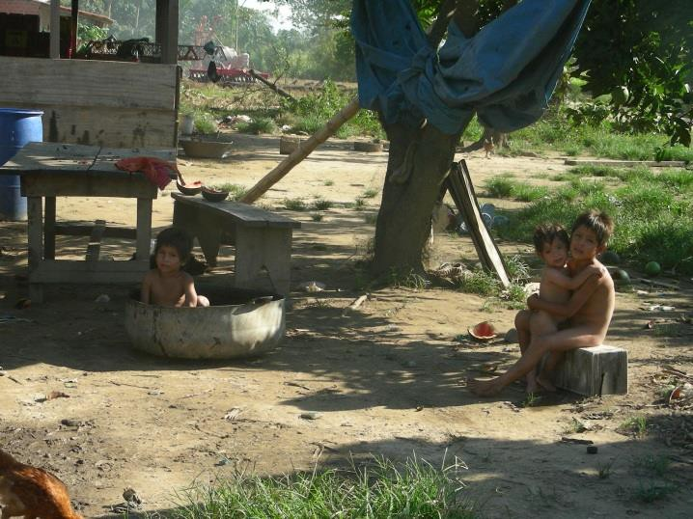
Current Conditions
Community Demographics
Residents of Guadalupe

Distance from Montero | Approx. 5 hrs
# Families | 30 total, 10 in area
# Residents | 50 in area
Projected annual rate of population  growth | Shrinking
Distance to health center | Located In central area
Is Etta currently working in community? | No
Community Organization / Groups |  | ?
Distance to electric grid | 30+km
Anticipated date of grid electrification | ?

Guadalupe is located about 9km from Monterrey. It is also is an indigenous community with residents’ primary language being Quechua but Spanish is also spoken. There are approximately 30 families in the community which is dispersed over an area of about
8km. In the central area there are 10 families living in an area within 100m of a central plaza. The central plaza contains a school and health clinic. General living conditions are poor. The community is only accessible by road in the dry season. The community was not notified of our arrival but we were able to meet with the community leader, teacher and health promoter at the clinic to discuss the current water situation.

Current Water Situation

Community members who live in the central area are currently using a hand pump that is connected to a hand dug well, estimated to be 10M deep. In the more remote areas families have their own hand dug wells. There is currently no water tank or distribution system.

A borehole was drilled approx. 400M from the central area in 2009 by H2O S.R.L and a handpump was installed by the municipality. See Appendix IV for technical profile of bore hole and the results of a water quality test. The community used the hand pump for a short period of time but the pump was damaged. Since then, the borehole was capped because there was no longer a working pump available. The community does not use the borehole.

The immediate area surrounding the borehole is covered by high grass and shrubs. There are multiple trees directly west of the borehole. It would be possible to install a pole mounted array, tower, and tank in the vicinity of the borehole with limited shading.

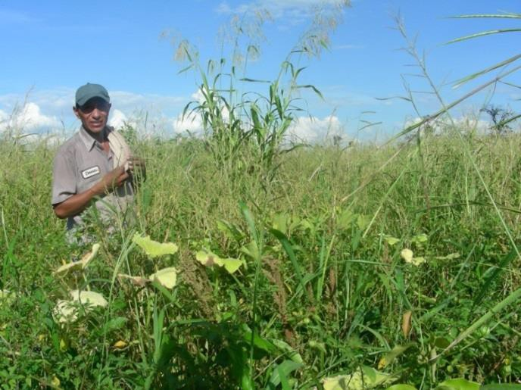
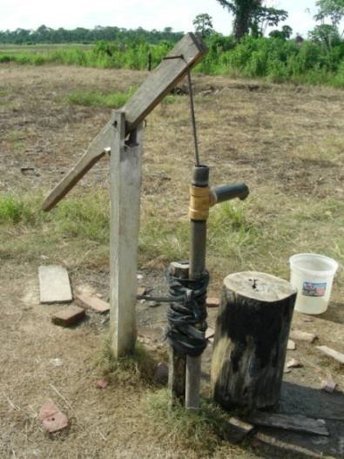

Bore hole location and existing hand pump on the hand-dug well in Guadalupe

Solar Pumping and Distribution Feasibility

There are two options for improving the water system in the community of Guadalupe. One option would be to re-install a hand pump on the existing borehole. At the very least this would insure that the residents in the central area (including the school and health center) will have access to potable water. However, the residents will still need to carry the water large distances.

The second option would be to install a PV water pumping system on the borehole. The system would require a storage tank and a limited distribution system that includes a
tap-stand in the centralized area near the school and health clinic. The tap-stand would
be public and not be metered. If the families wanted to add distribution lines to their own homes they could do so at their own expense. The community tap-stand would only service the 10+ families that live in the central area but the system can be oversized to accommodate more users or a larger future distribution system. See Appendix VI for diagram of community central area and proposed distribution system.

The following assumes that a PV pump will be installed on the borehole in Guadalupe.

Water Requirements

We will assume that the system will be sized to provide water for every member of the community. Using the minimum water requirement of 40 liters per day per person, approx. 148 inhabitants would need approx. 6000 liters per day (1585 gallons per day). The system would provide water for domestic drinking, cooking, and laundry, but not for crop irrigation or raising animals.

PV Array Location and Mounting

A PV array could be installed on a pole or ground mount in the area around the pump. There are some possible future shading concerns with two and high grass/shrubs in the area near the borehole. The community must be willing to trim or remove these trees if there is a problem. There is plenty of room for a security fence around the area.
There is little to no elevation gain in the community. See Appendix III: Bolivia Solar
Resource for recommended tilt and orientation of solar array

Water Storage Tank

A water tower would need to be constructed inside or outside the fenced area to the south side of the PV array If the tower is located inside the fenced in area enough room between the tower and PV array would be required to prevent shading. The

tank(s) will be approximately 10000 liters in capacity to provide the community with1.7 days of usage. The water tower structure must be funded and built by the community members to specifications dictated by always on technicians or engineers. This option has not been discussed with community members.

Distribution system

If a solar pump is installed a limited distribution system, approx. 400m of 3” poly pipe , would service the central area of the community in the vicinity of the school and health clinic. A public tapstand would be installed in this area. It is possible that the distribution system could be extended in the future to service individual homes.

Sustainability

One concern about installing a PV system with public tap stand in Guadalupe is the
lack of revenue generated from individual metered water sales. There will be no income to accommodate future repair or replacement of system components. Extensive community work would need to be conducted by Etta Projects and by the municipio of Santa Rosa to develop a water committee and a plan to ensure the sustainability of the project. Community water committee members as well as local government water officials would be trained in the function, operation, maintenance troubleshooting and repair of the PV water pumping system. Community members will be given all the tools and knowledge needed to install and maintain the system.

Project Implementation

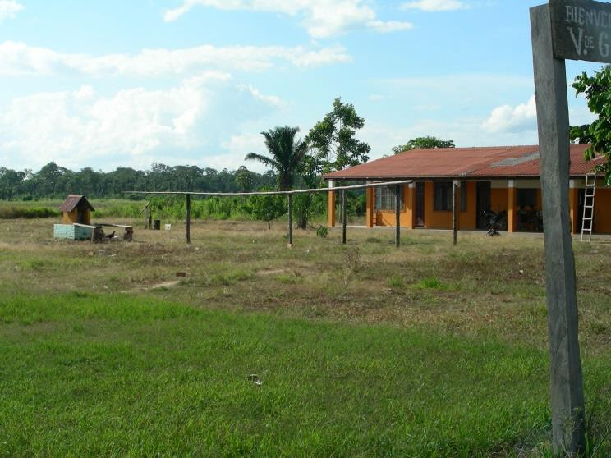
Assuming that the water tower has been constructed and the distribution system completely installed and all other preparations have been made before the arrival of Always On team members, it is possible that the installation of the solar pump in Guadalupe will take two or three days. Given the driving time from Guadalupe to Montero (aprox 4 hrs) it may be advisable for team members to spend the nights in Guadalupe. This would mean camping in the school or health clinic in Guadalupe. This installation would be done in conjunction with the installation in Monte Rey.

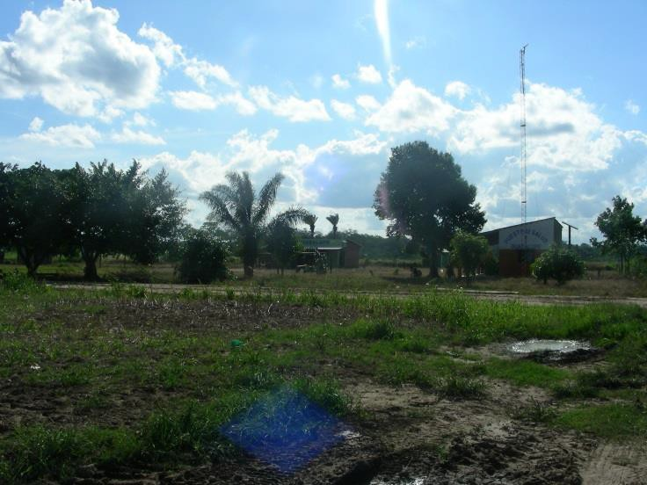

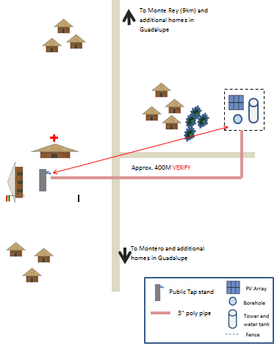
Guadalupe City Plan and Proposed System

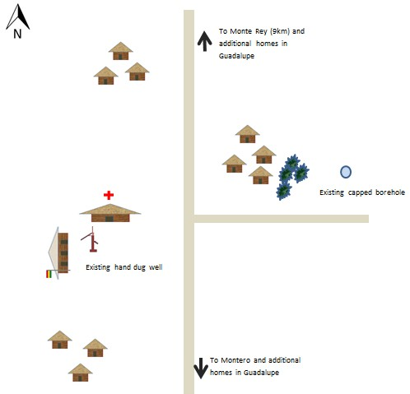

Technical Summery and Recommendations
See Appendix V for technical calculations for Pump and PV sizing.

Guadalupe
Municipality: Santa Rosa
Approx. Location 4-5 Hrs NW of Montero, 8km
South of Monterey
Number of total Families 47
Number of inhabitants
Estimated Growth Rate currently shrinking

Number of inhabitants living in central area that would be serviced by this borehole
Estimated Daily Water Requirements
(40L/day/person)
47 + school and health clinic

1000L

Are water quality test results available? Yes Diameter of borehole casing 4” PVC Borehole depth 94M Estimated productivity 3L/sec Static water level 6M Dynamic water level 32M Recommended Pump Depth 40M
Existing pump type No pump / borehole capped

Is tank/tower existing No
Size of Tank
Height of Tank to inlet: Distance from Borehole to tank Tank Material
Tower material
Condition of existing infrastructure Elevation gain from borehole to tank Tank inlet pipe diameter
Tank outlet pipe diameter

Peak Sun Hours 3.3
Array Mounting Type Ground or pole
Distance from Array to Pump
Size of Array needed

Recommendations:

The following action items would be necessary for this project to be implemented:

Etta Project

• Create a budget for all materials needed for the distribution system and public tap stand
• Act as liaison between project partners.
• Work with community members to develop a water committee which includes the necessary infrastructure manage ongoing maintenance and repair of system.
• Manage the construction of the water tower, distribution system and security fence. This includes purchasing of all components with grant funds. Water tower and distribution system must be complete before the solar pump installation
- Design and implement a hygiene education program in the community
- Design and implement a training program of the local water committee
- Work with AlwaysOn Solar technicians to develop system operations and management protocol.
• Assist AlwaysOn technicians with the ordering and purchasing of system components
• Assist with transportation, lodging, food and training

AlwaysOn Solar

• Provide system design and engineering
• Specify and source all components and materials
• Coordinate purchasing of all PV, pumping, and water distribution related materials with grant funds
• Design and implement a technical training program for users
• Oversee / manage installation of pump, controls, and PV array

Municipio de Santa Rosa
- Purchase one solar pump (extra) for the community
• Provide a representative to participate pump installation and training activities

Community of Guadalupe

• Provide labor and materials to construct a tower for the water tank. The tower must be constructed to pre-determined specifications.
• Provide labor for the installation of the water distribution system and pump
• Provide labor for the construction of a security fence around the borehole and PV array.
• Establish a water committee to manage pumping system and tariff collection
• Work with Etta Projects and Municipality of Santa Rosa to develop a sustainability plan for ongoing repair and maintenance

\

El Abra del Astillero

Municipality: Moro Moro

Community: El Abra del Astillero

Community Contact: Ervin Gomez

Current Situation
Community Demographics

Distance from Montero | Approx. 8 hrs.
# Families | 80
# Residents | Approx. 250
# Children in Escuela | 55
Projected annual rate of population  Growth | n/a
Distance to health center | ≈9km (Moro Moro)
Is ETTA currently working in community? | NO
Other past/present NGOs or projects in  community | CCM
Community Organization / Groups | Women’s group
Distance to electric grid | 9km
Anticipated date of grid electrification | n/a

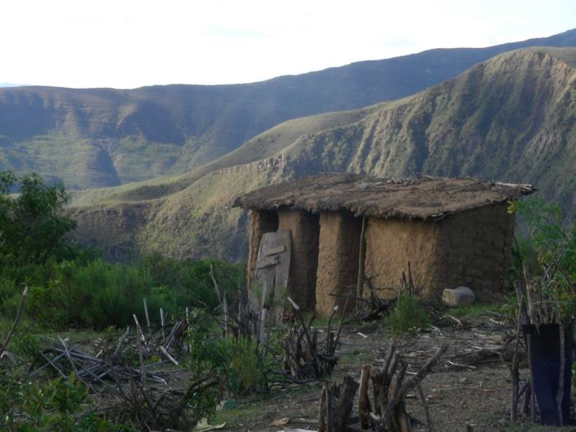

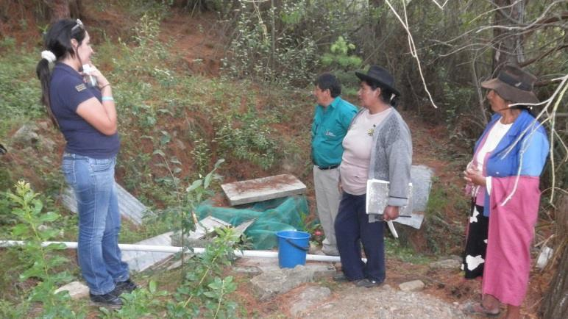
Home near El Abra: Community members and feasibility team members at artesian spring site..

El Abra del Astillero is located high in a mountainous region 9km south of the town Moro Moro. Moro Moro is the location of the municipality and health center. The road to El Abra del Astillero is long, rough, steep and nauseating. El Abra has a total of 80 families, aprox. 250 residents. There is a local school with 55 students and 8 teachers. Residents of El Abra claim that the local population is shrinking because of lack of access to potable water.

Current Water Situation

Approx. 400 meters from the town center of El Abra is an artesian well located down a steep embankment off of the road into town. Water flows out of the ground at this location and into a large concrete catch basin. From the basin water trickles into a secondary, smaller basin where it is gravity fed to a public tap-stand in the community. There is considerable seasonal variation in the amount of flow. At the time of this feasibility study, the dry season, water flowed at approx. 3.75 liters/min. Residents claim that most of the year the flow is considerably greater.
See Appendix VII for a diagram of the current and proposed system.

An NGO, MMC (Mennonite Central Committee) has been doing work in Moro Moro and the surrounding communities. In March of 2012 a 12,000L tank was installed alongside the road, uphill from the artesian well. A pipe was buried from the tank to the well. In addition, a water distribution system was designed and installed from the tank to the community. Currently, 39 families are connected to the distribution system as part of Phase I of the water improvement project. However, the large tank was never connected to the spring because there is no means of pumping the water from the spring to the tank. In addition, two 3500L black tanks were purchased and brought to the site. Plans were put into place to use these tanks as a secondary collection area to pump the water from. Currently the tanks are not connected. It is not exactly
clear who designed and began installing this water system and more research must be conducted.

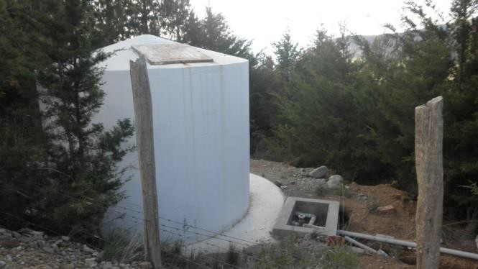
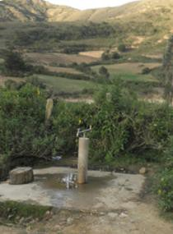

Public tap stand in El Abra: New (not connected) water tank near the road outside of El Abra

Solar Pumping and Distribution Feasibility

Water Requirements

We will assume that the system will be sized to provide water for every member of the community. Using the minimum water requirement of 40 liters per day per person, approx. 148 inhabitants would need approx. 6000 liters per day (1585 gallons per day). The system would provide water for domestic drinking, cooking, and laundry, but not for crop irrigation or raising animals.

PV Array Location and Mounting

A PV array could be installed on a pole or ground mount in cleared area within 100M of the pump. See Appendix III: Bolivia Solar Resource for recommended tilt and orientation of solar array. The pump location will not be in the town center so extra care will need to be taken to ensure security of the PV rray and pump.

Water Storage Tank

Water storage tanks have already been purchased.

Distribution system

Some families (approx. 1/3) have already been connected to a water distribution system (which is not currently operational). Upon completion of the pumping system other interested community members could connect to the distribution system under the management of the water committee and local municipality. Extension of the water distribution system in El Abra will not be funded in this project.

Sustainability

Etta Projects will complete extensive community work to develop a water committee and a plan to ensure the sustainability of the project. Community water committee members and local government water officials will be trained in the function, operation, maintenance troubleshooting and repair of the PV water pumping system. Community members will be given all the tools and knowledge needed to install and maintain the system.

Project Implementation

The actual installation of the pump and PV array in El Abra could be done in two or three days – this is assuming that considerable groundwork is completed ahead of time including the installation and plumbing of the secondary collection tanks. For the implementation of this project, team members will be based out of the larger town of Vallegrande, approx. 1.5 hours from the

Moro Moro area. Training activities can also be conducted in Vallegrande or Moro Moro. On team members, it is possible that the installation of the solar pump in Monte Rey will take two or three day

El Abra- Current and Proposed Water System

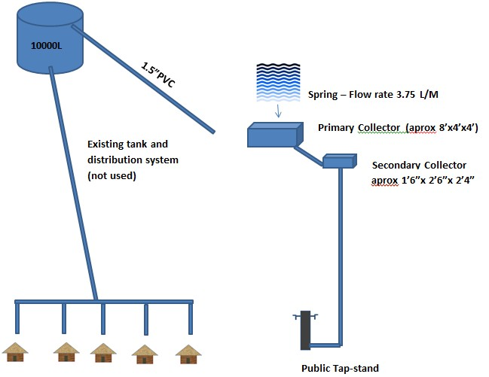

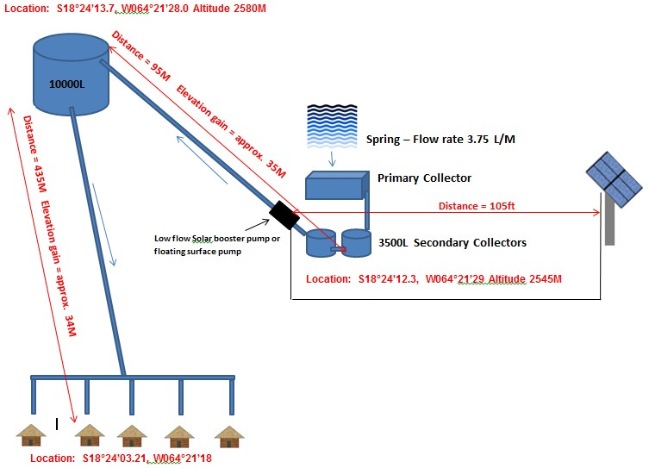

Technical Summery and Recommendations
See Appendix IIX for technical calculations for Pump and PV sizing.

El Abra del Astillero
Municipio: Moro Moro
Approx. Location 8.5 hrs. SW of Montero near
Vallegrande
Number of Families 80
Number of inhabitants Approx. 250
Estimated Growth Rate shrinking

Estimated Daily Water Requirements
(40L/day/person)
10,000L

Are water quality test results available? no
Artesian spring productivity 3.75 L/min in dry season Recommended Pump: Low flow booster or surface Existing pump type none

Is tank/tower existing Tanks existing, not connected
Size of Tank See below Height of Tank Inlet from spring: See diagram below Distance from spring to tank See diagram below
Tank Material 10,000 fiberglass, 3500L x2 plastic
Tower material none Condition of existing infrastructure disconnected Elevation gain from spring to tank See diagram below Tank inlet pipe diameter 1.5”
Tank outlet pipe diameter 1.5”

Peak Sun Hours 3.3
Array Mounting Type pole Distance from Array to Pump 100M Size of Array needed

Recommendations:

The following action items would be necessary for this project to be implemented:

Etta Project

• Establish a partnership with MCC who is already working in the community
• Gather additional information regarding the original project design
• Work in conjunction with MCC to a water committee which includes the necessary infrastructure to manage ongoing maintenance and repair of system.
• Work with MCC to develop a plan and funding for the installation of the remaining distribution system.
• Act as liaison between project partners.
• Work with MCC to manage the installation of the additional water tanks, distribution system and security fence. This includes purchasing of all components with grant funds. This work must be complete before the solar pump installation
- Design and implement a hygiene education program in the community
- Design and implement a training program of the local water committee
• Work with AlwaysOn Solar technicians to develop system operations and management protocol.
• Assist AlwaysOn technicians with the ordering and purchasing of system components
• Assist with transportation, lodging, food and training

AlwaysOn Solar

• Provide system design and engineering
• Specify and source all components and materials
• Coordinate purchasing of all PV, pumping, and water distribution related materials with grant funds
• Support the design of a technical training program for users
• Oversee / manage installation of pump, controls, and PV array

Municipality de Moro Moro

• Work with Etta and MCC to accomplish items listed above
• Provide a representative to participate pump installation and training activities

Community of El Abra

• Provide labor and materials to install the new tanks, attach plumbing pipes and prepare site for PV installation.
• Provide labor for the installation of the water distribution system and pump
• Provide labor for the construction of a security fence around the borehole and PV array.
• Establish a water committee to manage pumping system and tariff collection
• Work with Etta Projects and Municipio of Moro Moro to develop a sustainability plan for ongoing repair and maintenance

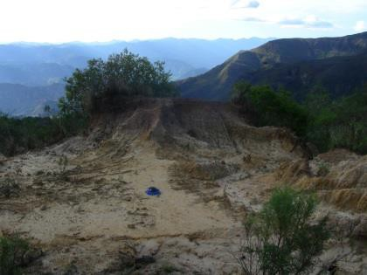
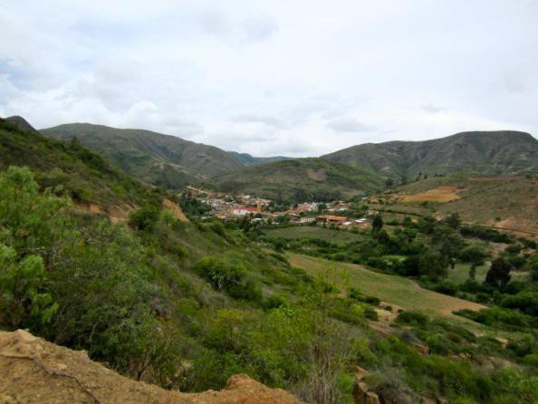
Moro Moro from the hills outside of El Abra ; Proposed site for PV array

The design and installation of a PV pumping system is the most straight forward part
of project development and implementation. The difficult areas, and those that require the most time and careful consideration , center around community participation and development and ensuring project sustainability. Without proper preparation, education and financial planning a community may be left without any access to potable water if the pumping system fails

A well designed and installed PV pumping system will operate for many years with very little maintenance or recurring expense. However, system failure and the inability (financially or technically) to diagnose problems and make necessary repairs or replacements can have serious consequences in a community that has no other potable water options. It is vital that a technical knowledgebase is established and that the community has access to funds in the event of problems. This can be accomplished with technical capacity building programs at the local and institutional level, and by developing a relationship with higher level technicians that may be deployed from urban areas. A financial structure must also be developed within the community to assure that funds are available if parts need to be repaired or replaced.

Technical training of system users and project stakeholders

AlwaysOn Solar will conduct a technical training program for system users and other project stakeholders. Typically, training programs last 3-5 days and are located in a central area so water committee members from each community can attend. At the very least, two members of the water committee must attend the training programs. The user based training program will focus
on the operation, maintenance, troubleshooting , repair and replacement of the PV pumping system components. Training programs will also cover broader information dealing with electricity, safety, tool use, etc… Trainees will install the PV pumping systems under the direct supervision of AlwaysOn technicians.

Etta Staff, Municipality water representatives and local water committee members will also receive technical training. It is the responsibility of these organizations to oversee the long-term sustainability of the pumping projects.

Establishing a network for replacement parts and higher level technical repair

It is possible that in the future a system component may need to be replaced because of wear, vandalism, or other unforeseen incidence. All efforts will be made to purchase system components locally so replacement parts and components can be readily available. Etta Projects and the local communities will maintain a relationship with Enersol, the local distributor and installer of PV components located in Santa Cruz. Enersol technicians are highly trained in the installation,repair and replacement of system components and have access to any replace part of higher level technical repairs.

Many of the components of these systems are very costly and it will the responsibility of Etta Projects to build community relations and assist the community in the development of the necessary human and administrative infrastructure to maintain system service in the long-term. This may include working with the community to develop a water committee which collects regular payments for water service. It is instrumental that community members are capable of making regular payments. The level of payment and the conditions of use must be clear and agreed upon before the project begins. It is possible that the Municipios will be willing to fund the purchase of some replacement parts up front to help relieve the financial burden of component replacement. These components can be purchased from the municipio by the community.

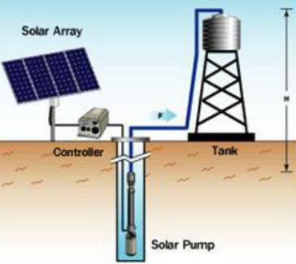
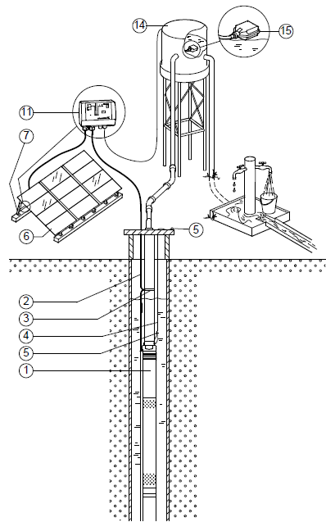
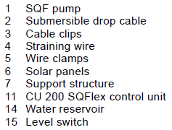
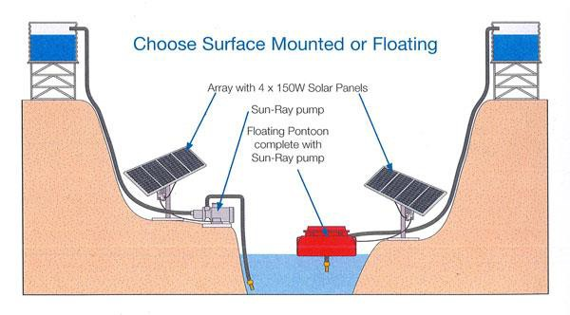

Submersible Pump

Surface or Floating Pump

Appendix III: Bolivia Solar Resource
Data collected in Santa Cruz, Bolivia

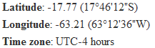

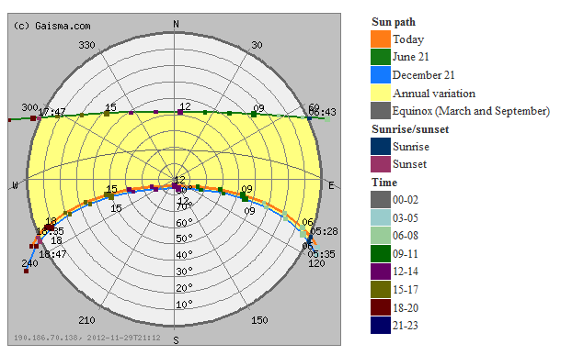

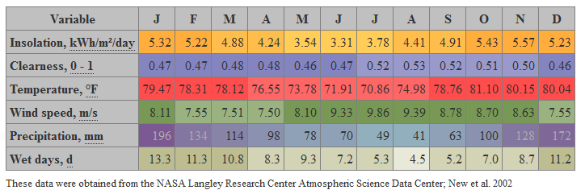

Comments:

Azimuth, Tilt Angle and Solar Insolation Values

The sun path diagram for this zone indicates that the sun is in the northern portion of the sky for most of the year. From October until March the sun rises and sets increasing south of east and west until the December solstice when the sun rises at 120 degrees SE and sets at 240 degrees SW. During the June solstice the sun rises at approximately 60 degrees NE and sets at 300 degrees NW. The sun reaches a maximum altitude of 50 degrees from the horizon at solar noon on the June solstice and 90degrees during the December solstice. The magnetic declination of the Santa Cruz area is -10degrees West.

The table illustrates the annual meteorological conditions for this zone. The month of June has the lowest annual solar insolation value, 3.31 kWhrs/m2/day or 3.31 Peak sun hours. July and August are the months with the least amount of recorded rainfall and some of lowest insolation values. This indicates that during the dry season there is more cloud cover.

It is recommended that the solar array be sized and oriented to maximize the amount of solar energy available in the month with the least amount of insolation, June. To accommodate the magnetic declination the solar array should be oriented 10 degrees east of magnetic north, or true north. The recommended tilt angle is 15 to 17 degrees.

Summary of Solar Resource Data for PV Installations

Peak Sun Hours (PSH), Solar  Insolation – kWhrs/m2/day | 3.31
Magnetic Declination | -10 degrees West
Recommended orientation | 0 degrees true north
Recommended Tilt Angle | 15-17 degrees

Appendix IV: Pump Tests / Well Profiles / Water Quality Tests

Monte Rey

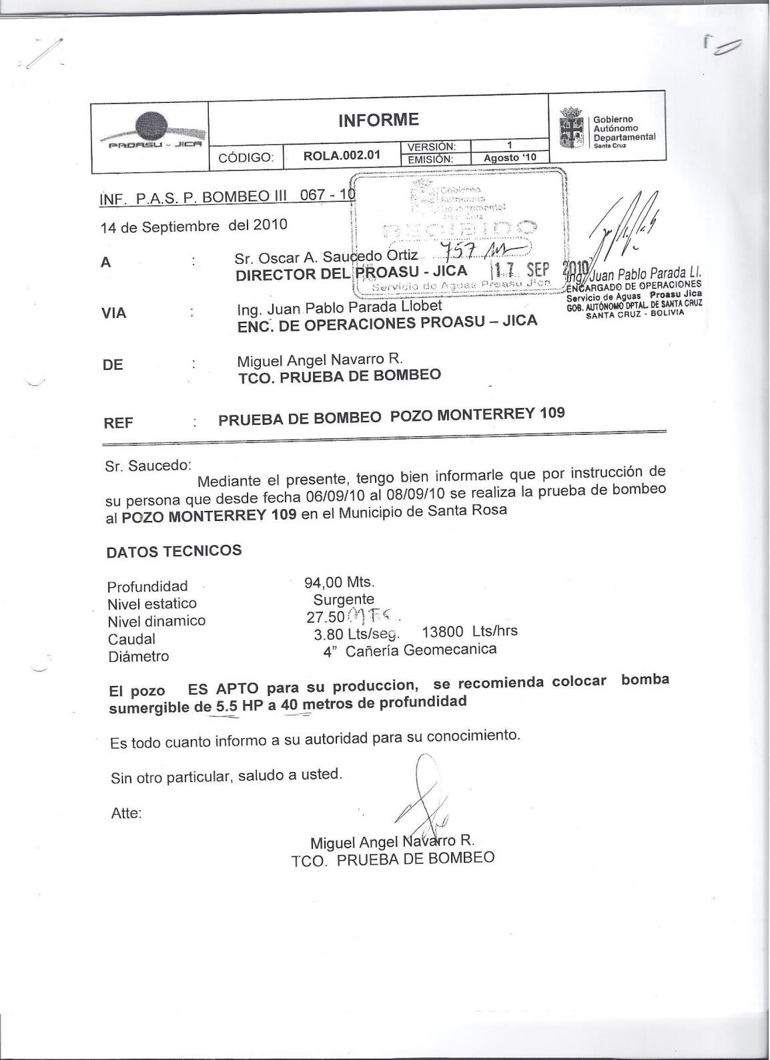

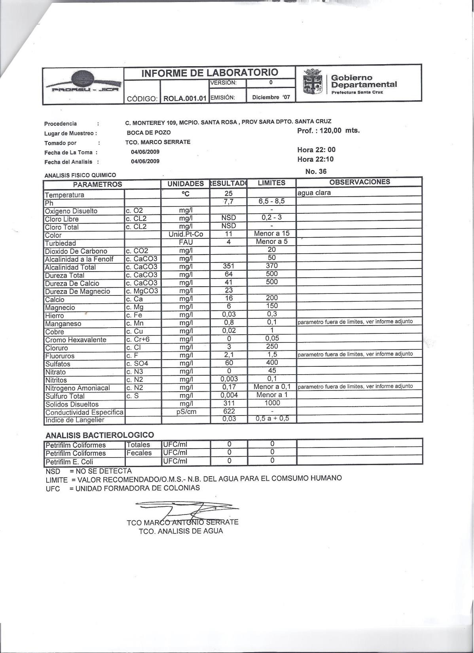

Guadalupe

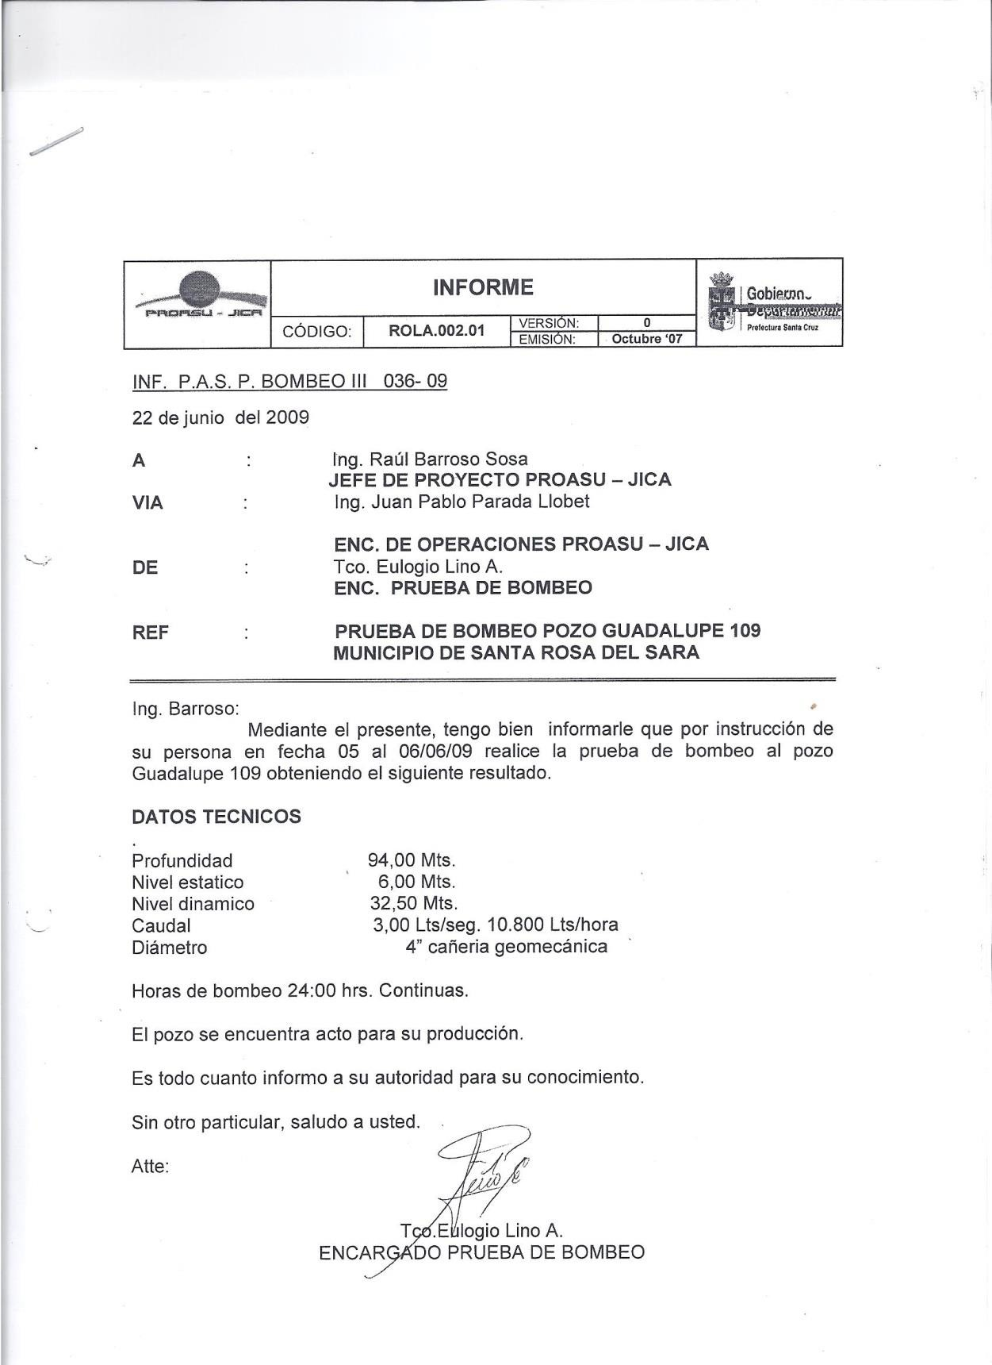

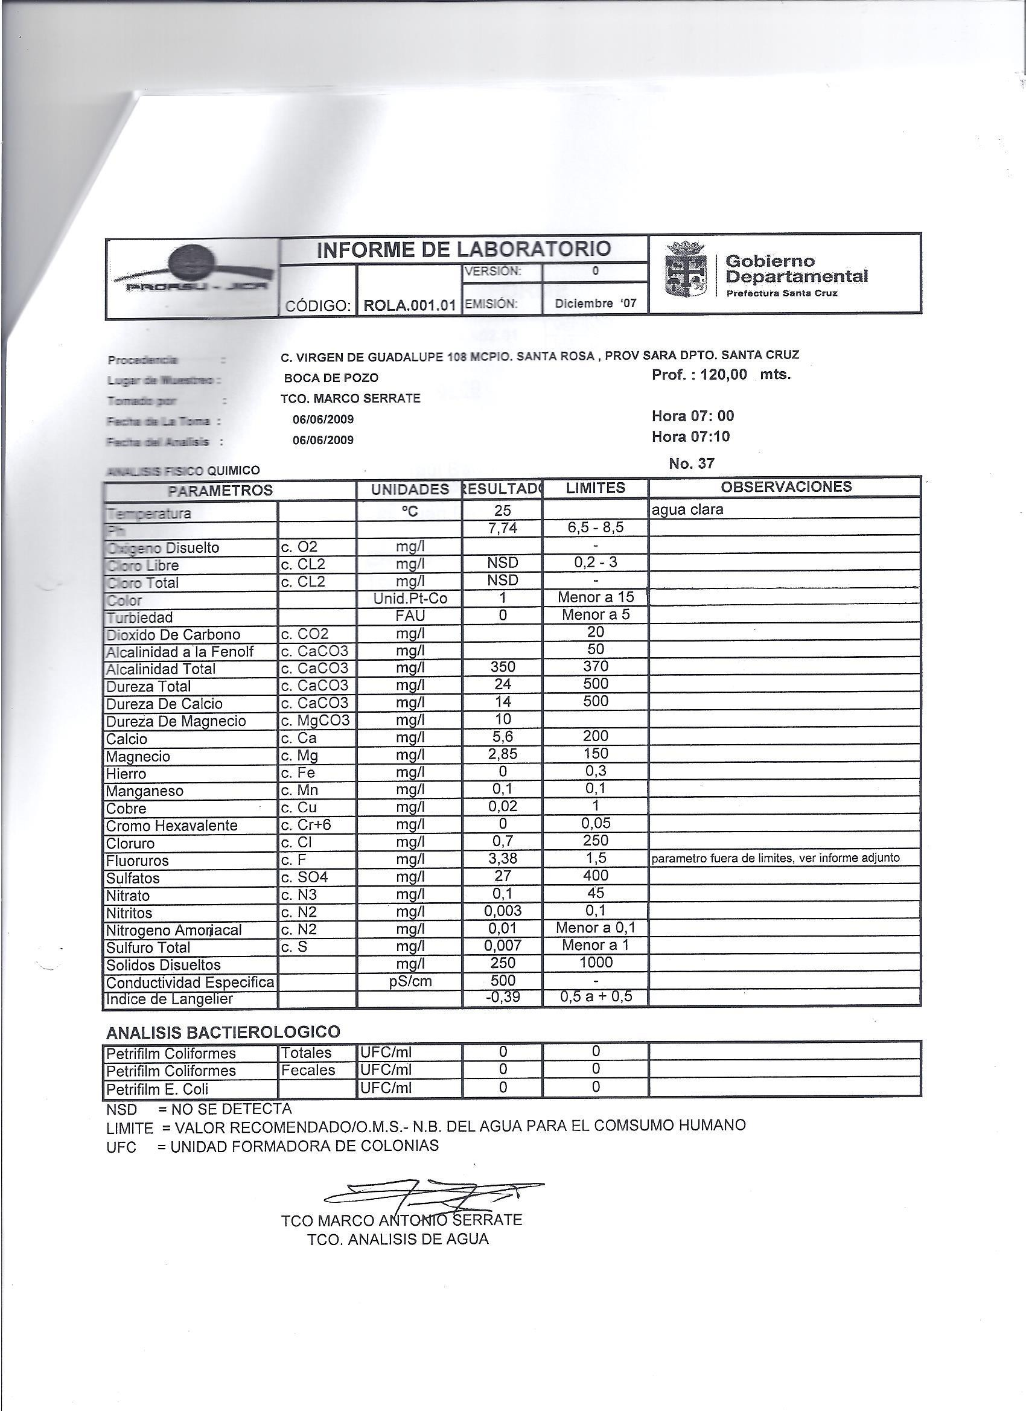

Appendix V: Pumping Calculations

Monte Rey

Date: 23-Dec-12
1 Location of Borewell:

Monte Ra y

1 Hydrolic Ene rgy Ne e de d

2 Poulation 2000 census 148
Eh = ρgHV/3.6x106
Eh = ρgHV

2020 estimated at 3% growth 195 Eh = hydraulic energy required in KwHr/Day

3 Daily production liters (40 lpd/person)
4 Head (meters)
Well Depth Dynamic Head Tank Height Terrrain Rise
Friction Loss adder(see calcs 3 & 4)
7800 ρ = density of water (1000kg/m3)
g = gravitational acceleration (9.81 m/s 2)
where
94 H = total hydraulic head (m)
28 V = volume of water required (m3/day)
6
2 Eh = H x V x 0.002725
1.41 Eh = 37.41 x 7.8 x 0.002725

Total Head (meters)
37.41 Eh = 0.79515
Kilow a tt-hours

5 Pumped piping distance 100
6 Gravity piping distance 700

2 Sola r Arra y Size

7 M4 =Head x cubic lpd needed
8 Solar Go (If M4 < 1500)
292
Yes
A = Eh/eFId

A = array size in Kilowatts

9 Tested Recovery Rate (lpm) 228
10 Solar Pumping Rate Needed*
Eh = hydraulic energy needed in KwHr/day
where e = daily subsystem efficiencies (typically .25 - .40)

gal/min*
liter/min**
11 Hydrolic Energy Needed (KwHr/day)
10
39
0.795
F = array mismatch factor (0.85 on average)
Id = average daily solar irradiance (use worst month of 3.3 for Monte Ray

12 Solar Array watts 516 A = Eh / e / F / Id
A = 0.79515 / 0.4 / 0.85 / 4.53

A = 0.516

*the gpm rate is daily consuption liters /3.8 gal/liter/3.3 peak sun hours/60 minutes/hour
** the lpm rate is daily consumption liters /3.3 peak sun hours/60 minutes/hour

Site Monte Ray
Kilow a tt

3 Friction Losses of Water Flow in Pipes - Pumping up from well to transition to 2"

Village
Monte Ray

Flow Rate (gallons per minute) Pipe diameter
Friction lost factor per 100 feet of pipe from chart
1

1.5" loss
10 gpm
1.5"
0.72

Fittings Quantity
factor Extension

90° Elbow 4 4.00 16.00
45° Elbow 0 1.75 0.00
Insert Coupling 0 1.25 0.00
Gate Valve 0 0.80 0.00
Male-Female Adaptor 1 2.75 2.75
TEE flow through run 0 2.30 0.00
TEE flow through branch 0 7.00 0.00
Union Fitting 1 2.00 2.00
Ball valve 1 0.80 0.80
Check Valve 1 0.80 0.80
Other 0 1.00 0.00
Fittings Total (feet) = 22.35 feet
2 Pipe Run lengths (meters)
Well depth 35
Lateral Distance 2
Vertical Distance 0
Other 0
Total Pipe length (m) 37 x 3.3 ft/m= 122.1 feet conversion to feet

3 Total feet of pipe for friction calcualtion =
4 Calculate what to add to overall head due to friction

Total feet divide by 100
Multiplied by friction factor from chart Feet to add to overall head length is = Meters to add to overall head length is =
144.45 feet

1.44
0.72
1.04 feet
0.32 meters

4 Friction Losses of Water Flow in Pipes - 2" from top of well to Tank location

Village
Monte Ray

Flow Rate (gallons per minute) Pipe diameter
Friction lost factor per 100 feet of pipe from chart
10
2
0.21

1 Fittings Quantity 2.0" pipe Extension
90° Elbow 4 6.00 24.00
45° Elbow 0 2.50 0.00
Insert Coupling 0 2.00 0.00
Gate Valve 0 1.50 0.00
Male-Female Adaptor 1 4.50 4.50
TEE flow through run 0 4.30 0.00
TEE flow through branch 0 12.00 0.00
Union Fitting 1 2.50 2.50
Ball valve 1 2.50 2.50
Check Valve 1 2.50 2.50
Other 0 3.00 0.00
Fittings Total (feet) = 36.00 feet
2 Pipe Run lengths (meters)
Well depth 0
Lateral Distance 500
Vertical Distance 8
Other 0
Total Pipe length (m) 508 x 3.3 ft/m= 1676.4 feet conversion to feet

3 Total feet of pipe for friction calcualtion =
4 Calculate what to add to overall head due to friction

Total feet divide by 100
Multiplied by friction factor from chart Feet to add to overall head length is = Meters to add to overall head length is =
1712.40 feet

17.12
0.21
3.60 feet
1.09 meters

Guadalupe

El Abra
