Project Narrative

1. Briefly describe the project.
- What were your original objectives?
In February of 2012, in collaboration with Rotary International, Etta Projects began the project “Comprehensive Sanitation Improvement Project,” intended to improve community sanitation and promote healthier villages through the construction of ecological Latrines and a community hygiene program. The latrine model used in the project is simple, low-cost and eco-friendly. Our original goal was to build 45 composting latrines in two villages while implementing a hygiene & sanitation educational program intended to further enhance the project’s sustainability.
More specifically, the Comprehensive Sanitation Improvement Project included the following original objectives:
- Improve basic health and sanitation by constructing eco-bathrooms at 45 family homes in two villages.
- Educate and encourage the beneficiaries to adopt sanitary bathroom practices.
- Provide hygiene education on bathroom use, hand-washing, food preparation, garbage disposal, water storage
- Establish a process to monitor family bathroom use and evaluate sanitation education in the project communities.
- Stimulate visible improvements in community health by reducing incidence water-related infections and illness.
- Involve the beneficiaries in all aspects of the project – planning, construction, utilization and sustainability.
- Offer community health promoters and teachers tools and resources that will result in sustainable health practices.
- What was actually accomplished?
Over the past 18 months, Etta Projects has worked to better manage excrement in the communities through latrine construction and family education about health and hygiene practices.

Over the course of the project cycle, we have achieved the following results:

- Construction of 45 ecological composting latrines
  - Village San Martin: 11 latrines completed and in use
  - Village La Patria: 15 latrines completed and in use
  - Village Los Naranjos: 12 latrines completed and in use, plus 6 latrines with completed bases but still are in the process of building the walls & roofs
- 45 families from the three communities San Martín, Naranjos and La Patria are trained in health issues: sanitation, hygiene, ecology, nutrition, prevention of hydric diseases, self-construction of ecological latrines, solid waste and recycling management.
- Children of the participating families trained in danger of excreta, hygiene and hand washing.
- 7 trained sanitation promoters that carry out house visits and activities to strengthen community hygiene and sanitation

The project successfully completed all four program components:
- Community Hygiene Promotion
The initial phase of the project intended to raise public awareness about the consequences of poor sanitation as well as to organize and motivate villagers to change their current sanitation situation. In each of the communities, meetings were held with villagers to discuss sanitation and health topics such as water related illnesses, the danger of excrement, options to improve sanitation and benefits of the ecological latrine model. After learning about the importance of sanitation, families had the option to participate in the program. One requirement of the program was to attend these capacity building workshops.

Families participated in a series of eight capacity building workshops. Each workshop had an average attendance of 17 individuals. These workshops included:

    - Overview of Water Bourne Illnesses
    - Overview of Ecological Latrines (Part 1)
    - Overview of Ecological Latrines (Part 2)
    - Use and Maintenance of Ecological Latrines
    - Health and Nutrition
    - Hygiene and Basic Sanitation
    - Health and the Environment
    - Storage and Disposal of Garbage
    - Recycling
    - Food Preservation and Storage
    - Training on Ecological Latrines Maintenance
    - Utilizing Fertilizer from Ecological Latrines

An additional three workshops were conducted in participating schools for local children. Examples of proper hygiene methods were given to the children to demonstrate sanitary habits. The three workshops focused on:

- The Sanitation of Bodily Excrement
- Proper Hand Washing
- Use of Ecological Latrines

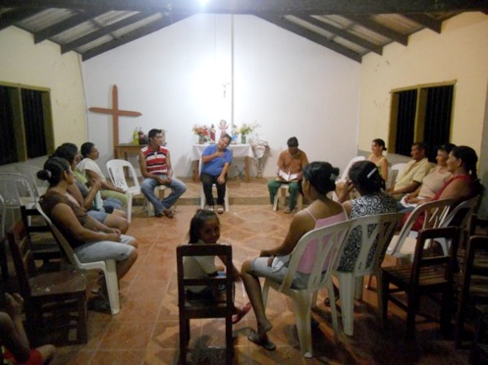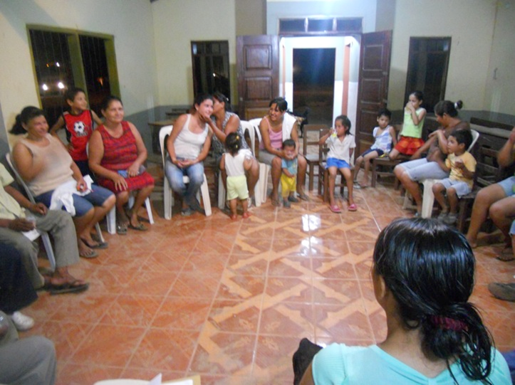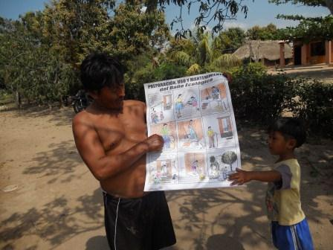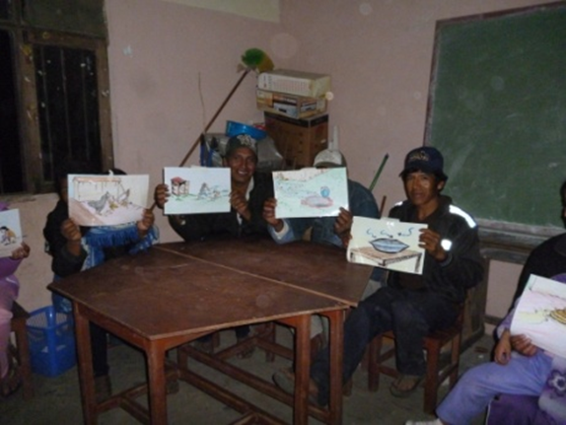

- Latrine Construction
The construction of latrines began in the community of San Martin, subsequently La Patria, and finally Los Naranjos. The project offered workshops intended to teach participants the steps of building their latrine. The workshops included themes in: Selecting the Location of Latrine, Forming & Pouring Slab for Lower Foundation, Forming and Pouring Slab for Upper Foundation, Construction of Chambers, Building the Sub-Floor, Building Walls & Roof. By gaining an in-depth understanding of how to correctly build latrines, families were able to actively participate in the construction process.

Families were divided into groups during the construction process, with each group consisting of approximately 10 families. All families collaborated on the construction process. In total, 21 men, 14 women and 10 children (over the age of 12) assisted in bathroom construction. These individuals assisted with activities such as: hauling water; transporting brick, gravel and sand; weaving the cement slabs top and bottom; preparing cement mix; passing cement mix and brick and brick lying. In San Martin men and women supported the construction process equally; however in Patria construction was led in large part by the women while in Los Naranjos the men supported the majority of the manual labor.

Families had the option of constructing latrine walls using brick, mud or wood/bamboo at a lower cost. Below is a breakdown of each participating community:

 | SAN MARTIN | LA PATRIA | NARANJOS
Brick  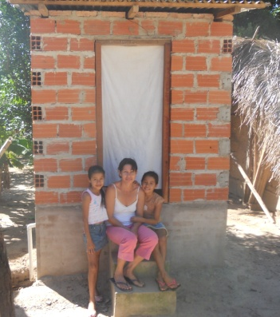 | 11 | 14 | 9
Mud  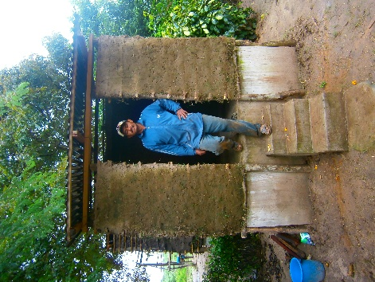 |  |  | 4
Wood/Bamboo  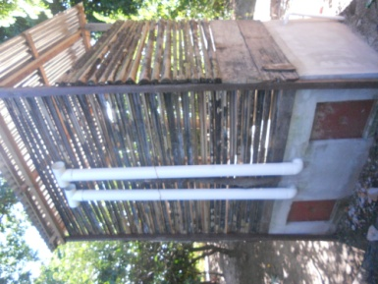 |  | 1
Total Bathrooms | 11 | 15 | 13

Below are pictures of families constructing their ecological latrines:
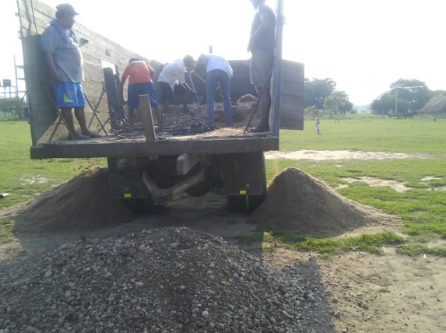
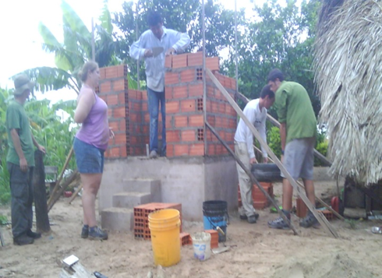

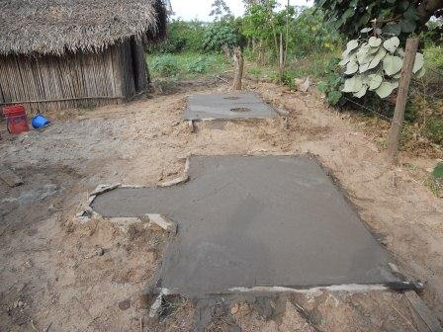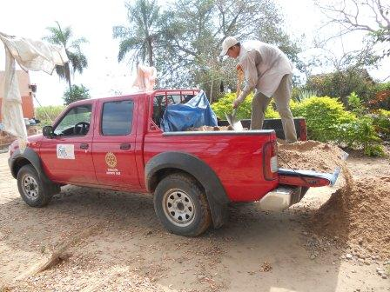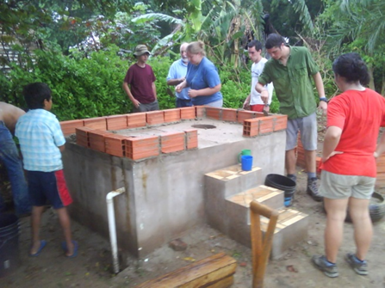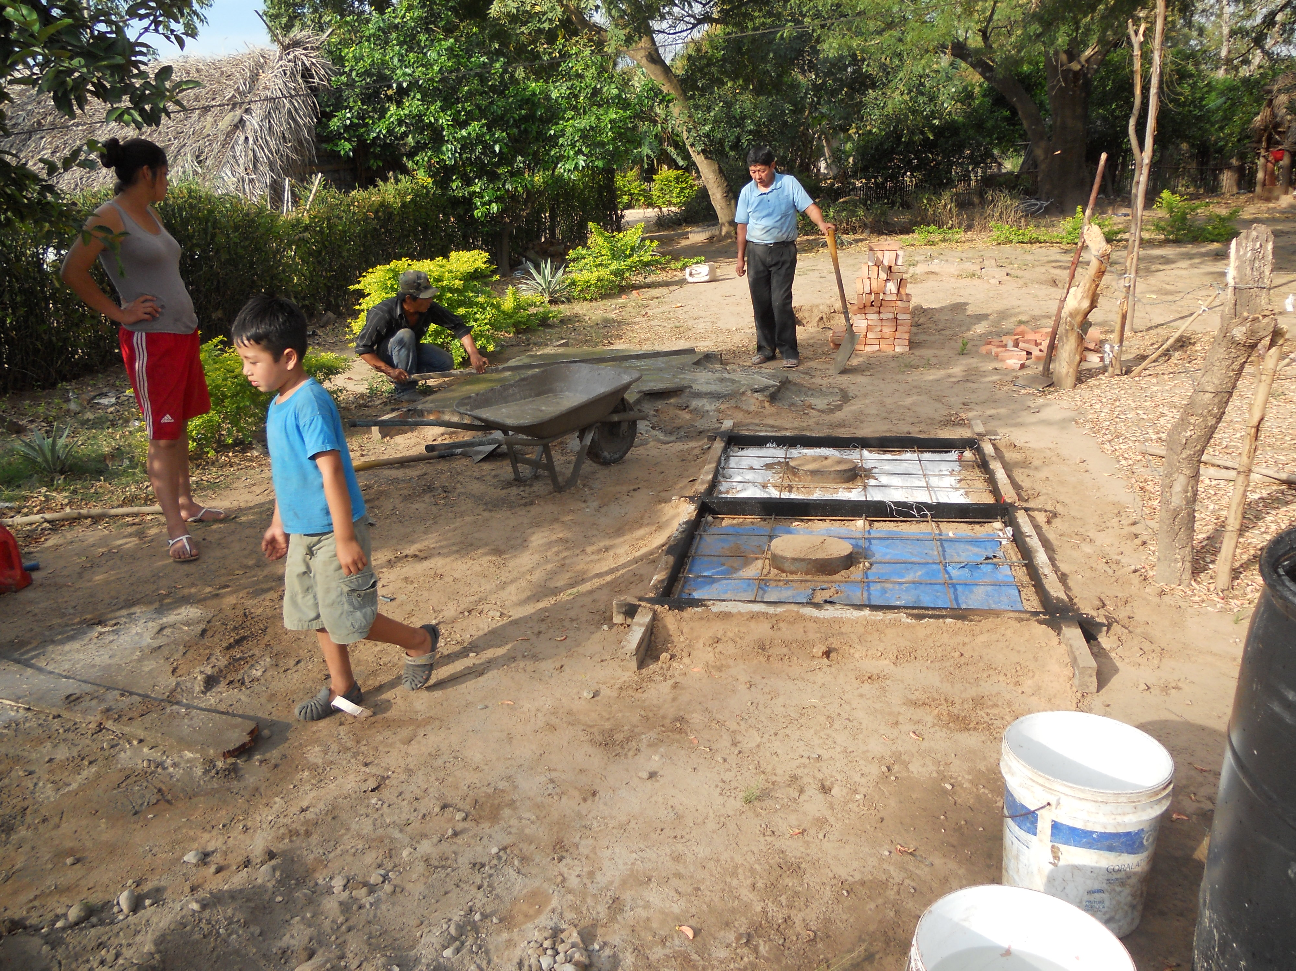

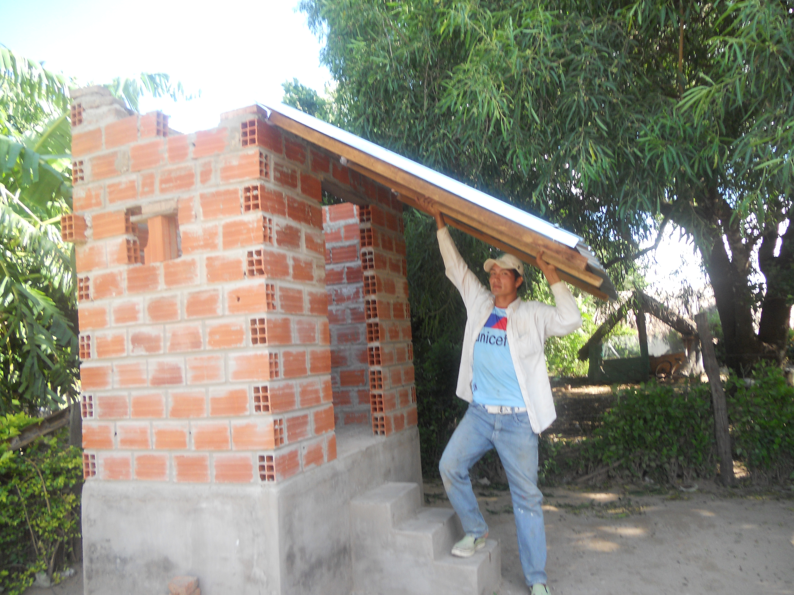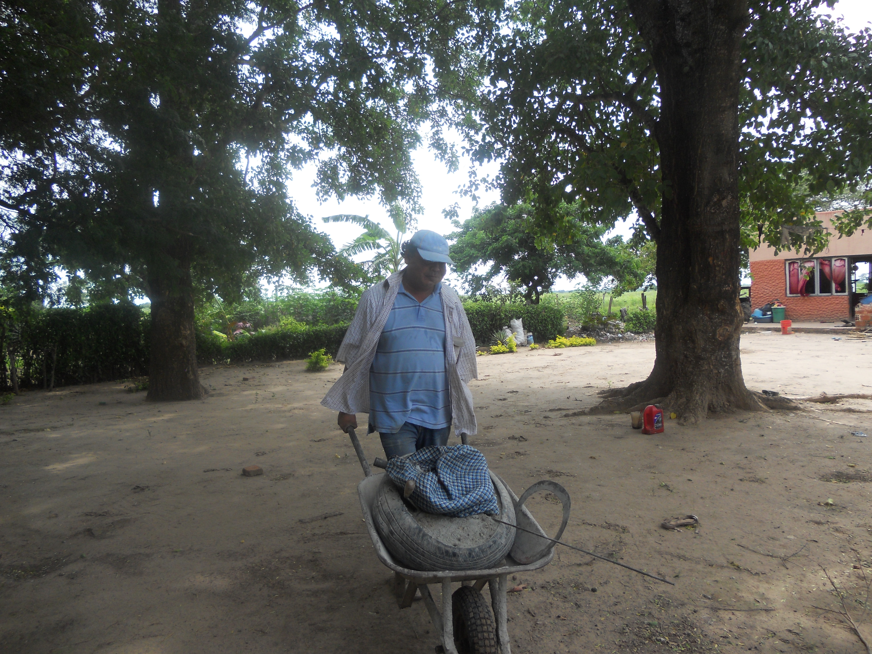

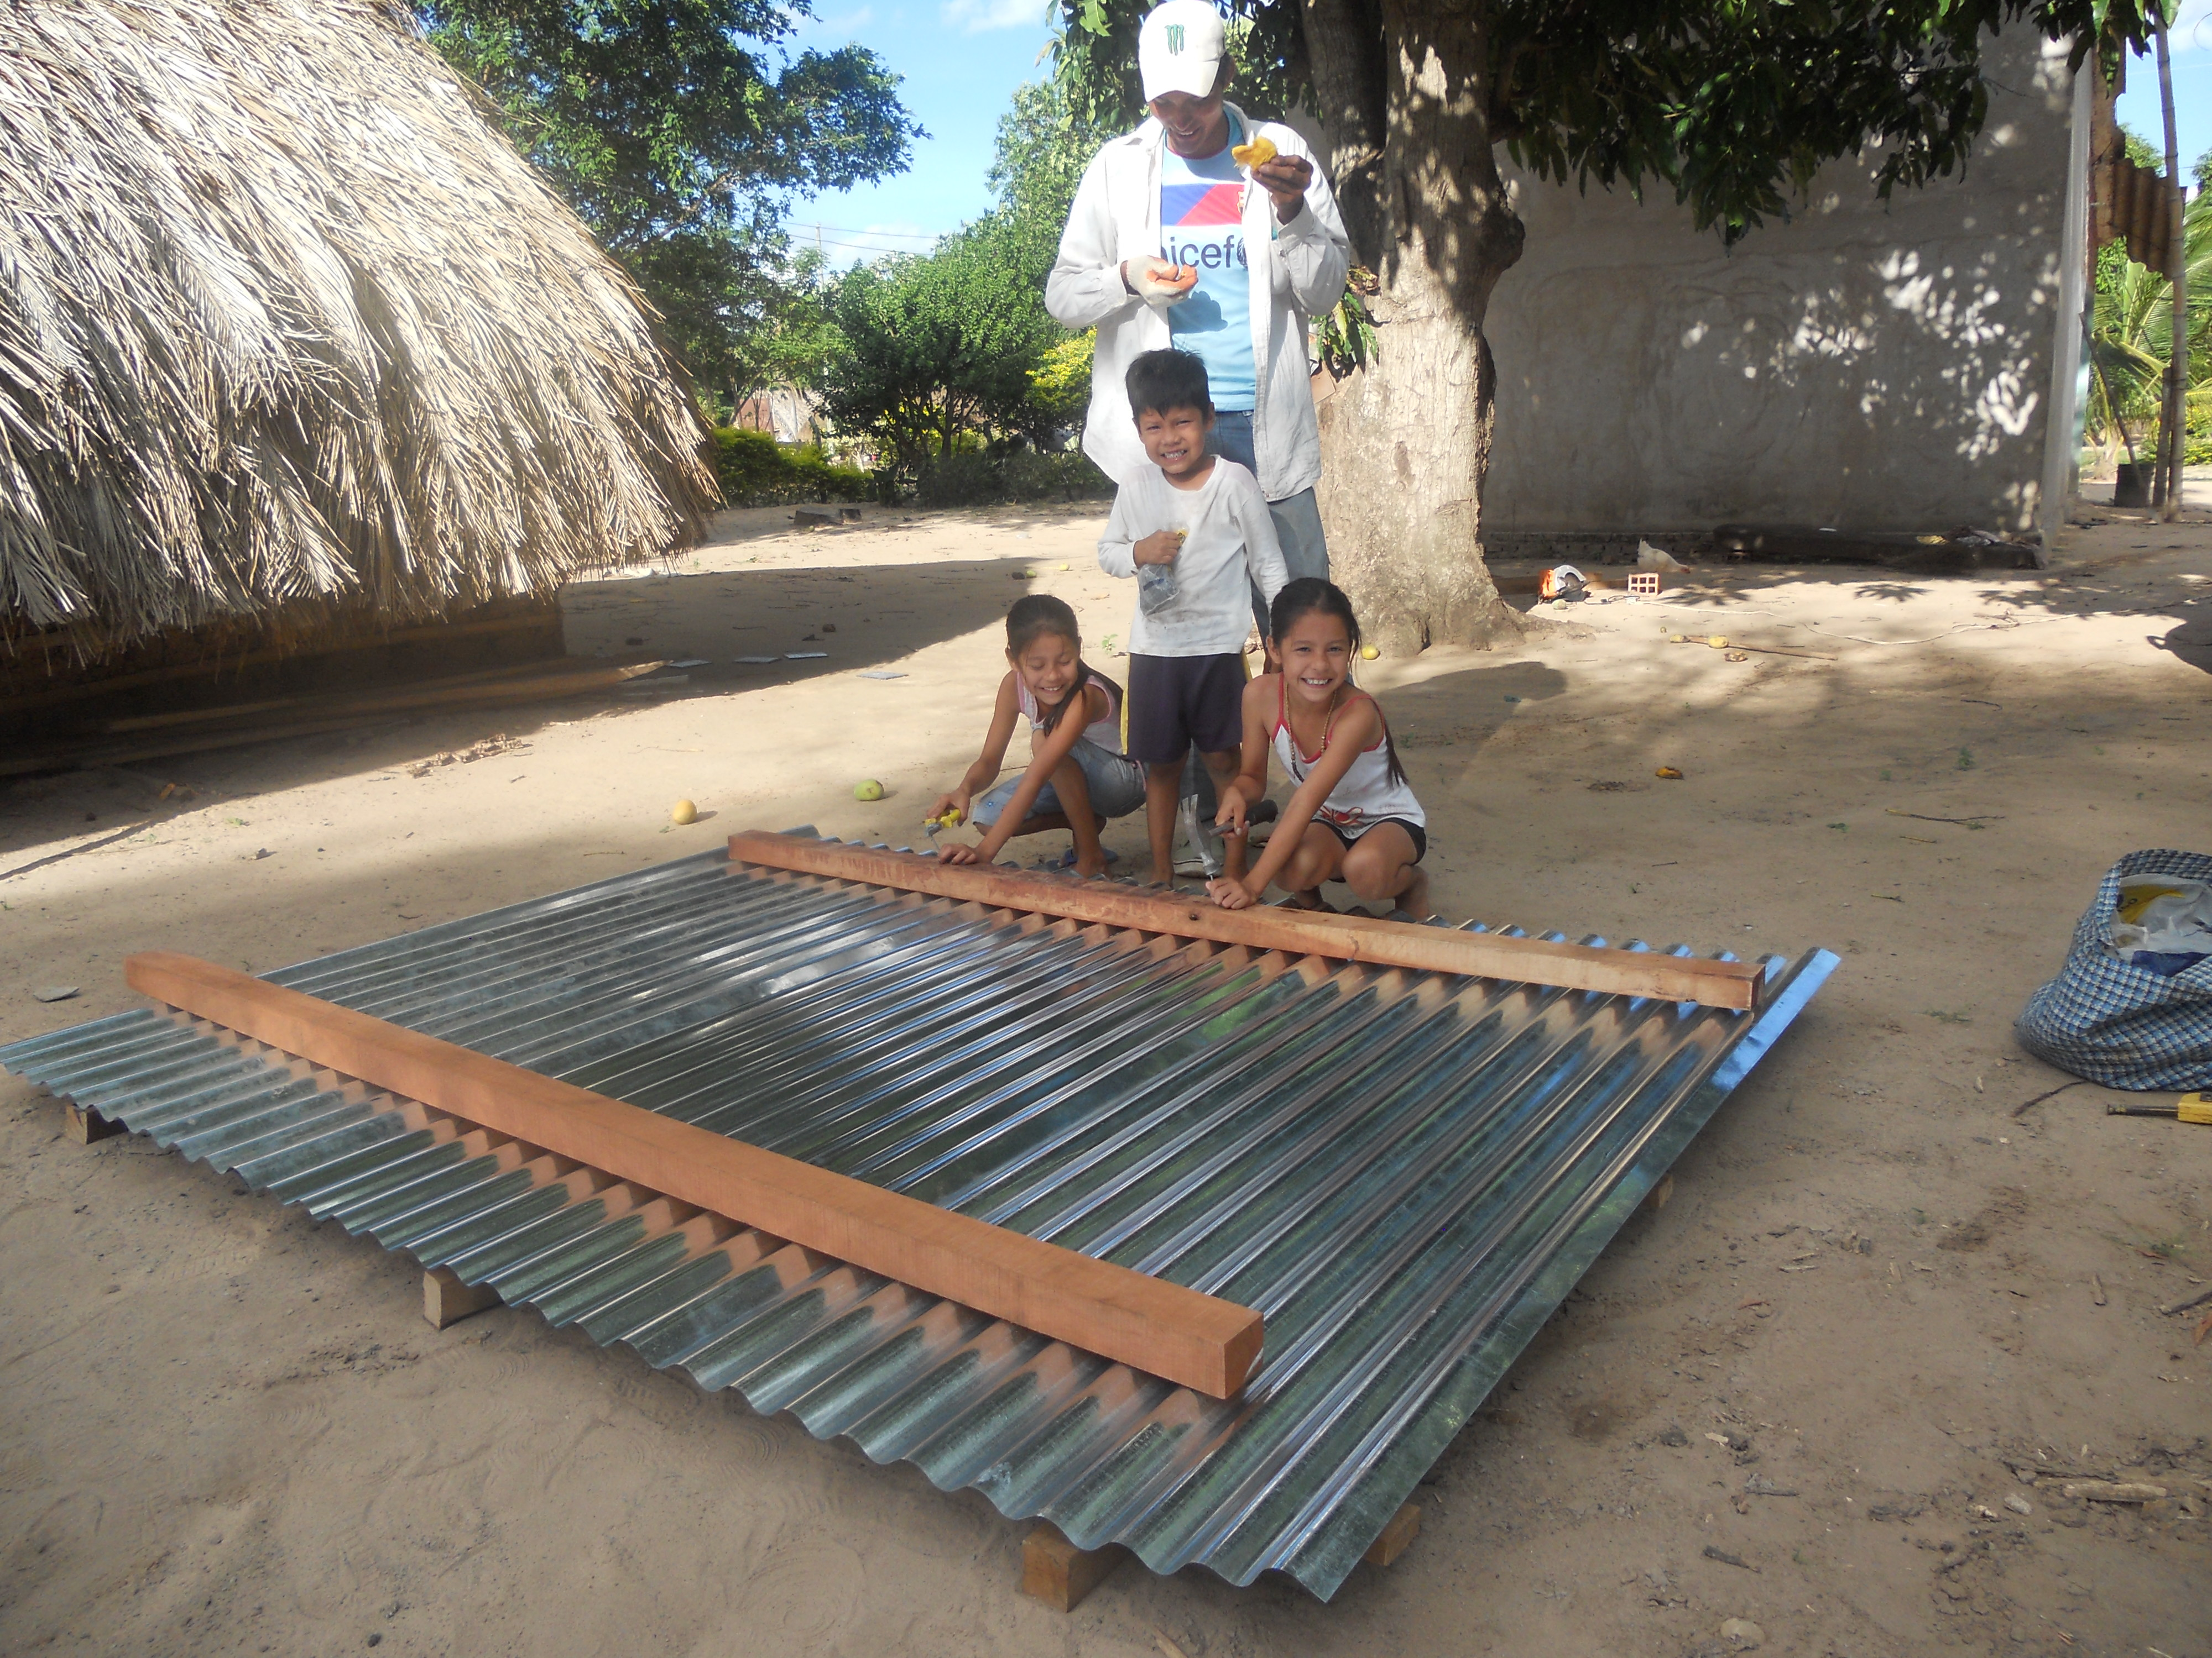
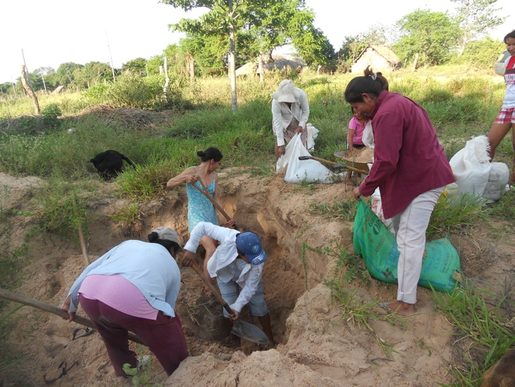
The following chart shows the process used to build the latrines:

Latrine Feature | Description
Double-vault base  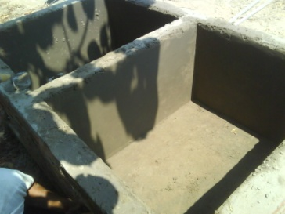 | Lower and upper slates, stairs, coating on inside and outside to prevent leaking
Roof  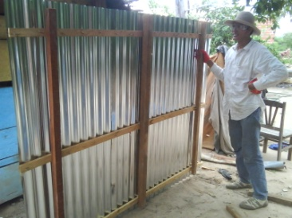 | Frame, slats, slat and corrugated panels
Cement doors  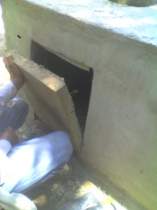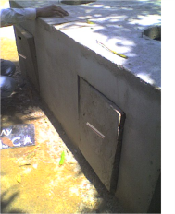 | Doors of cement with 5/16 iron frame
Sanitation Installarion  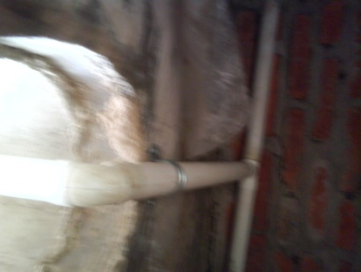 | PVC pipes, elbows Ts 1 1/2 ", which are secured with clamps and dowels to the sub floor
Toilet Insert  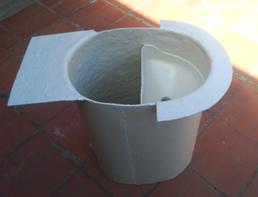 | The toilet inserts are made from plastic coated with fiber glass.
Ventilation Tubes  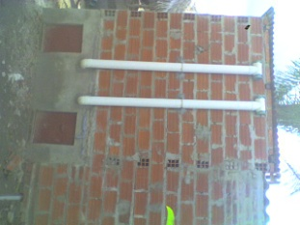 | Ventilation pipes found on the back of the walls and are connected by a 4 "PVC elbow and at the top a T protected with millimeter mesh of the same size

Below are examples of pictures of completed latrines:

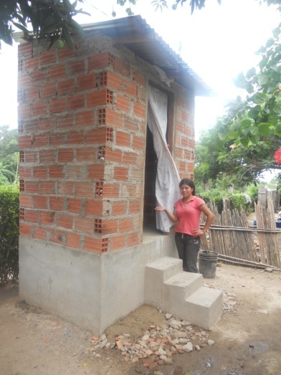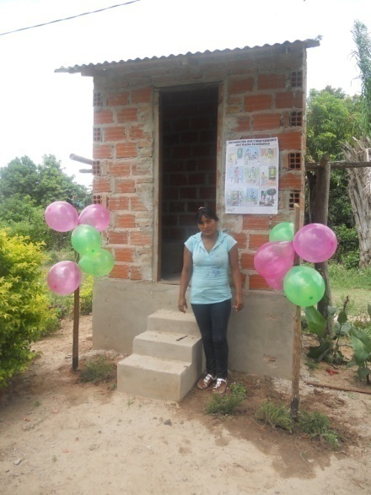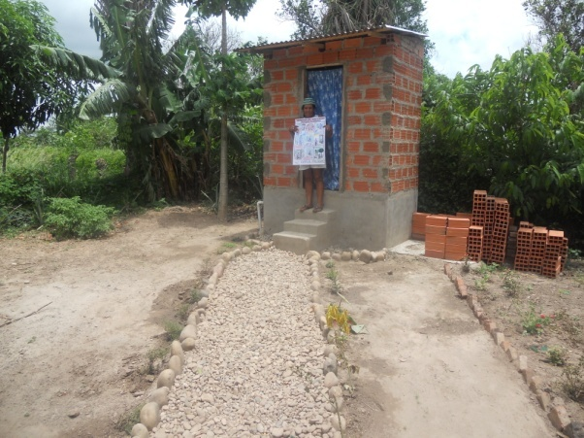

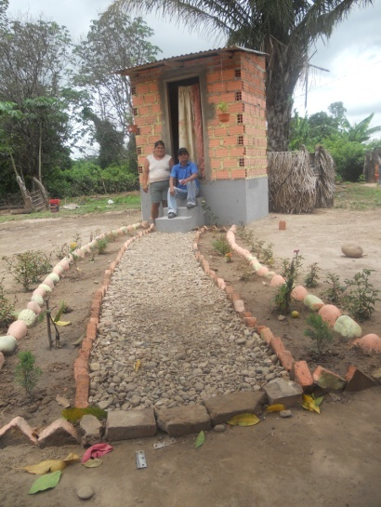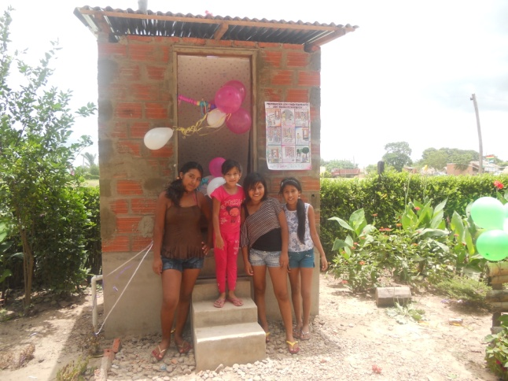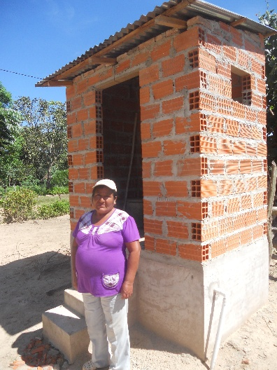

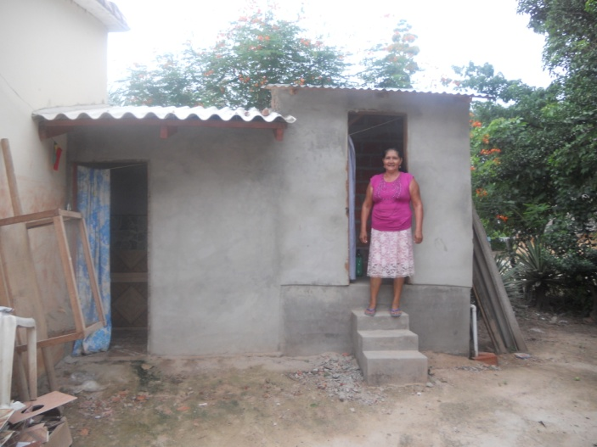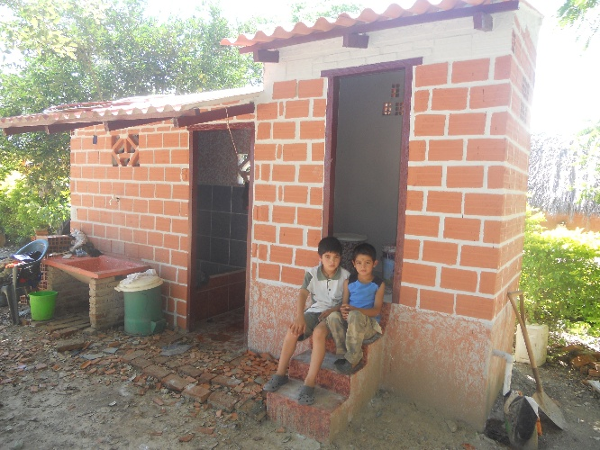

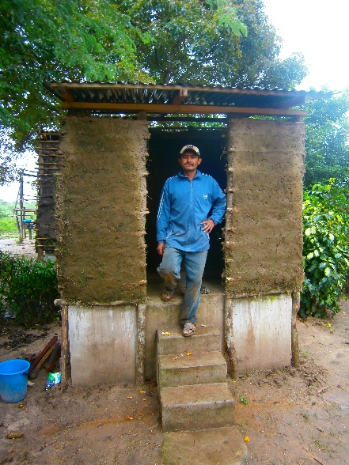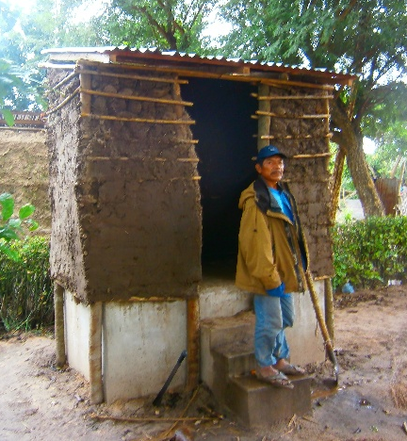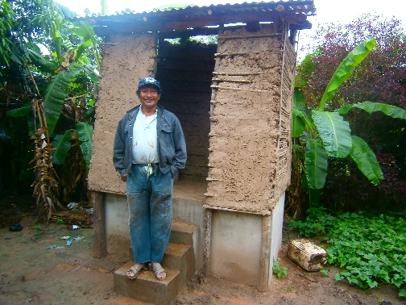

- Training of Sanitation Promoters

Each community democratically elected sanitation promoters. The promoters hold an important leadership role by supporting project activities, helping to organize families and monitoring latrine use & maintenance. Almost all seven sanitation promoters also serve as Community Health Promoters so they have an ongoing interest and investment in improving health in their communities.

In the three participating communities of San Martin, La Patria and Los Naranjos, eight capacity building workshops were conducted for seven women Sanitation Promoters throughout the project cycle. These workshops included:

- Overview of Sanitation Promoters
- Prevention of Water Bourne Illnesses
- Basic Sanitation and Hygiene
- Maintenance and Use of Ecological Latrines
- Monitoring and Evaluation of Sanitation and Hygiene
- Storage and Disposal of Garbage
- Utilizing Fertilizer from Ecological Latrines

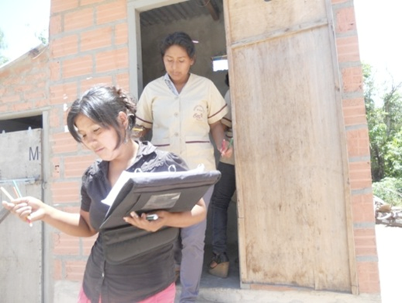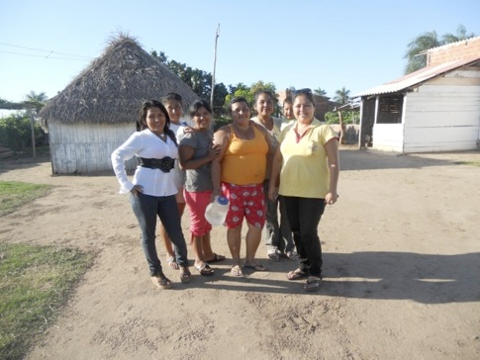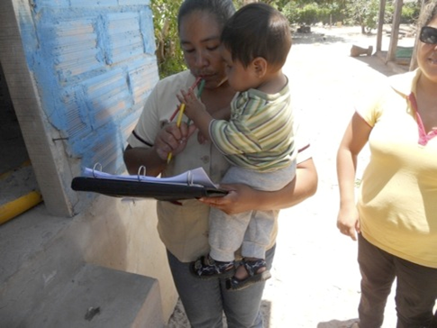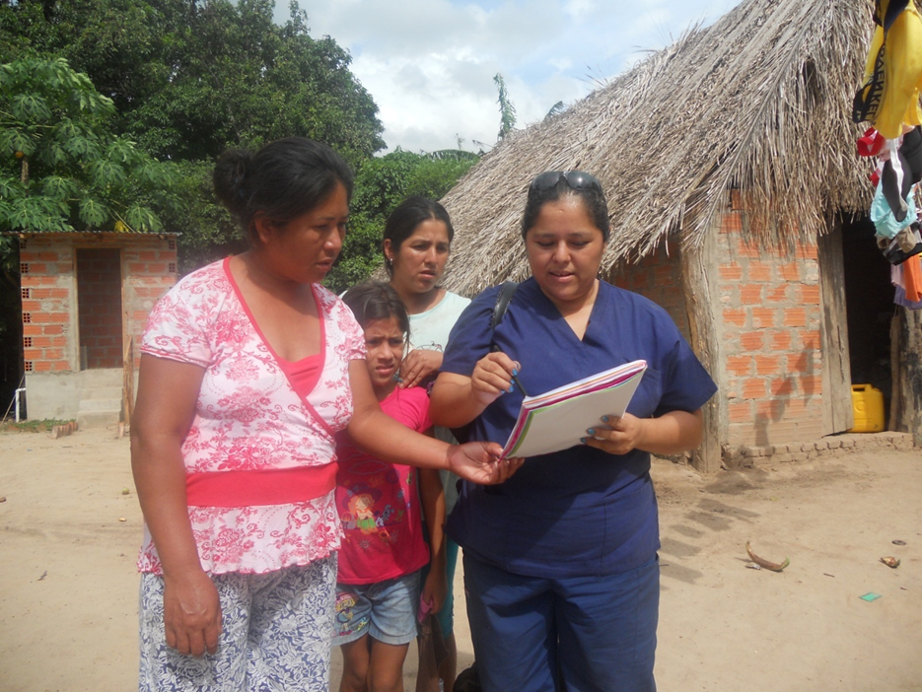

Etta Projects secured additional funding for small stipends to distribute to the sanitation promoters in exchange for their support. The stipends were paid through the distribution of food, household goods and hygiene & sanitation materials.

The photos show the distribution of the stipends being paid in goods.
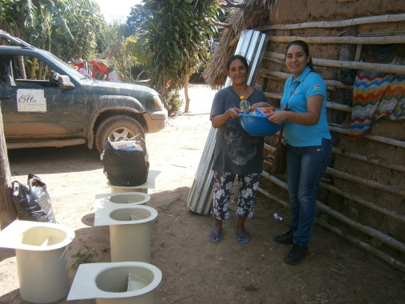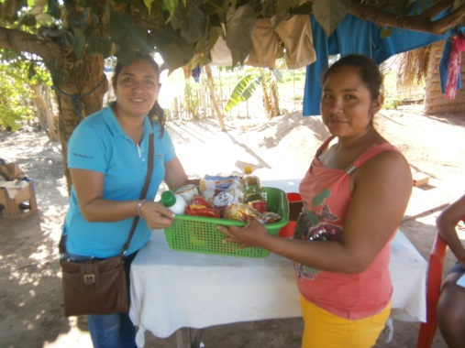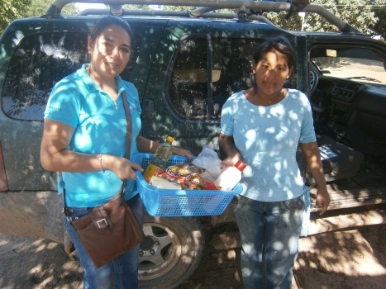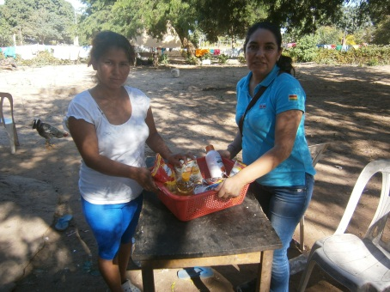

- Participation of local Municipality

The Municipality of Minero was active in the project throughout its duration. Local representatives participated in various phases of the project and made random visits to the villages to contribute to a training session or monitor the construction process. The local municipality also made a financial contribution of $3,100 to the project towards construction materials.

- When and where did the project take place, and who were the beneficiaries?
The project began in February of 2012, and was completed in June of 2013 (in reality, six families are still in the process of completing the walls and roof of their latrines). The project took place in three villages (San Martin, La Patria and Los Naranjos); all three villages are located in District 2 in the Municipality of Minero. Residents’ primary language is Quechua but Spanish is also spoken. The area is dominated by large sugarcane farms. General living conditions are poor. All the participating families live permanently in the rural villages and lack many of the basic services needed to provide an acceptable level of sanitation for the rights of human beings.
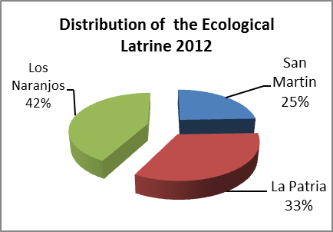
The project is distributed in the following way:

Village: | San Martin | La Patria | Los Naranjos
Number of  Benefitted Families | 11 | 15 | 19

2. Scope change. If the project was changed, how and why was it changed?
Throughout the course of the project, the scope of the project changed in the following ways:
- # of Communities
Baseline data collected prior to beginning the project revealed that the villages San Martin and La Patria had a combined total of 45 families. Once we began the project we learned that various families share one piece of property. Most often these families chose to only construct one latrine. This lowered the number of anticipated latrines in these two villages, therefore allowing the project to expand to the neighboring village, Los Naranjos.
- Project Design
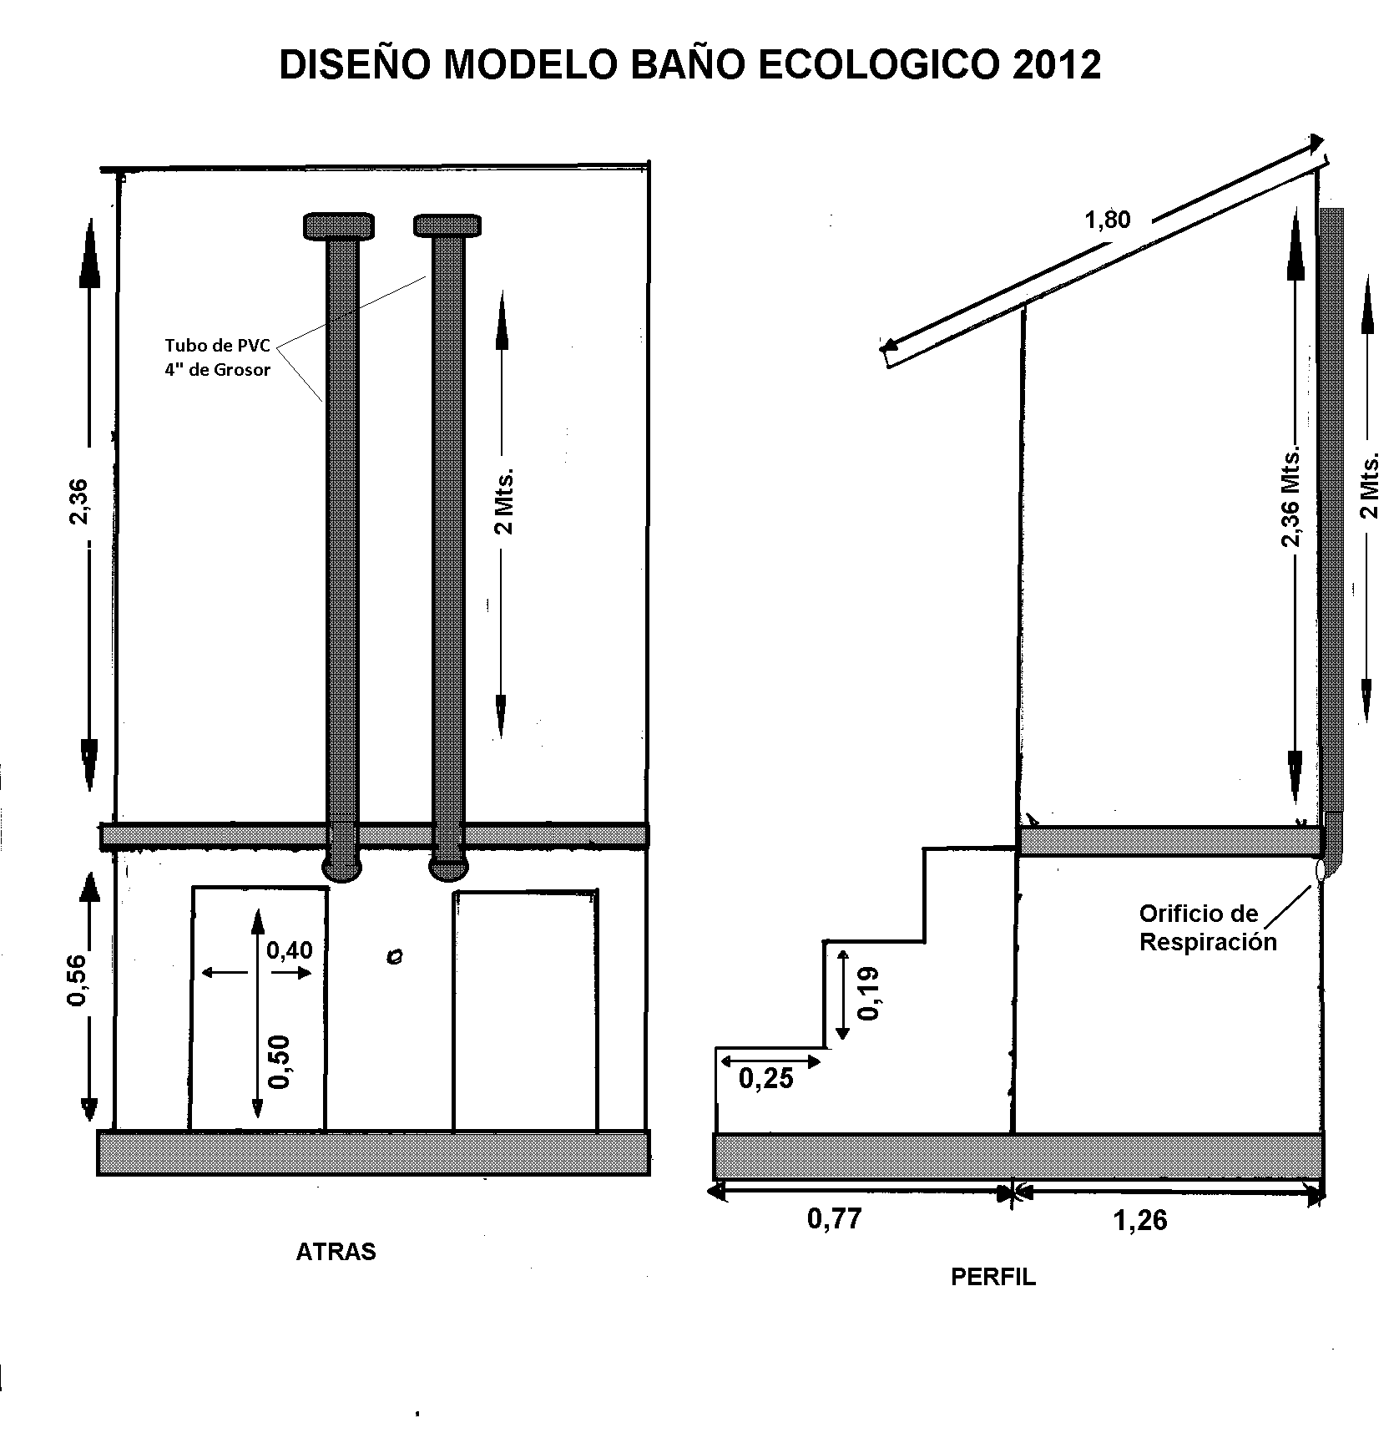
The ecological latrine model has not changed itself, but many of the materials used in the construction process have changed. The following chart breaks down the improvements the team made to the design.
Modification | Before | After | Description
Toilet seat | 2011 Model  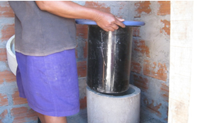 | 2012 Model | Toilet seat has same design, but we now use a fiber glass/plastic combination instead of sheet metal for increased sustainability. Price increased from $17.29 to $55.
Ventilation Tubes | No ventilation tubes  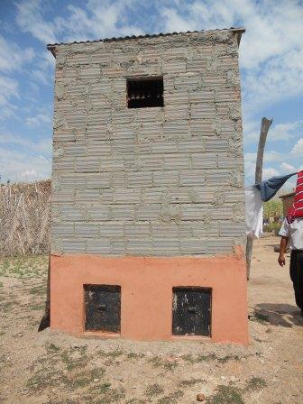 | Current model | There are contradicting opinions on the benefits on ventilation tubes. Mid-way through the project we decided to install ventilation tubes to decrease the humidity in the chambers. Ventilation tubes add an additional cost of $14/latrine
Double chamber doors to remove compost | Metal doors  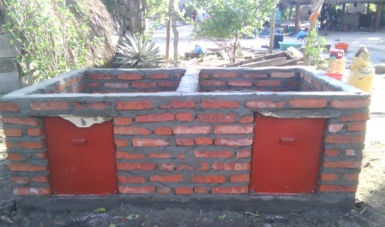 | Cement doors | The project originally used metal doors to make it easier for families to remove compost. Despite this advantage, the cement doors eventually proved to be more cost effective and more sustainable. Metal doors cost $36.50. Cement doors cost $14.
Urine Tubing | ¼” PVC tubing  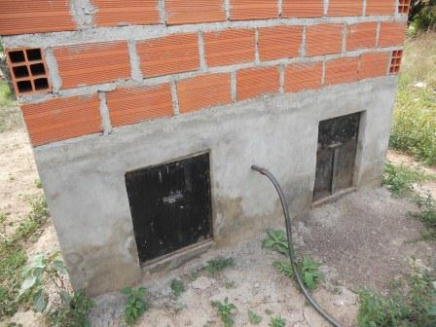 | ½” PVC tubing  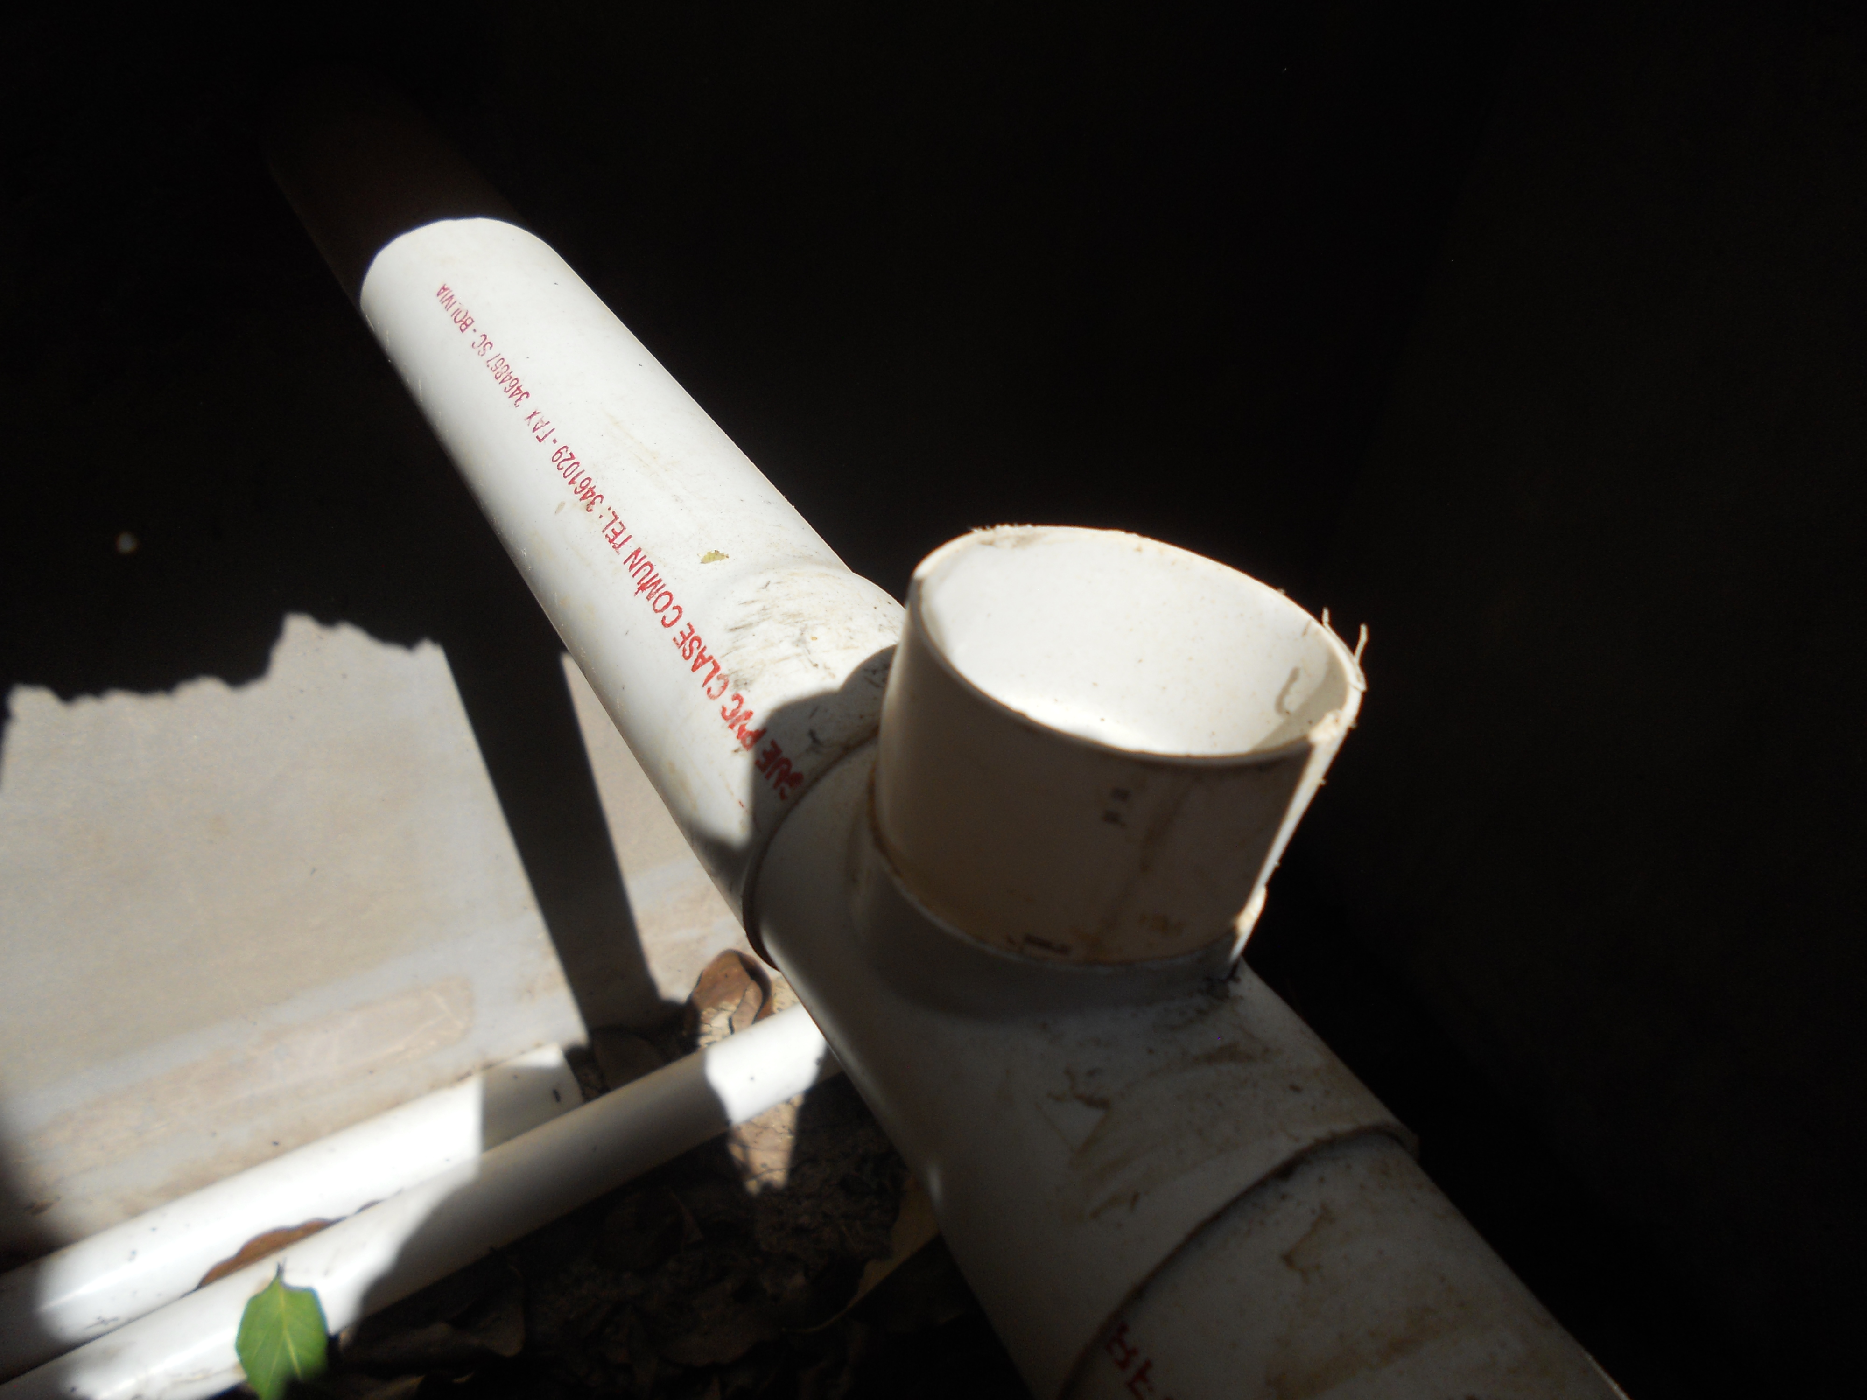 | This year the project increased the diameter of the urine tubing and changed the design to install the tubing. Instead of hanging the thin tubing with wire, we interlock one tube to another for a more secure design. The total price of the new design is $11.

- Project schedule

In 2012 and 2013 Eastern Bolivia had an unprecedented amount of rainfall forcing the project to constantly reschedule workshops and activities. Originally we anticipated completing this project by December of 2012. Heavy rainfall postponed both training sessions and latrine construction. Physical factors such as impassable roads caused by the rain made it virtually impossible to transport construction materials to the villages. We quickly learned that timelines had to be flexible. We moved locations of the workshops, combined trainings to recuperate time, increased transportation services and even changed activities all together. With rainfall continuing even now in the month of June, the project was forced to extend the project past the anticipated closing.

- Community Participation

Heavy rain prevented many villagers to work consistently in the sugarcane fields, losing their main source of income. The lack of work made it even more difficult for families to pay their financial contribution to the project and/or secure the resources needed to build the walls of the latrines. Rotary Club of Lake City, Florida made an additional contribution of $1,200 to help create a loan program to families for materials to build the walls. This allowed many families to move forward in completing their latrines. Despite the extra financial support, some families still found coordinating the transportation and labor challenging. This is laregely why six families are still working to complete their latrines.

Additionally, the project encountered moments when the sanitation promoters found it challenging to complete their assigned activities. Most promoters are simultaneously mothers and wives who work long hours every day in the field. Additional responsibilities and leadership roles in the community (such as their role as health promoters) place a strain on their abilities to complete their assigned tasks. As a result, there has been some turnover in Sanitation Promoters. This turnover delays the process of capacity building as new participants must be effectively trained.

This challenge held true for all segments of the participating population particularly during the months they work on the field, where nearly 100% of community members work on sugarcane plantations. Participants often leave their houses for work before 5:00 AM and return home after 7:00 PM. This work schedule made it difficult to secure consistent participation from families.

Community Impact
3. How many people benefited from the project? | 235
 | Adults |  | CHILDREN
 | MEN | WOMEN | CHILDREN
SAN MARTÍN | 28 | 19 | 19
NARANJOS | 34 | 29 | 37
LA PATRIA | 19 | 24 | 26
TOTAL: | 81 | 72 | 82
 | TOTAL BENEFICIARIES | 235
4. What was the impact of the project on the beneficiaries?
  - Number of Functioning Latrines

The project goal was to construct 45 bathrooms in the three participating communities. Throughout the project cycle, Etta Projects has completed 45 latrine bases, with 39 latrines currently in use (100% of bases completed and 87% of latrines currently in use). Heavy rain delayed project construction throughout the year, with consistent heavy rain in December of 2012 and January, February and March of 2013. Due to these delays, 6 of the latrines are still currently under construction. The chart below depicts the percentage of participating families who demonstrated proper use and maintenance of their bathroom over the project cycle.

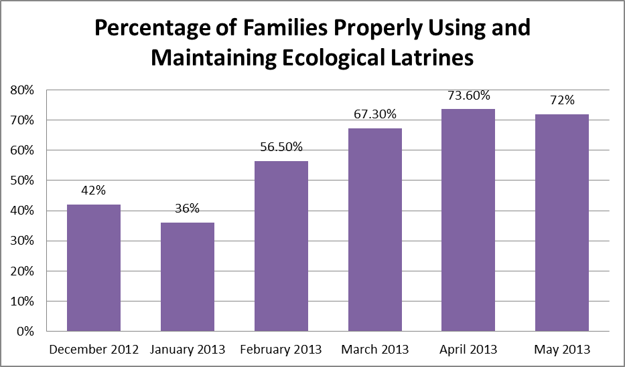

  - Improved Hygiene

Throughout the project, the percentage of participant families practicing sanitary hygiene habits increased from 40% in July 2012 to 71% in April 2013. Please note monitoring was not realized in January or February due to school vacations and outside employment by Sanitation Promoters.

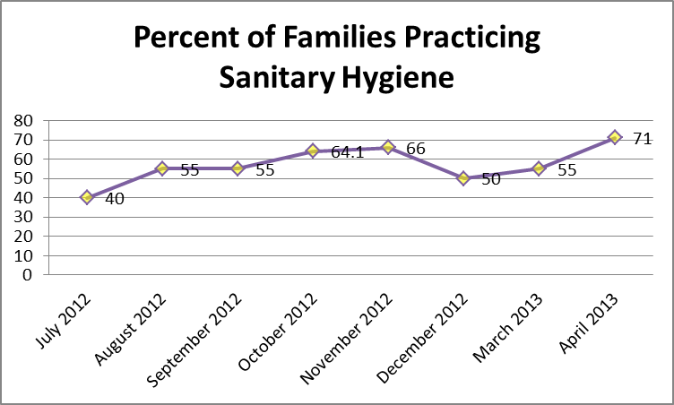

  - Increased Knowledge

Utilizing verbal tests after each workshop, community knowledge of basic health and sanitation topics rose from 10% after the first workshop to 86% after the final workshop. Average community attendance over the 12 workshops in San Martin was 83%, 79% in La Patria and 55% in Los Naranjos.

Using Etta Projects’ general test on hygiene and sanitation, the average score of Sanitation Promoters saw a dramatic increase from 20% during the first workshop to 92% following the eighth workshop. Attendance over the eight workshops was 95%.

  - Project Satisfaction

Using a satisfaction survey, 100% of project participants were, “very satisfied” with the training sessions. 40% and 70% of participants were “very satisfied” with family relations and bathroom maintenance. A complete breakdown of participant satisfaction is below.

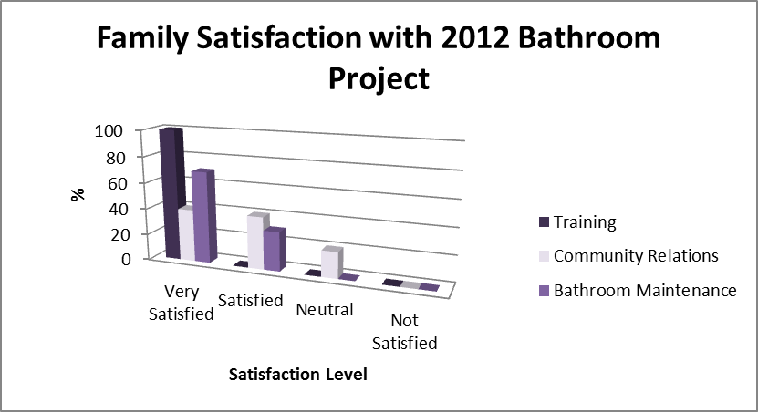

4. What are the expected long-term community impacts of the project?
We expect that both aspects of this project- hygiene promotion and sanitation- will be managed and sustained long after the grant period. The latrine has a guarantee of 20 years; therefore families will have a way in which to safely dispose their human waste for years to come. The educational component of the project which instills safe hygiene habits will also continue to contribute to the improved level of health of the community.

This sanitation program has a goal to offer 100% coverage to families of District 2 of the Municipality of Minero, and we believe the successes of this project will encourage families from surrounding villages to improve their sanitation systems and consequently their family’s health.

