Field Trip Plan and Report

I. Program Information
Activity | Site Inspection with EMW Board Members
Program Name | Clean Water – Kampong Tralach Schools
Report Author | IV Bunthoeun & Carys Everett
Key Program Staff | Kim Hor, IV Bunthoeun, & Carys Everett
Program Location(s) | Cambodia
Travel Date | 18 February 2013
Report Date | 22 February 2013

II. General Description

Instructions: Describe what you plan to do, i.e. key aims, objectives, expectations, and / or activities.
Take EMW board members, Jerry Falk, John Keker, Peter Singer, and Chris Hest to visit school water systems in Kampong Chhnang. Meet with school directors and teachers.

III. Activity Summary

Instructions: To be completed following field visit
EMW board members visited three schools in Kampong Chhnang, the first school was Soramarith High School where we met the two school vice directors, and asked many questions regarding the school water supply, school system and university scholarships. We observed the solar system and IV explained the project to the board members. IV and Chris met with the school director, who expressed his gratitude and pride of the system.
The second school was Salalek 5 Primary School, where we met the school director and school water committee member and inspected the new system installed there. The school thanked EMW for facilitating this project and expressed interest in improving the sanitation situation if EMW can find additional funding. IV explained the clean water project.
The third school was Hun Sen High School and Kampong Tralach Secondary School where we met the school director and some school teachers. The teachers answered many questions and IV explained the school water project.

IV. Detailed Activity Report

Instructions: To be completed following field visit
As above

V. Results / Follow up / Actions / Challenges
Item | Date | Who
- Install signs for both schools, these have been prepared but not printed  - Collect water quality test results, awaiting results still  - Conduct school WASH education / awareness campaign | February  February  March | IV  IV  IV

VI. Photographs
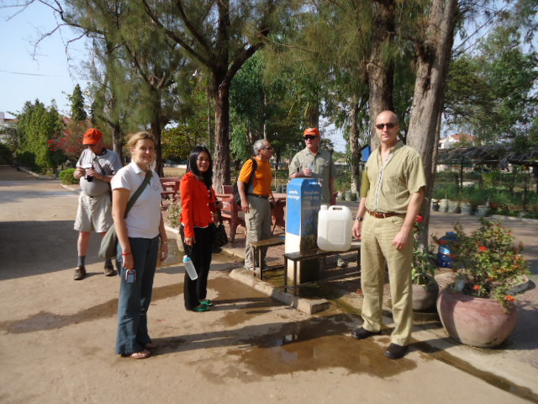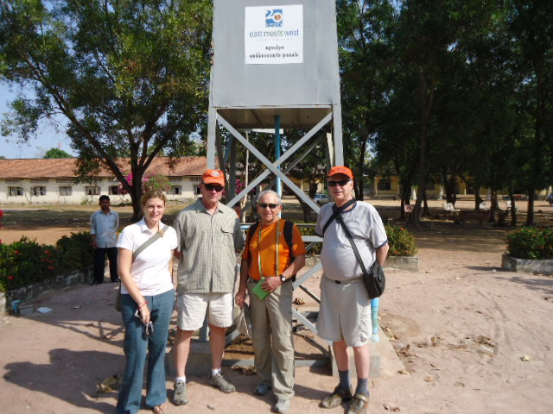
Inspecting water system at Soramarith High School

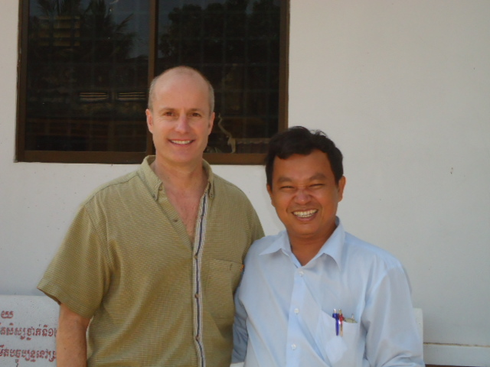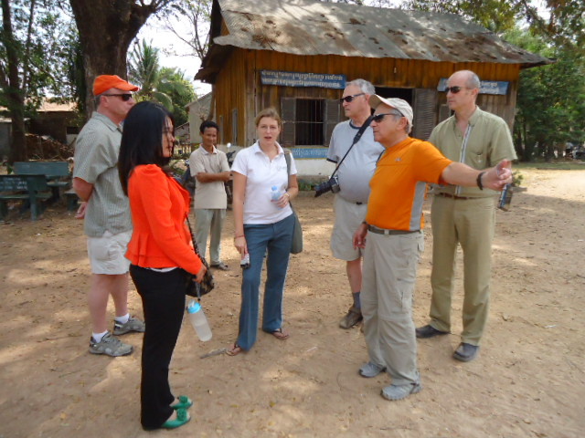
Meeting Principals at Soramarith High School and Salalek 5 Primary School

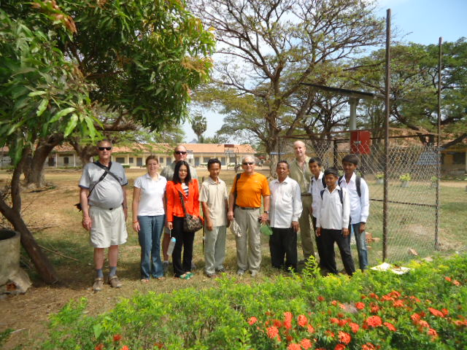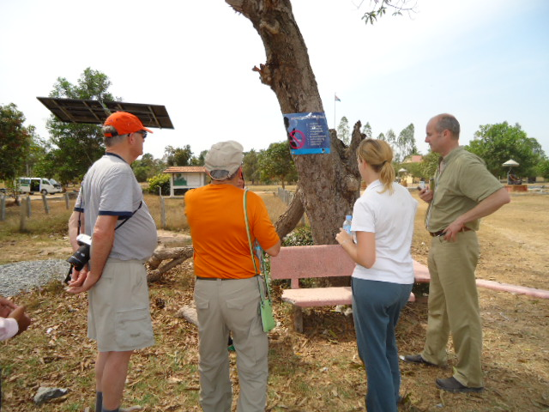
Inspecting system at Salalek 5 Primary School and Hun Sen High School and Kampong Tralach Secondary School

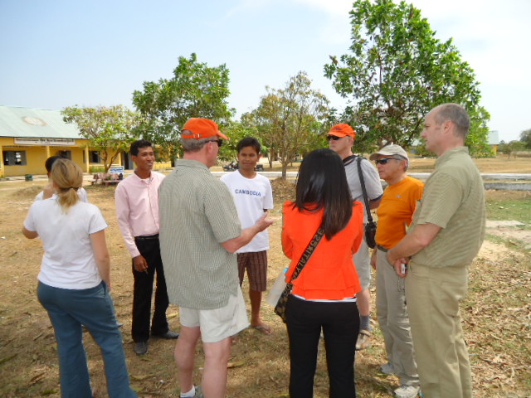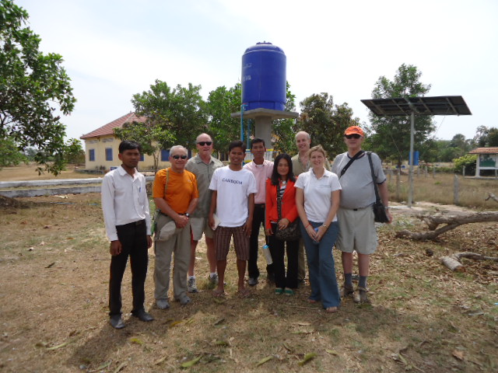
Discussing with school teachers and inspecting system at Hun Sen High School and Kampong Tralach Secondary School

