Field Trip Plan and Report

I. Program Information
Activity | Construction Supervision
Program Name | Clean Water – Kampong Tralach Schools
Report Author | IV Bunthoeun
Key Program Staff | Kim Hor, IV Bunthoeun, & Carys Everett
Program Location(s) | Cambodia
Travel Date | 25-26 December 2012
Report Date | 26 December 2012

II. General Description

Instructions: Describe what you plan to do, i.e. key aims, objectives, expectations, and / or activities.
Construction supervision for solar and pipe installation at schools, meet School Water Management Committee.

III. Activity Summary

Instructions: To be completed following field visit
Water management committee members from both schools were trained in managing and maintaining the water pipe and solar pump system. The water management committee members cooperated with and supported the contractors throughout the construction works.

During the construction work (preparation for pipe installation) at Salalek 5 Primary School, the existing well collapsed. The school director paid to drill a new well approximately 1.5m from the existing (collapsed) well. Both schools also funded boxes to protect the solar water pumps, and the primary school installed security fences around the solar panels.

By the end of 26 December 2012, the solar pumping systems were completely installed and functioning well, but the pipe system are still in progress and is expected to be completed the following week.

IV. Detailed Activity Report

Instructions: To be completed following field visit
Salalek Pram Primary School
IV met with Mr. Phonny Phorn, (School Director), In Tha, Thou Vanthol, Chhum Raty, and Kim Sothea (School Management Committee Members).

During the construction work (preparation for pipe installation) the existing well collapsed. The school director paid to drill a new well approximately 1.5m from the existing (collapsed) well. The new well is 19 m depth, 60 mm diameter casing, 27 mm diameter pipe. The cost of the new well was $140USD.
Salalek Pram Primary School also contributed one metal box, fencing, padlock, and foundation for the water pump for security. The cost of the box was 25,000 Riels = $6.25US (cm x 3 x 4 x 2).

The school confirmed the number of beneficiaries:
School children = 754
School teacher = 13
Total beneficiaries = 773

Hun Sen High School and Kampong Tralach Secondary School
IV met with Mr. Chhim Sara (Officer), Mr. Chhem Ryna (Teacher), and Mr. Naiy Kanol (Deputy Director). The school contributed one metal box with a padlock for the water pump for security. The cost of the box was 25,000 Riels = $6.25US (cm x 3 x 4 x 2).

V. Results / Follow up / Actions / Challenges
Item | Date | Who
The water pressure at some taps is low, particularly when several taps are running. IV informed and discussed with Mr. San You, SCV, he will take a look and advise on how to improve the filter system. IV will follow up with Mr San You and investigate the cost of purchase a new set of filter for each schools. | January | IV

VI. Photographs
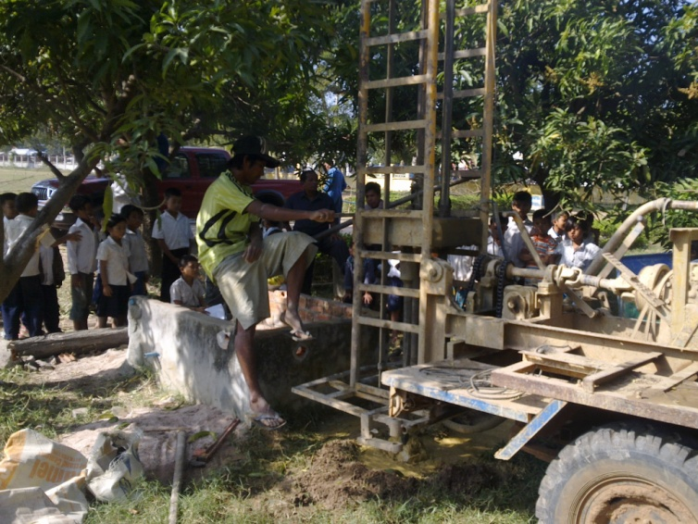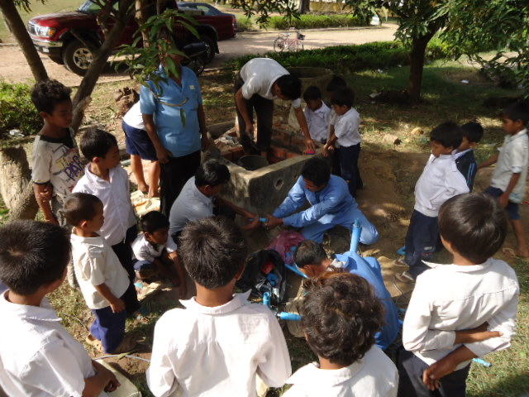
Drilling new well at installing pump at Salalek 5 Primary School

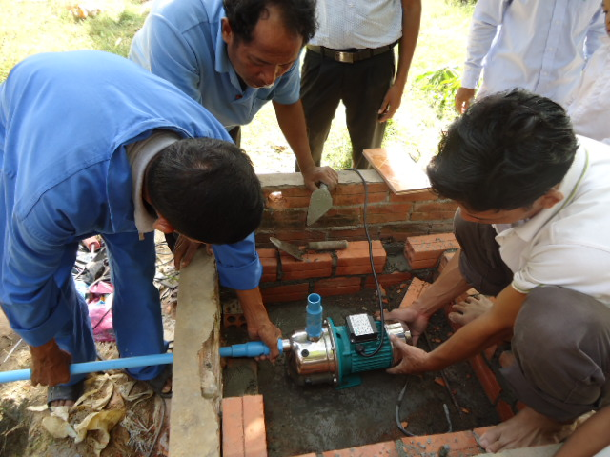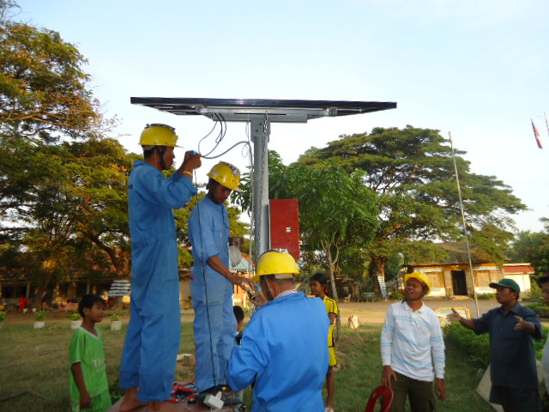
Installing pump and solar panels at Salalek 5 Primary School

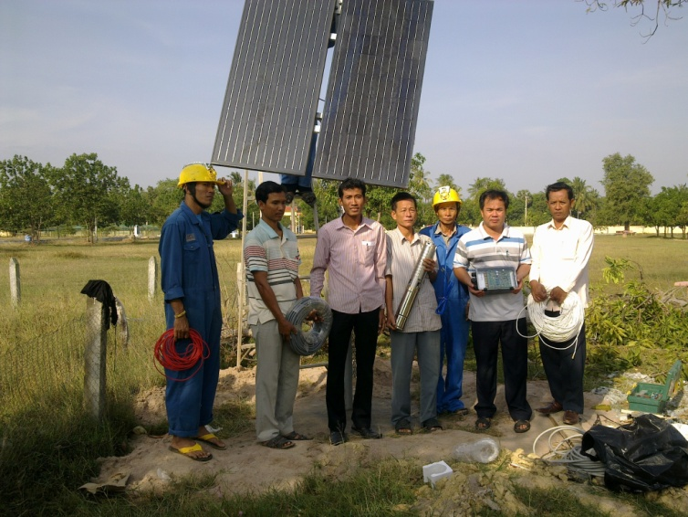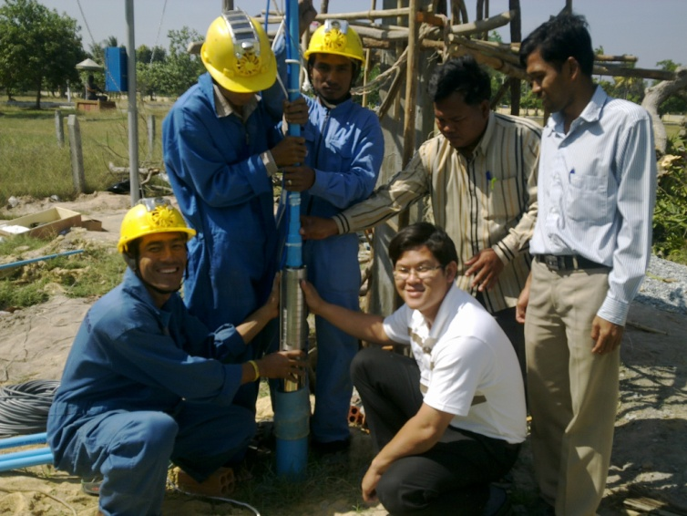
Installing solar panels and pump at Kampong Tralach Secondary and Hun Sen High School

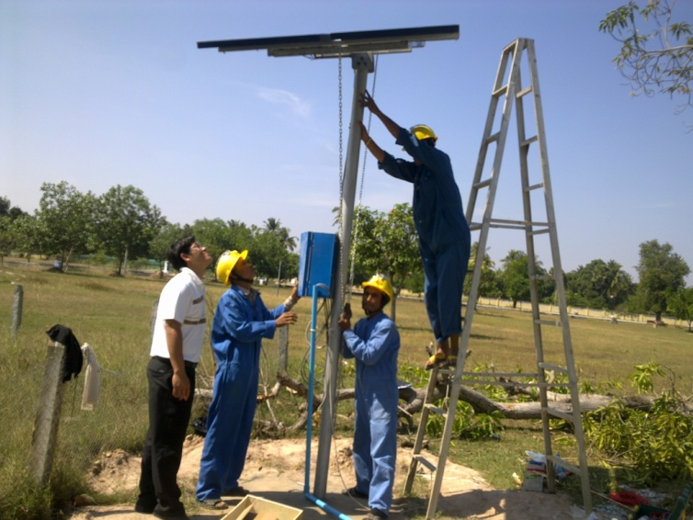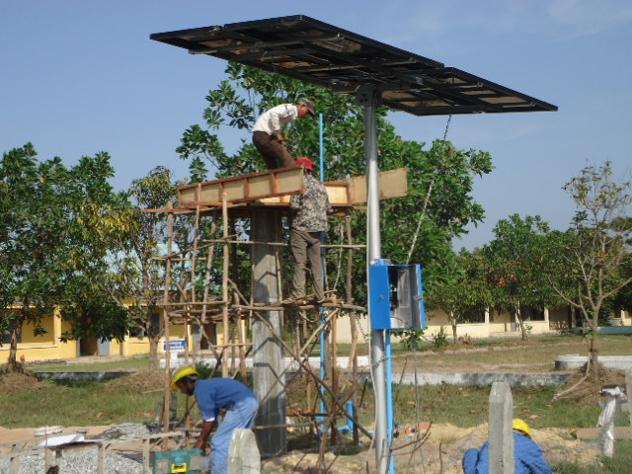
Installing solar panels and constructing elevated platform for water tank at Kampong Tralach Secondary and Hun Sen High School

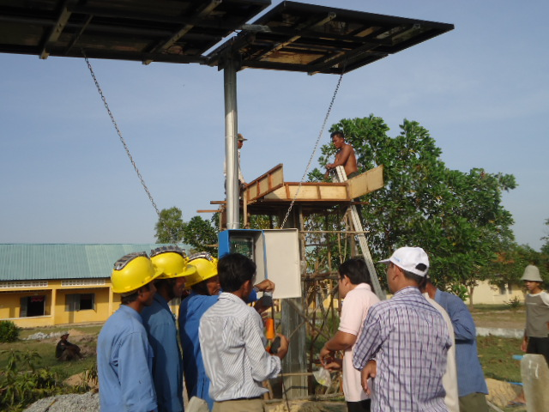
Training teachers on use and maintenance of solar pump at Kampong Tralach Secondary and Hun Sen High School

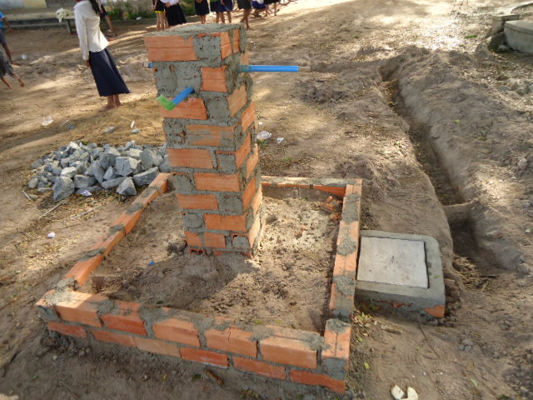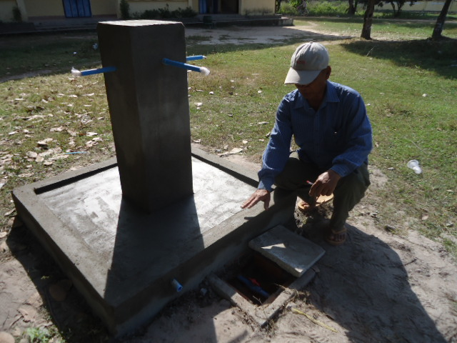
Construction of tap stands

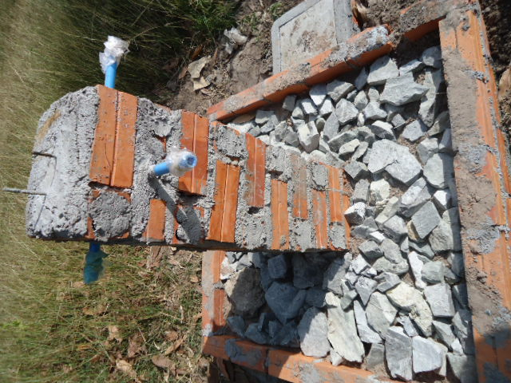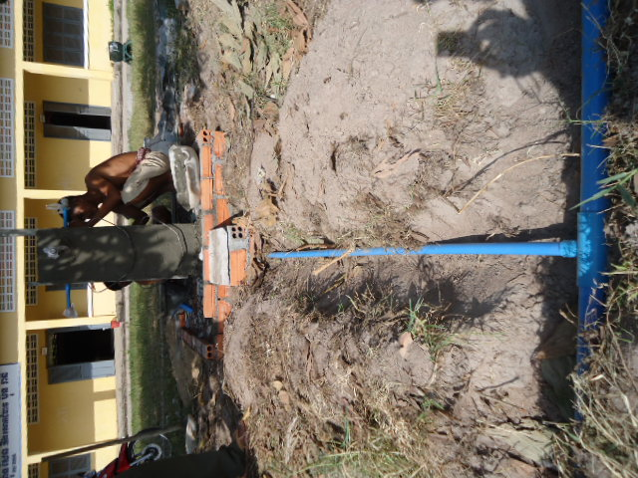
Construction of tap stands

