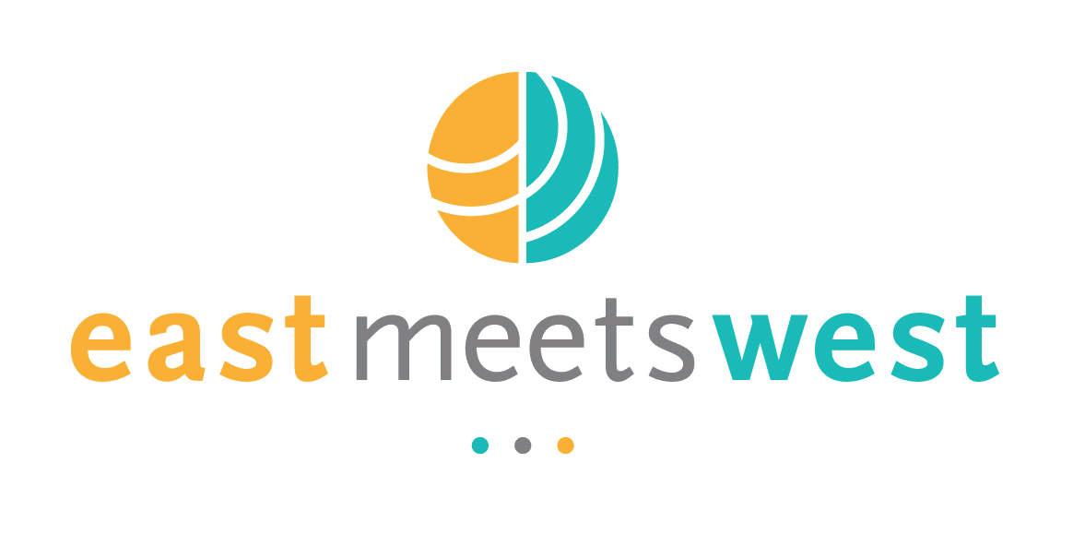
Field Trip Plan and Report

I. Program Information
Activity | Water sampling and installation of additional filters
Program Name | Clean Water – Kampong Tralach Schools
Report Author | IV Bunthoeun & Carys Everett
Key Program Staff | Kim Hor, IV Bunthoeun, & Carys Everett
Program Location(s) | Cambodia
Travel Date | 08 October 2012
Report Date | 09 October 2012

II. General Description

Instructions: Describe what you plan to do, i.e. key aims, objectives, expectations, and / or activities.
Review of existing water supply at all schools, discussion with school regarding tap locations and project progress, collect water samples from primary school and secondary school for additional water quality tests.

III. Activity Summary

Instructions: To be completed following field visit
At the primary school the teacher informed us that the existing (unused) well near the northern building was drilled for water quality testing by another NGO in 2008. The well is approximately 60m deep, but the school doesn’t know anything about the water quality testing results. The school currently uses another shallow well (approximately 15m deep) which is pumped to an elevated storage tank using a portable diesel pump. The water is filtered by two small membrane filters located in the office building and drinking water is available at two taps, one inside and the second outside the office. The filters and tank were installed by SCV social enterprise in 2011. A second well, approximately 24m deep located near the water tank, has a hand pump and is currently used for non-drinking purposes (i.e. watering flowers). We collected a sample from this well for testing.
The secondary school has a similar set up, provided by the SCV social enterprise, a shallow well is connected to the water tank with 3 filters to provide drinking water, again with only 2 taps for students near the office buildings. The collapsed well has not yet been re-drilled, therefore we were unable to collect a sample.

IV. Detailed Activity Report

Instructions: To be completed following field visit
As above

V. Results / Follow up / Actions / Challenges
Item | Date | Who
- Contact SCV social enterprise to arrange meeting  - Investigate options to modify existing water supply system, rather than installing a new system, i.e. expand system to provide more taps and provide solar powered pump at each school | October  October | IV  IV

VI. Photographs
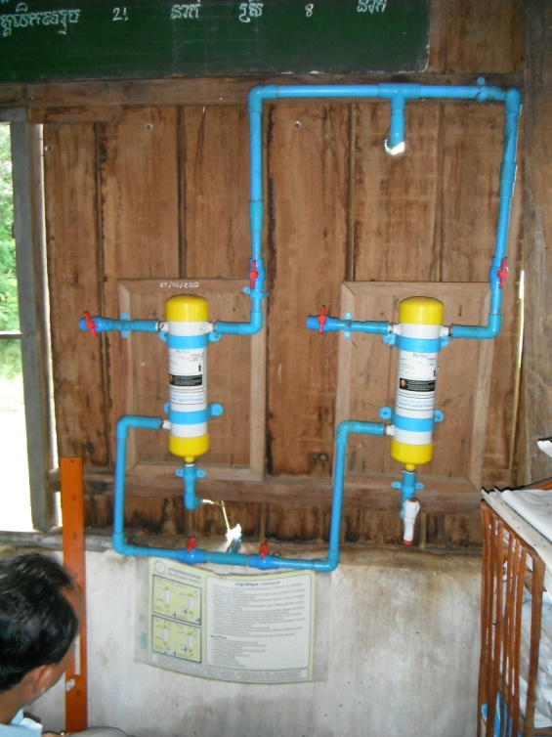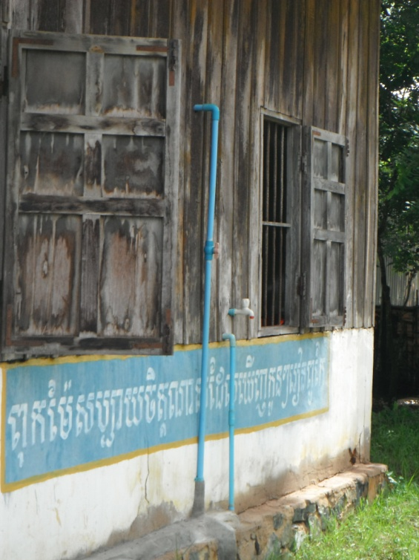
Existing water filters provided by SCV with one tap inside office and second tap outside for students

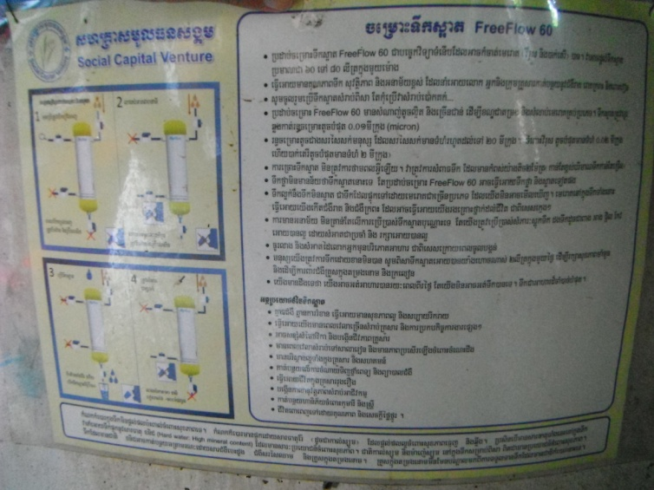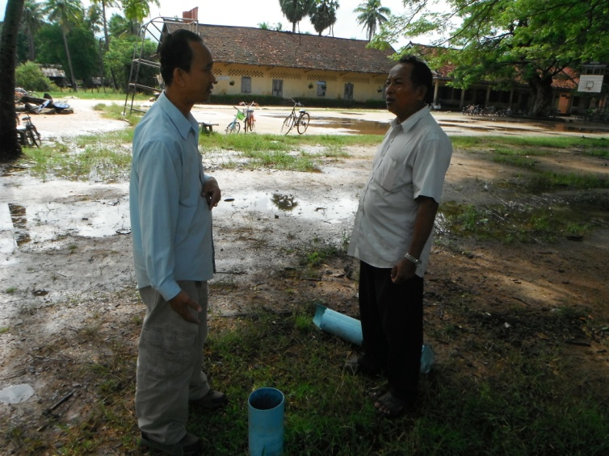
Instructions for use and maintenance of filters, discussing existing unused 60m deep well with school

