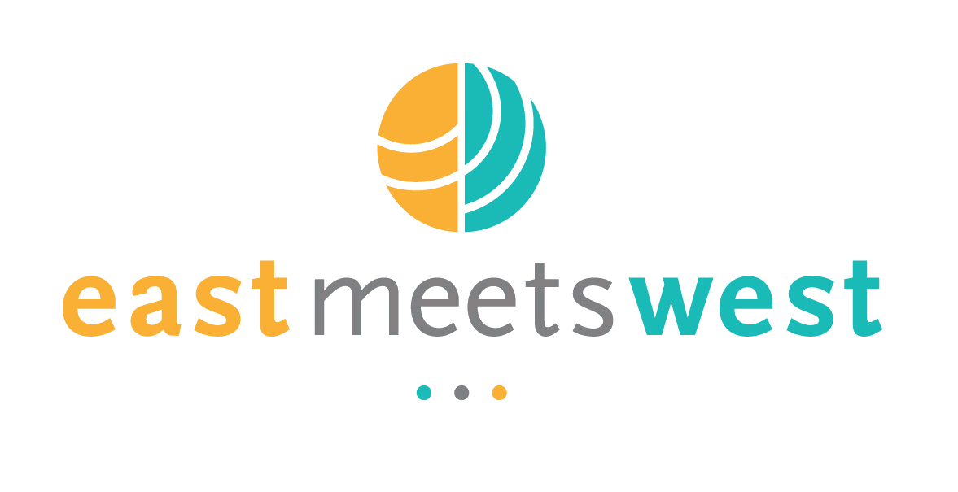
Field Trip Plan and Report

I. Program Information
Activity | Water and Sanitation User Group Study Tour
Program Name | Clean Water – Andoung Snay
Report Author | IV Bunthoeun
Key Program Staff | Kim Hor, IV Bunthoeun, & Carys Everett
Program Location(s) | Cambodia
Travel Date | November 13, 2012
Report Date | November 23, 2012

II. General Description

Instructions: Describe what you plan to do, i.e. key aims, objectives, expectations, and / or activities.
EMW collaborated with Gret to conduct the study tour visit for 5 WSUG’s member to visit two pipe water supply systems in Talorn and Prek villages, Treay Slar commune, Saang district, Kandal province.
- Pipe water supply system running by community
- Pipe water supply system running by private sector
Aim:
To educate the WSUG about operation and maintenance of community piped water supply systems.
Objectives:
- To visit existing community based pipe water supply systems and meet the operators to learn lessons from them regarding challenges related to operating and maintaining the system.
- To develop relationships between Andoung Snay WSUG and other existing operators, and to create support network.

III. Activity Summary

Instructions: To be completed following field visit
The WSUG have a clear understanding of the issues and challenges faced during operation and management of a water supply system. They also learnt about methods to encourage the community to connect to the system, potential technical issues, dealing with maintenance issues, collecting fees, leakage in pipes / meters, and understanding how to build communication between their networking groups for assistance.
The WSUG emphasized that they are so happy with this opportunity to visit those pipe water supply system and get a clearer understanding of the importance of water and sanitation for community health and improve people access to safe drinking water. They said that these two site visits were very helpful and useful for them.

IV. Detailed Activity Report

Instructions: To be completed following field visit
Participants
- Mr. Iv Bunthoeun, EMW Clean Water Project Manager
- Mr.Mam Deth, Engineering Gret Organization
- Mr. Yos Vuthy, Chairperson of WSUG
- Mrs. Sor Vuthy, Vice Chairperson of WSUG
- Mrs. Van Phearum, Accountant of WSUG
- Mr. Nhoun Ladang, Member of WSUG
- Tort Sopharin, Member of WSUS
- Mr. Leak Mengly, Chief of pipe water supply at the community
- Mr. Khinh Tayveng, Chief of pipe water supply at private sector
During the visit to both systems the WSUG had gained more understanding regarding, the operator’s experiences of operation, maintenance, fee collection and information relating to the management of the water supply system.
During the visit to the water supply system operated by community the following information was gathered:
- 1 Manager
- 2 labors (salary = $120usd each)
- Treay Slar village, Talorn commune, Saang district, Kandal province.
- Supported by UNICEF ($29,930USD)and Liberte Egalite Fraternite ($31,683USD) and CC Talorn CC and Khporp CC ($5,200USD) , PALEPAC program implemented by GRET
- The project started in 2009
- Connection fee per household is about $30 dollars
- Total HH is about 3,000HHs
- HH connected is 700HHS
- Fine is about 2500Riels = $6.25usd when they connect to another house without permission (reconnect)
- Cost per cubic meter is 1,800 Riels = $0.45usd
- Average water use of each family from 3-5 cubic meter per month
- Water source is surface water (river)
- Cleaning sand filter tank every week
- Every day monitor and maintain on pipe system and the is a call from community when there is something found
- They use only 1 form for monitor and collect payment from community (invoice).
- There is no BY Law but they like contract paper or regulation.
- Water leaking and losing is about 300 m3 per month
Operation:
- There are 3 pumps (1 to pump water to water treatment plant, 1 to pump water from storage tank to tower tank and 1 as reserve)
- They use Chlorine for killing bacteria
- They use alum for flocculation to improve settlement performance
- Water treatment plant Size 3 x 12 x 3
- Tower tank can store 28m3
- Tower tank is 15m high (12 m up to the lower part of tank and 3 m high of tank)
- Monthly income is about 4,500,00 Riels = $1,125usd
- Monthly expensed is about 3,160,000 Riels =$790usd
- Give to CC $300usd per year and sometime the CC gave back for connection for the very poor families (pay for connect fee and then poor family respond for the amount of using every month.
During the visit to the water supply system operated by private enterprise the following information was gathered:
- Location: Prek Baltichhing village, Trery Slar commune, Saang district, Kandal province
- 1 Manager
- 4 labors (salary = 550,000 Riels is about $137usd)
- Supported by GRET and USAID
- The project started in 2009
- Connection fee per household is about $35-$40 dollar
- Total HH is about 3,800 HHs
- HH connected is 2400 HHS
- Fine is about 2500Riels = $6.25usd when they connect to another house without permission (reconnect)
- Cost per cubic meter is 1,700 Riels = $0.425usd
- Average water use of each family from 3-4 cubic during rainy season and 8-9 cubic meter during dry season per month
- Water source is surface water (river)
- Cleaning sand filter tank every week
- Every day monitor and maintain on pipe system and the is a call from community when there is something found
- They use only 2 forms. 1 for monitor the use of Chlorine and alum and 1 for collect payment from community (invoice).
- They have business license for their private company and contract with Gret.
- They did not know of water leaking and losing because they did not use volumetric meters to monitor. They have just install volumetric meters this month.
Operation:
- There are 6 motor pump (1 to pump water to water treatment plant, 1 to pump water from storage tank to tower tank and 3 for pressuring water for distribution in case the distribution pressure is not strong enough and 1 for reserved)
- They use Chlorine for killing bacteria
- They use alum for flocculation cut up performing
- Water treatment plant Size m x 3 x 18 x 3
- Tower tank can obtain 32m3
- Storage tank size m x 4 x 17 x 2
- Tower tank is 12m high
- Monthly income is about 25,000,00 Riels = $6,250usd
- Monthly expenses are about 5,000,000 Riels =$1,250usd
- Electricity used per month = 2,000KW x 1,200 Riel = $600 usd
- Fuel per month = 30l x 4800 Riels = 144,000Riels =$36 usd
- Building cost for tower tank was approximately $15,000 usd, storage tank was approximately $10,000 usd, and Treatment plant approximately $27,000 usd, and the pipe distribution system about $250,000 to $300,000 usd

V. Results / Follow up / Actions / Challenges
Item | Date | Who
Discuss additional training requirements with WSUG  Confirm any forms / documentation required for the operation and maintenance | November  November | IV  IV

IV. Photographs
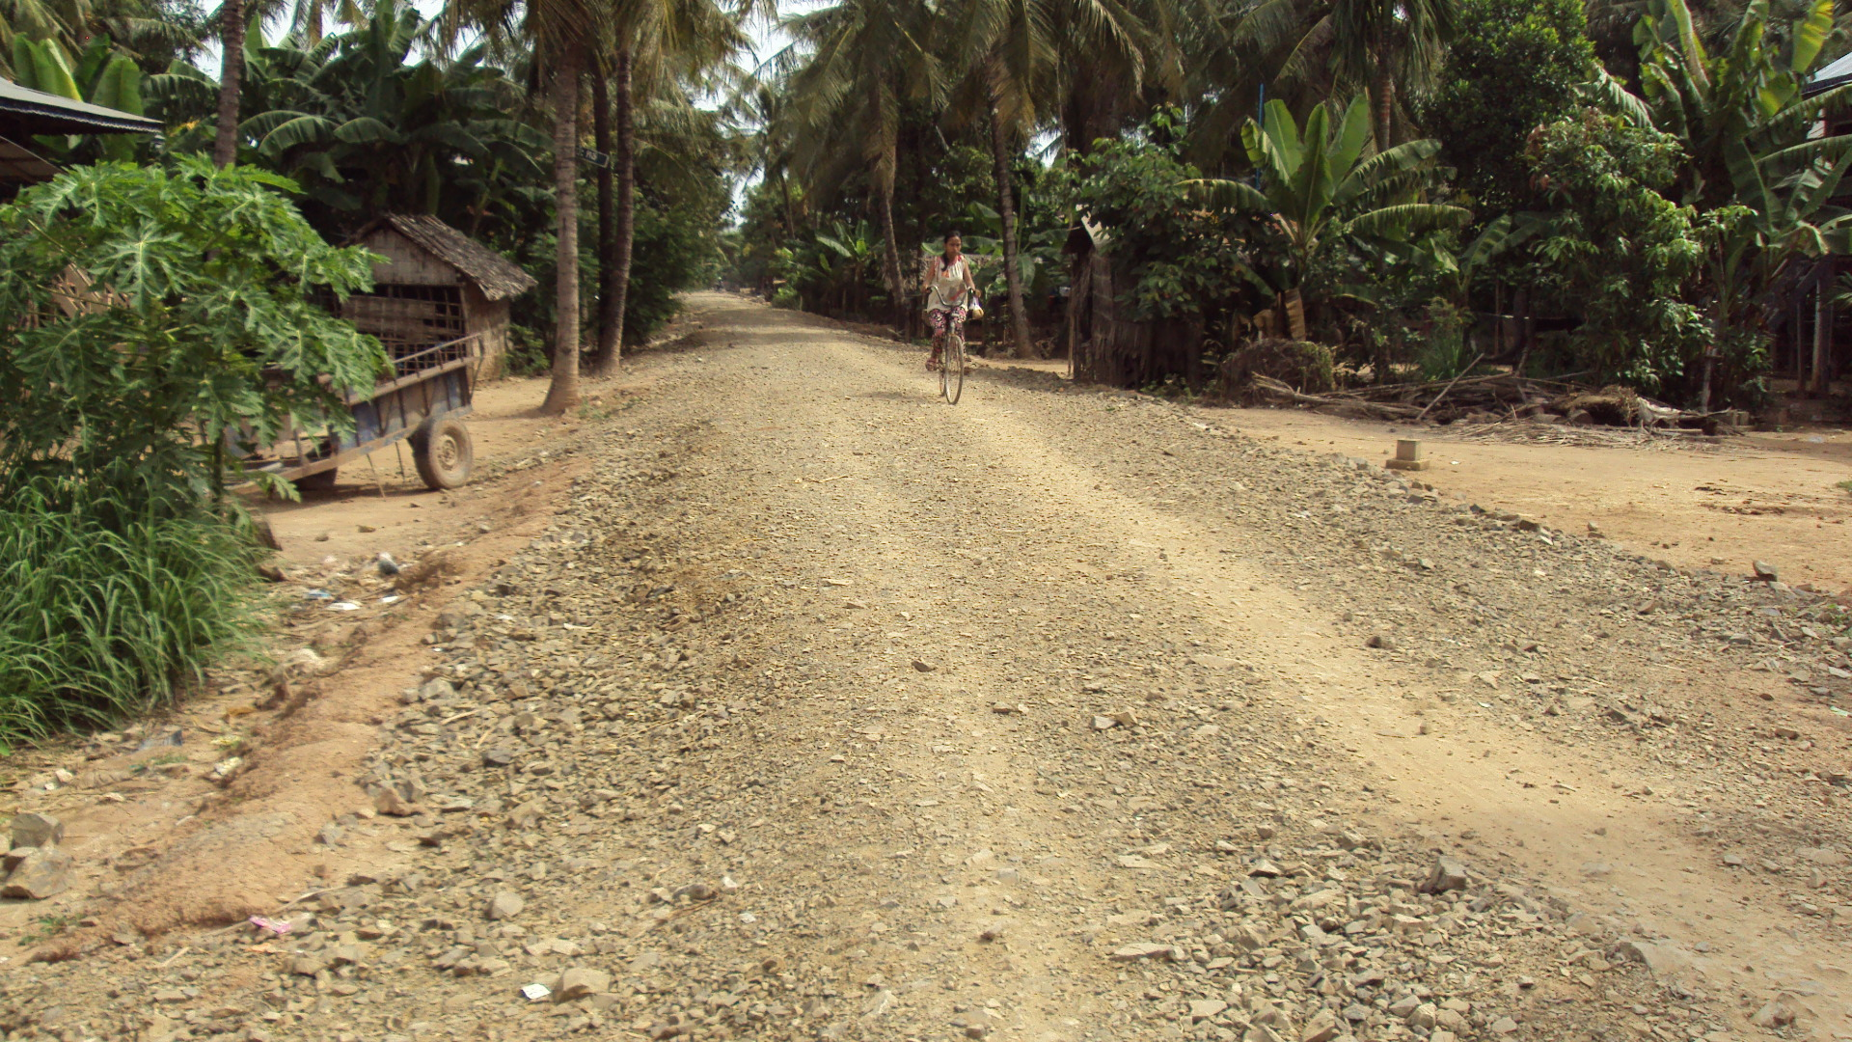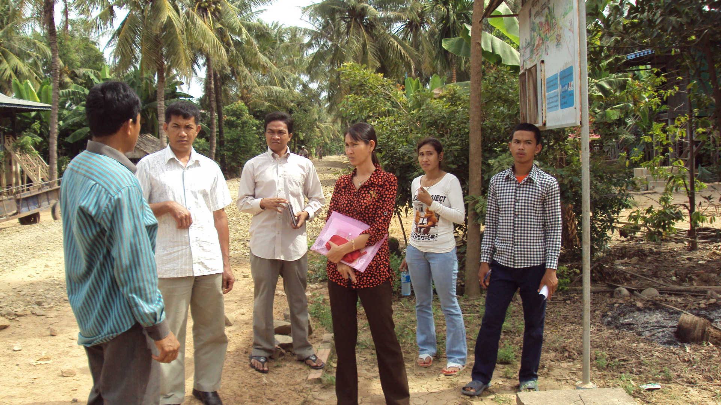
Mr. Leak Mengly, Chief of pipe water supply at the community explained pipe water supply system to WSUG.
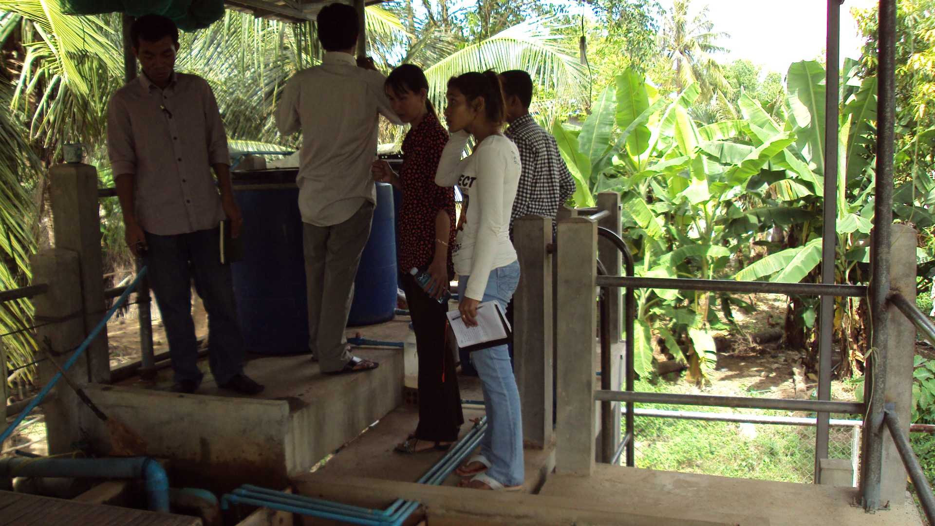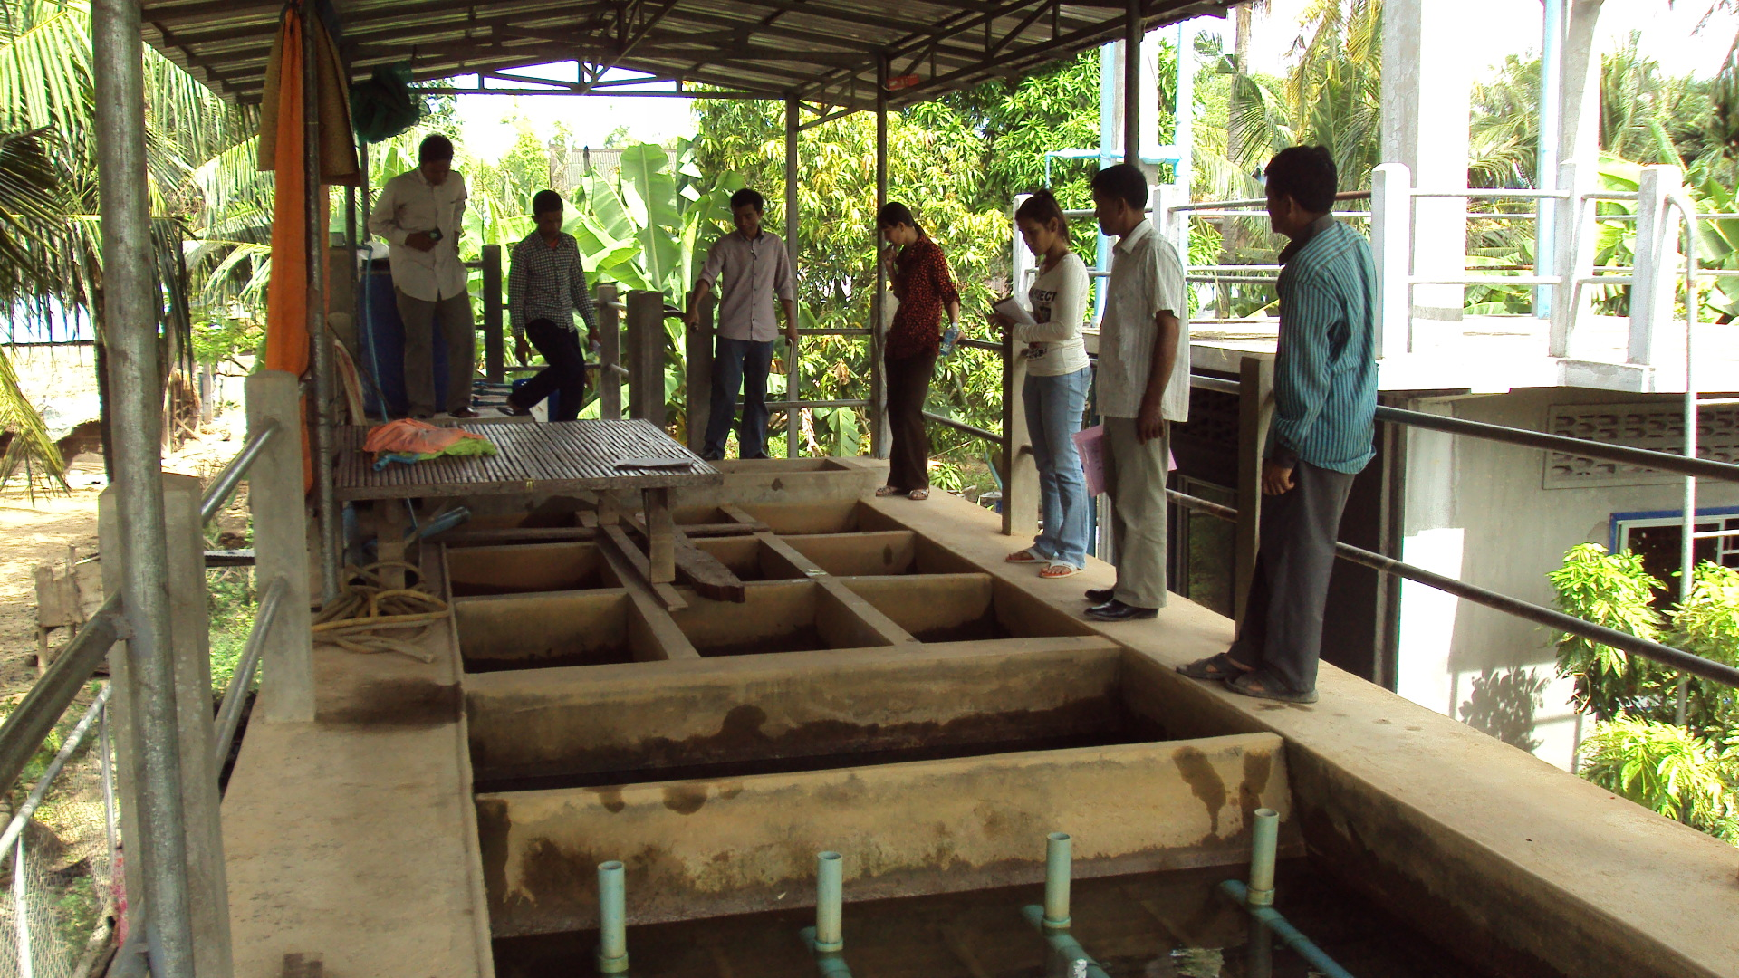
Mr. Khinh Tayveng, Chief of pipe water supply at private sector, explained the pipe water supply system to WSUG


