Main Activity Report:
Introduction Meeting: 04.04.2012, Wednesday
- Palmyra project Officer and Field Worker have introduced about the sanitation activity which is supporting by PWX, Bangalore for the development of the rural area.
- There are 15 members from various SHGs were presented in the meeting.
- Explained about the possibility of construction of septic tank with toilet to provide the sanitation facility at individual household level.
- The participants said that they will have discussion with their family members and inform in the next meeting.
- Palmyra explained about the contribution, availability of space, willing to utilize the toilet, physical work contribution during the construction of toilet like curing, making dig for septic tank, etc.

Village level Meeting: 15.04.2012, Sunday
- Palmyra field worker participated in the village level meeting to discuss about the interest for identification of the beneficiaries.
- They have selected 10 members to start the activity as a first stage.
- The beneficiaries were chosen based on the space availability, patta for housing area, willing to contribute, approach Block Development Officer to access Govt. fund for sanitation activity.
- The people had contradiction about the construction. Either fix one Mason with One Helper or individual household can construct the toilet by themselves with their own people.
- Beneficiaries are expecting to construct by themselves. Some of the beneficiaries have completed construction of house under the Govt. program, that has balance materials of bricks, sand, jelly, they feel that they would like to use the material for toilet construction work.
- The beneficiaries will invest Rs.10,000/- as their own fund, after completion of the toilet work, the individual beneficiary will apply to the BDO to claim the toilet cost .

Formation of User Group in Endiyur Village for implementation of th activity in the village
Date: 21.04.2012, Saturday
- Project Officer and Field worker from Palmyra facilitated the meeting for Beneficiaries with Mason & helper with Engineer.
- Engineer (Beneficiary Husband) who helped for preparation of the sketch / drawings for the toilet with estimate for construction of one toilet. The estimate is given below in table 1.
- Some beneficiaries would like to construct with simple method with low cost. Few members felt that the septic tank should be cleaned 2 years in once, so it can be little bigger for more than 5 members in a family/joint family.
- One member said that the kadappa slap can be fixed on top of the septic tank which will absorb the heat and not disturb the top of the septic tank
- The Mason asked Rs.7000 as a labor for construction and completion of one toilet with septic tank including plumbing, door work.
- Beneficiaries were requested him to do the work at the rate of Rs.6000/-
- As per the request of individual beneficiary, If Mason does any additional work like bath room facility, increase the size of septic tank for joint families, the additional labor will be paid by them.
- Participants made request that they can construct the toilet as per the design with estimate. Palmyra can organize doors, toilet sink, pipes and fittings only.
- During the construction Palmyra do the facilitation work to complete the work properly.
- Palmyra will have link with the people from starting the activity to use the toilet.
- Palmyra also will help the people to receive the grant from the BDO with proper application form.

Tentative Budget is Prepared by Beneficiaries with Mason, Engineer & Palmyra Staff
Materials | Price in Rs.
Bricks (4000) | 16,000
Sand (2 Units) | 4,000
Cement (12 Bags) | 3,960
Jelly (0.25 Unit) | 600
Iron Rod (8/10mm = 120 Kgs) | 1,800
Labor | 6,000
PVC Pipe | 660
Pan | 600
PVC Bend, coupling | 80
PVC L | 90
Pipe (aeration) | 300
Door | 1,000
Miscellaneous | 100
Total | 35,190
Funds Mobilization | Amount in Rs. | %
Palmyra Contribution | 16,500 | 47
BDO Contribution | 3,200 | 9
Beneficiary Contribution | 15,490 | 44

Attach Sketch: Prepared by local village Engineer (working in BDO office)
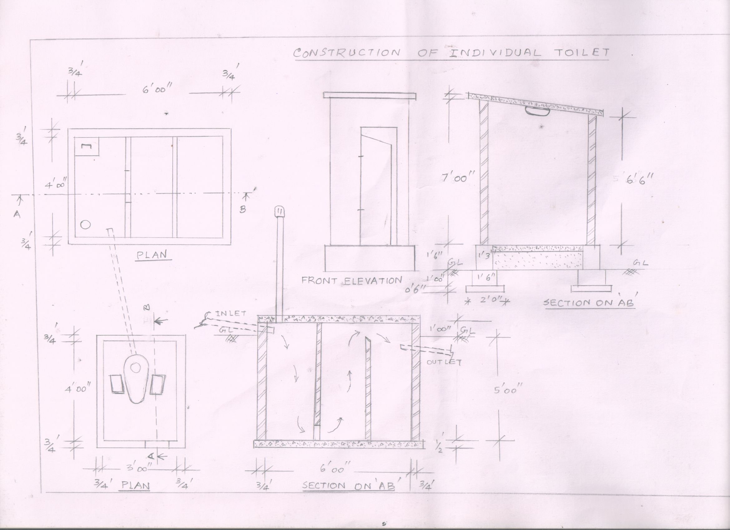

Progress as on 31.05.2012
Mrs. Ponnammal has completed the toilet construction work. She has spent an amount of Rs.40,000 for toilet and bathroom. Hired only Mason for 12 days and Paid Rs.6000 to him. Labour contributed by the household members.
She is a member of Vaigai SHG
Beneficiary Name | Mrs. Ponnammal (55)
Husband Name | Mr. Arumugam (60
Education | Illiterate
Occupation | Coolie
Elder Son | Balamurugan (34, 7th std, Coolie) +Vijayalakshmi (Wife, 8th std) )(25 + Daughter(1)
Second Son | Elangovan , Coolie worker (lorry loading, tar road labour, agri coolie) (31, 10th Std) + wife Pachaiyammal (23)
House type | Thatched Roof
Sources of Income from the joint family (3 families) | Rs.250/day for 1 earning member = Family 3 Male earnings = Rs.250 *15days*6months * 3 members = Rs.67500/annual Income. Rs.5625/Average monthly income . Female 2 persons earn Rs.40 (Rs.40x2female x 15 days x 4 months)day as agri labour. Rs.80/ (Rs.80*100=8000) day for NRGEA work for 1 person in a family.  =67500+4800+8000= Rs.80,300/- annual income earned by 3 families
Housing Type – Thatched Roof | 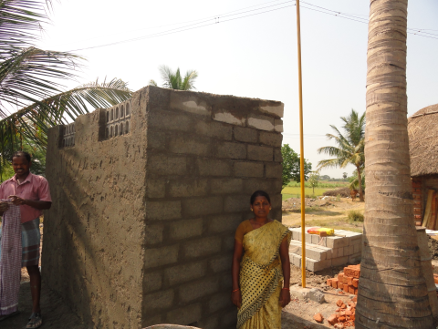  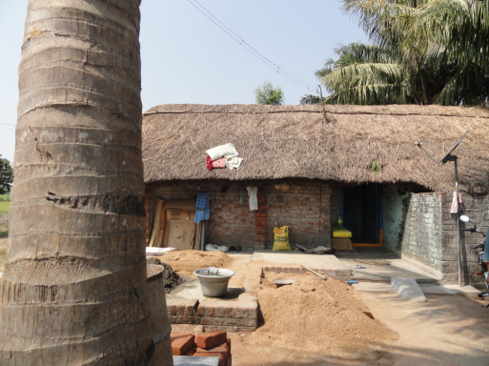  Toilet cum Attached Bathroom Construction in Mrs. Ponnammal House

Training on Importance and proper use of sanitation Facility and use of safe drinking water
Date: 02.06.2012
Place: School Building

Resource Persons:
- Mr. Munusamy, Village Panchayath President, Endiyur
- Mr. Sathiyamoorthy, Sanitation Officer, Block Development Office, Marakkanam Block.
- Palmyra Staff
Participants: 30 members participated in the meeting.
Discussion with members:
- Mrs. Tamilselvi, working group member has welcomed the participants for the meeting.
- Mrs. Dhanam, Project Officer, Palmyra given introduction about the importance of the sanitation and drinking water use and maintain the water bodies clean and water contamination due to human waste, field run of fertilizers, etc.
- Mr. Munusamy, Panchayath president has appreciated Palmyra activities implementation in the village for the welfare of the people. He has compared with the government sanitation program and the PWX activity and explained to the people to use the facility in a appropriate manner. He also requested to increase the number of toilet facility for the village. There are 1050 families living in main village of Endiyur (775)including the habitation of Kuruvammampet (275). There are 50 Households (Pucca House) having toilet facility. Palmyra is providing sanitation facility for another 25 poor families under PWX project. The PP requesting the PWX to increase the no. of sanitation facility to cover the entire village.
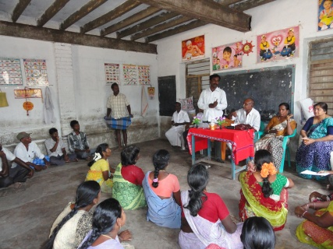
- Mr. Sathiyamoorthy, Sanitation Officer, BDO, Marakkanam Block informed that the people should use the toilet to avoid the open deification. He has suggested to the beneficiaries, after completion of the toilet construction, they can fill the prescribed application form and submit it through Palmyra to claim subsidy amount from BDO. He also explained about the personal hygiene and health aspects.

- The beneficiaries point of view: They feel happy to construct by themselves to organize only mason, helper role done by the family members, organized quality materials of bricks, sand and other materials, construction size, attached bathroom, etc. Mrs. Ponnammal family has completed the toilet. Mrs. Ponnammal with her Younger Son Mr. Elangovan was received cash through the village panchayaths president during the meeting. He said that he is very happy to utilize the toilet by 3 families’ together living in same house. He has designed and constructed according to their interest with attached bathroom facility. He thanked to the working group, Palmyra and PWX.
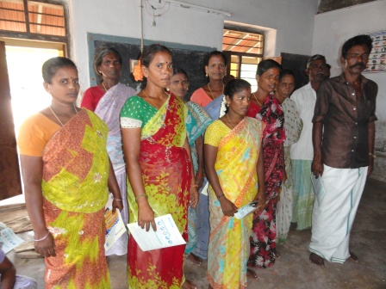
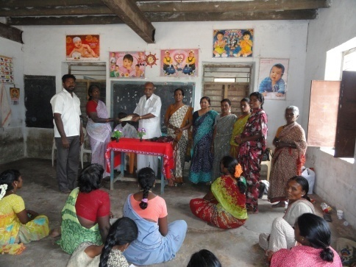

The panchayath President given cahs to Mrs. Ponnammal
10 Beneficiaries selected for first Batch
for Toilet construction under PWX Project

Apart from 10 beneficiaries, others made request to Palmyra to select them for remaining 15 toilets construction facility. Palmyra informed them that we will visit the beneficiary family and select the beneficiaries based on the criteria.

The meeting was ended in the afternoon.

27.06.2012:
Field Visit: Went with working group to all 10 beneficiaries to ensure the completion of construction of toilet. 9 toilets are completed, 1 is in completion stage. Photos are attached.

