AGUA PARA LA SALUD
PULAY WATER PROJECT

Final Report

Section 1: Organization Information and Project Overview

- Date: 22 February 2009
- Project Name: Pulay Water Project
- Implementation Community: Pulay , Nebaj, Dept. Quiche, Guatemala
- Name of Person(s) who completed this report: Lynn Roberts
- Name of Executing Organization (Partner): Agua Para La Salud
- Organization Contact Name: Lynn Roberts
- Address of Organization: Nebaj , Quiche, Guatemala
- Phone: 502-5775-0250
- Fax: 502-7755 8113
- Email: lynnrober@gmail.com
- Website (if applicable):

1. Type of project
X-- Water & Health Education
Sanitation (Latrines) & Health Education
Hand-washing stations & Health Education
Other (please describe):_______________________________________

- Please provide a brief description of the work completed and how it addressed the needs described in the project proposal.
The project was designed to solve a water shortage problem in the community by (1) installing a new spring and a 5 kilometer conduction line from this spring to existing tanks in the village. (2)Provide more storage for one of the sectors in the community with a 5 cubic meter storage tank serving 25 families (3) Improve storage in the main part of the village by repairing the two main storage tanks to close leaks in their bases. (4) Health education was carried out house to house and in public meetings.
(5) An additional project was implemented at the end of the main project as a result of remaining funds and the village’s willingness to fund extra work on the village water system. This project was reported on the PeerWater web site.

3. What other groups/sectors were involved in the implementation of this project?
NGO (name of organization)_________________________________________
Local Government (office) __________________________________________
Public Health Institutions/Clinics______________________________________
Private Sector _____________________________________________________
X-- Other (please describe ) The project was carried out with the help of the village water committee, village members, and village health promoters.
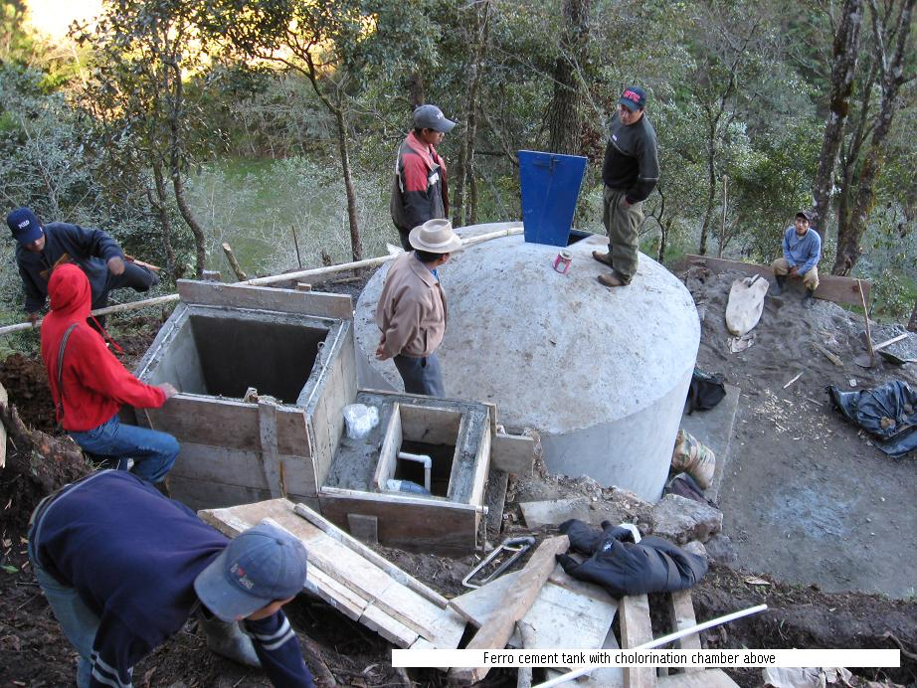
5 cubic meter storage tank and chlorination chamber above under construction

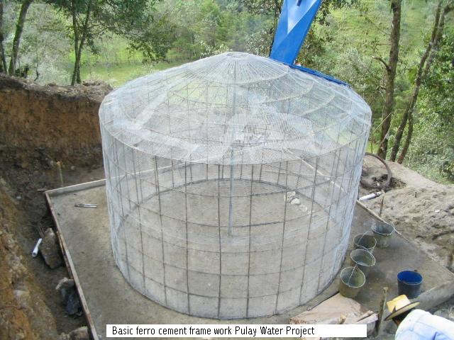

4. Will the community receive support from local institutions/organizations for ongoing assistance with health, water and/or sanitation efforts as a result of this project?
X-- Yes → a) What organizations/groups will provide support? Local health officials will continue the health promotion and APS will provide technical assistance upon request of the village.
b) What type of support will be provided? _______________________________________________________

No → Please describe why support from local institutions/organizations is unavailable. _________________________________________________________

5. As a result of this project is the linkage between the community and the institution/organization:
X-- New
Strengthened
Unchanged (same as before this project was implemented)

Section 2: Community Information (ALL REQUIRED)

1. How common are the following health problems in this community?

Health Problem | Very Common | Somewhat Common | Not Very Common
Gastro-Intestinal/Diarrheal | X
Skin Infection |  | X
Respiratory Infection | X
Malaria |  |  | X
Cholera |  |  | X
Dengue Fever |  |  | X
HIV/AIDS |  |  | X
Dehydration |  |  | X
Maternal Mortality |  |  | X
Infant Mortality |  |  | X
Eye Infection |  | X
Neurological Disease (Meningitis) |  |  | X
Other HUNGER SEASONALLY |  | X

- What water, sanitation, and health needs still exist in the community?
The most pressing problem in health in the community is education and bad hygiene habits. The government is sending nurses and technicians to the community to attempt a habit change along these lines.

Section 3: Health and Hygiene Education

- Total estimated number of adults that received health education:
900 adults ----- Visits were made to each house with a hygiene habits hand out and instruction. Most often the women are home and about 35% of the men attended the health class.

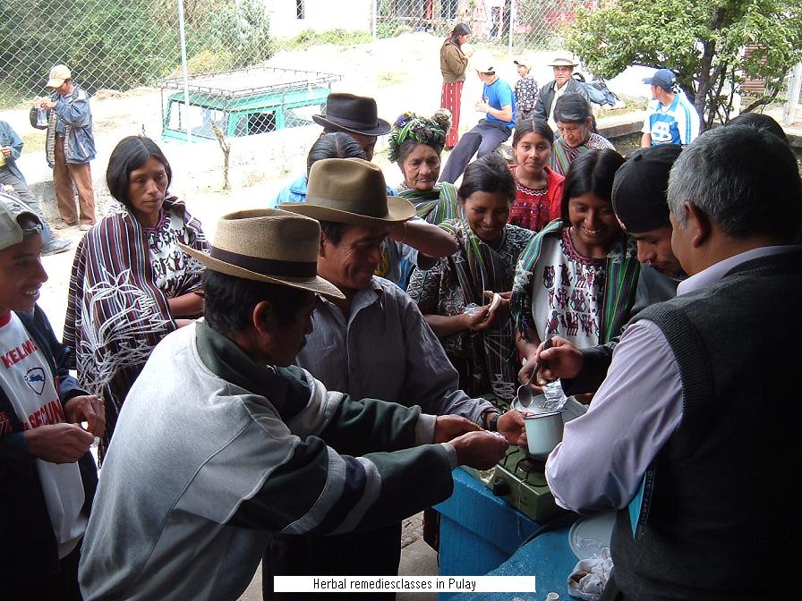
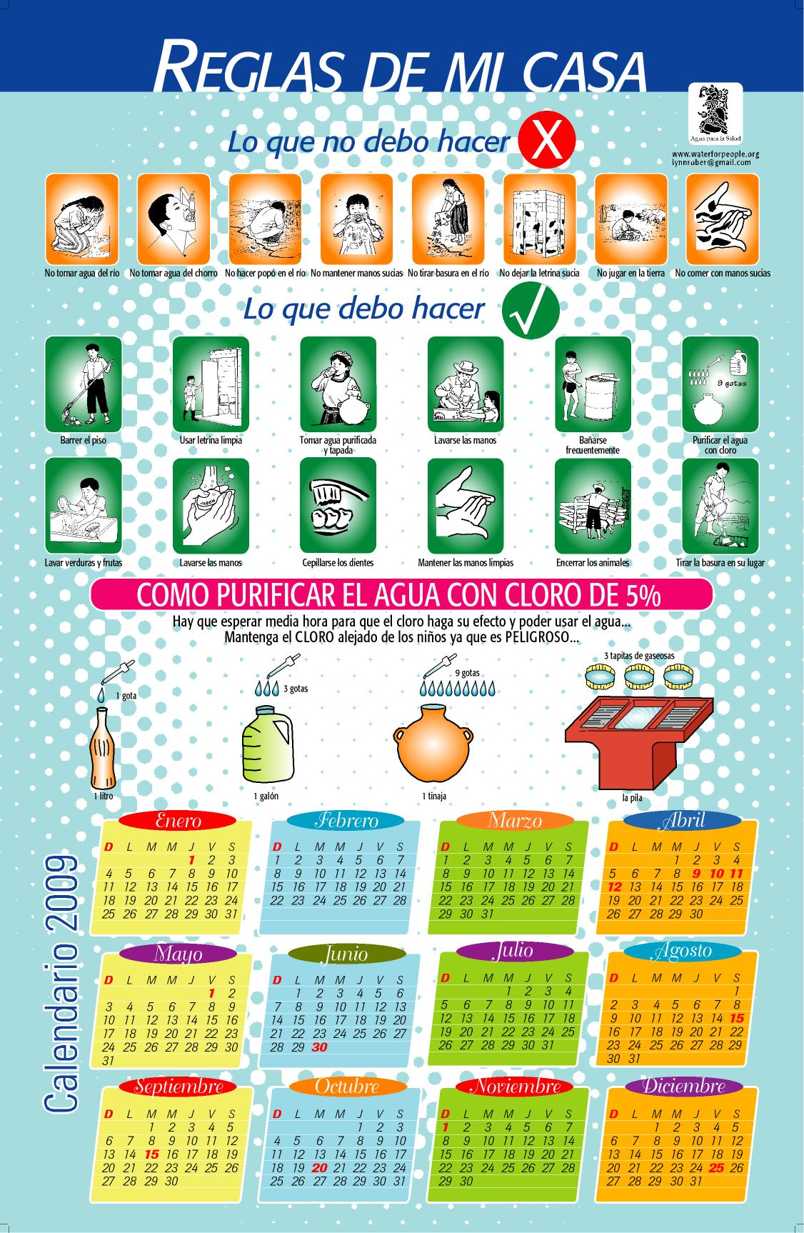
Instructional calendar used in the house to house health instruction

2. Total estimated number of children that received health education: About 400 children attend school and materials were given to the teachers to augment hygiene classes.

3. What were the greatest successes of the health and hygiene education efforts?
From our standpoint providing sufficient water supply to allow teachers , parents, and officials to teach healthy habits is our most successful accomplishment. In the initial meetings all of the villagers were reporting lack of water both in quantity and time available. At the close of the project all were reporting water available in sufficient quantities and available at all times.

4. What unexpected problems and challenges were encountered during the planning and implementation of the health and hygiene education? How were these problems addressed? The most serious problem encountered was the lack of attendance at classes and apathy amongst the population. Addressing this will take generations of constant reinforcing of good hygiene habits by teachers and government officials.

5. In the following table please identify whether or not the following topics were covered in the health and hygiene program:

Health and Hygiene Topic | Topic will be covered in the health and hygiene education component
Health and Hygiene Topic | Yes | No
Hand washing techniques | X
Proper food handling | X
Water treatment | X
Proper human waste disposal | X
Personal hygiene | X
Signs of infection |  | X
Signs of dehydration | X
Treatment of diarrhea | X
Parasites in water | X
Water and malaria |  | X
Water and animals | X
How to take temperatures | X
Proper garbage disposal | X
Natural and Herbal Remedies/  Traditional Medicines | X
OTHER- please list:

- Please identify which of the following methods were used to teach community members about health and hygiene and write the number of times each was conducted.
X--Household visits
X-- Workshops
X-- Classes taught in the school(s)____
Other (please describe) __________________________________

- What curriculum did you use?
X-- SARAR
Child-to-Child
Plays/Dramas
X-- Visiting Health Educator
UNICEF
did not use an existing curriculum, developed one for this project

8. Will health and hygiene education be continued now that WFP funds are used?
X-- Yes → What organizations/groups will provide support? There is a village health clinic run by the government that has nurses that come frequently to diagnose and give health classes.
No → Why not? ___________________________________________________

Section 4: Water System
A. Overview of Project Implementation and Outcomes
1. Number of people who use this water system for their drinking and cooking needs: between 1750 and 2000

2. Was the water system constructed and implemented as specified in the design submitted to PEERWATER?
x—Yes Some minor changes were made to the design to fit the terrain and facilitate the digging of trenches.
No → Why not and what changes were made?
__________________________________________________________________________________________________________________________________________

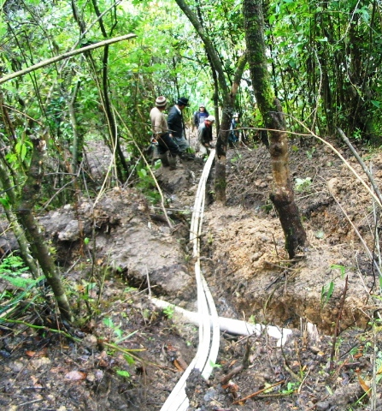
5 kilometer pipe line trenching

- What were the greatest successes of the implementation of this water system?
The water provided by the introduction of the third spring source into the distribution system served to pacify all of the villagers who were in the beginning before the project complaining of constant water shortages. All report at the end of the project that they had water all day every day.
The calculations we made at the end of the project for the total flow from the springs indicated that they had sufficient water to at the rate of 80 liters per person per day for a population double the size ( 20 year growth rate of 3%)that exists today in the village.

- What unexpected problems and challenges were encountered during the planning and implementation of the water system? How were these problems addressed?
At the end of the project there was less water coming into the distribution tanks then was the case before the project. The villagers along with our engineer when into the mountains and found that an outside construction company had cut the main line from the old spring to use the water to wash sand for a construction project. They left without repairing the line. After the repairs all the houses received water.

5. Have women’s water responsibilities changed since implementation of this project?
X-- Yes → In what ways? The women can now depend upon a water supply at their homes and do not have to visit the contaminated river to wash clothes and draw water for house hold use.
No

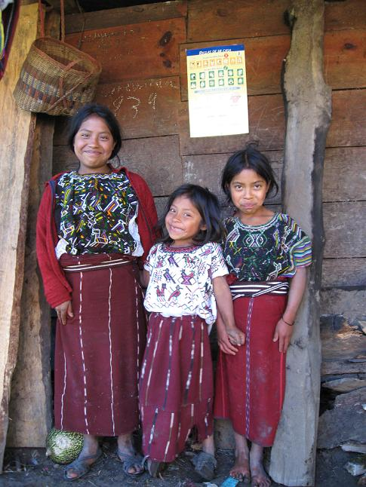

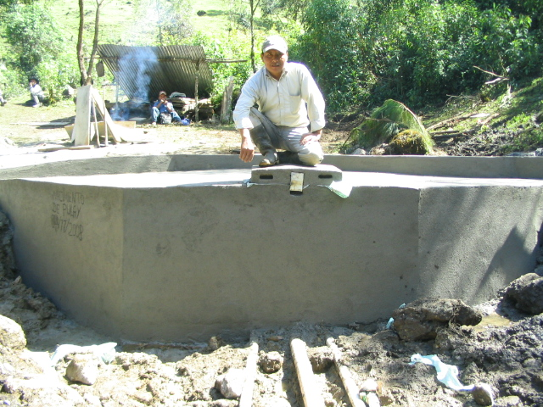
New spring box in Pulay with Antonio Cavinal Toma the builder of the structure

6. Approximately how many hours do women spend collecting water per day for household drinking and cooking needs? During scarcity of water in the past this activity could take several hours a day carrying water. Now this time has been eliminated and can be used for other activities such as care for children; house hold duties ; participation in health classes; economic activity; and participation in town meetings.

B. Operations, Maintenance and Technical Committee

7. Number of men and women on the water committee:
Men ---5
Women ---0
Men do admit that they consult their wives on matters of water since the women do most of the activities related to water use.
8. Do women occupy leadership positions on the water committee (such as president, secretary, treasurer, etc.)?
Yes
X-- No → If no, please explain why not.
It is a Mayan custom norm that women generally do not hold positions of authority at the village level. This should begin to change as the population becomes more educated.

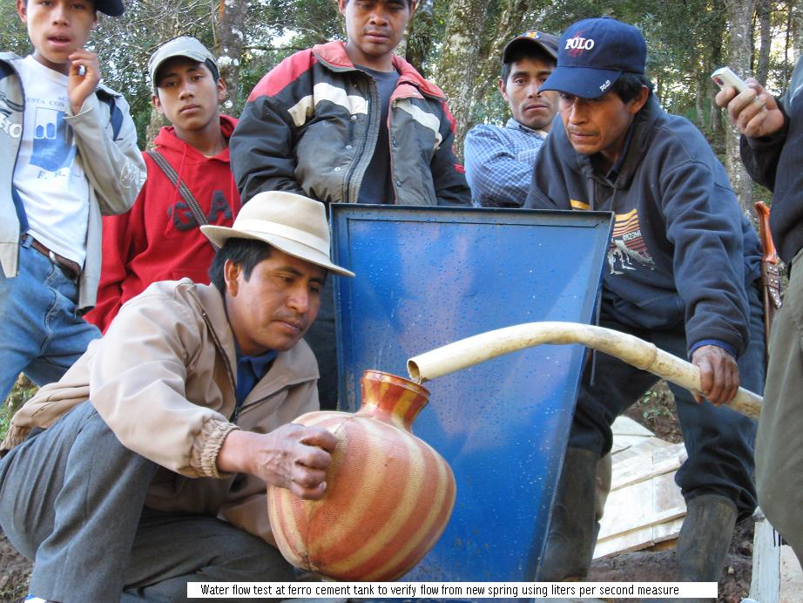
Water committee chairman measuring the flow from the new spring to the new 5 cubic meter ferro cement storage tank

9. Is the water committee responsible for:
  - Operations and maintenance of the water system
X-- Yes
No/No water committee → If no, who is responsible? ____________________________________________________________

  - Collection and management of water tariffs/payments and fund
X-- Yes

No/No water committee → If no, who is responsible? ____________________________________________________________

10. Has the water committee met at least once a month during project implementation to discuss water system issues?
X-- Yes

No

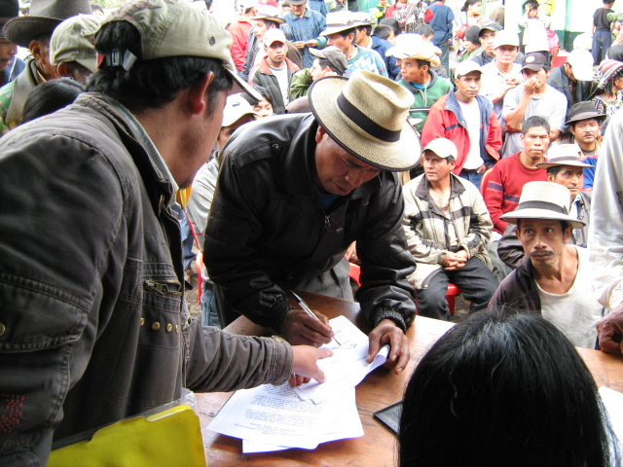
Decisions are made in public meetings and agreements signed by the entire community

11. Does the water committee have a formalized set of governing principles, rules and regulations regarding management and use of the proposed water system?
X-- Yes

No

12. Does the water committee have guidelines for operations, maintenance and repair of the system?
X-- Yes

No

13. Does the water committee have a process for training new individuals in operations and maintenance, if necessary?
X-- Yes

No

14. How is the community involved in major decisions regarding the water system?
Mayan communities make decisions by consensus in open meetings
15. Is a user tariff assessed to pay for repairs and maintenance of the water system?
X-- Yes

No → If no, how are repairs and maintenance paid for? __________________________________________________________________

16. Who determined the tariff/water payment?
X--- Community members
X-- Water committee
Other (please describe) ____________________________________________

17. How often are tariffs/water payments collected?
Monthly
Every six months
X-- Yearly
X-- Emergency
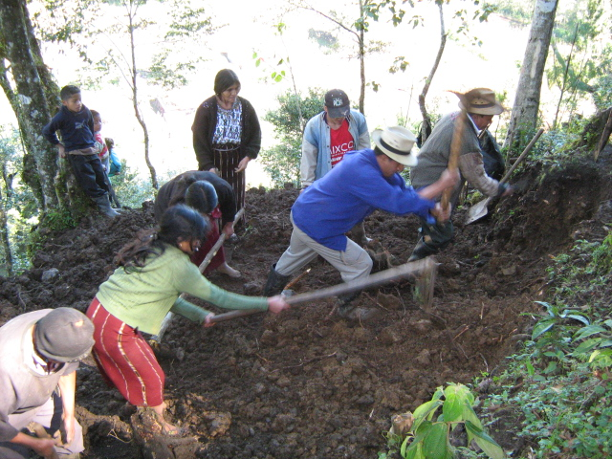
Preparing the base for the 5 cubic meter tank
18. Is there a formal process for the collection and accounting of water tariffs?
X-- Yes → Please describe:
Water committee keeps a book of all work done by individuals on the water system and who has paid their yearly fees.
No

19. Did the water committee open a community bank account for water funds?
Yes
X--- No → If no, why not? There have been several bank failures in the near past and people do not trust them.
20. Are water committee members trained in financial accounting and management of the water fund?
X-- Yes
No

21. How much money is currently in the bank account? ___0__ The village has a fund that has about Q5000.00 ($650.00)

Section 8: Project Budget

- Provide overall cost of entire project.
Funds allocated from PEERWATER EXCHANGE
Q200,174.05 | $26338.69

Local Currency cost of project Q184.090.26

US Dollars cost of project $24,222.40___________

- Please show a final breakdown of the following expenses:

SECTOR | AMOUNT IN US $$
Community Contribution | $3920.00
NGO Contribution | 0
Municipality Contribution | 0
PEERWATER Contribution | $24,222.40

3. Please provide a final budget and an itemized list of the breakdown of costs:
 | TOTALS-Q | $ | PERCENT
MATERIALS | 134189 | 17656.45 | 72.89
TRANSPORTATION | 2459 | 323.55 | 1.34
SALARIES | 27942.26 | 3676.61 | 15.18
HEALTH--CHLORINE | 0 | 0.00 | 0.00
COMUNICATIONS | 0 | 0.00 | 0.00
OFFICE | 13500 | 1776.32 | 7.33
HOTEL-FOOD | 6000 | 789.47 | 3.26
FREIGHT | 0 | 0.00 | 0.00
VILLAGE LABOR | 0 | 0.00 | 0.00
MEDICAL | 0 | 0.00 | 0.00
ADMINISTRACION | 0 | 0.00 | 0.00
SPENT | 184090.26 | 24222.40 | 100.00
DONACION | 200,174.05 | 26338.69
BALANCE | 16,083.79 | 2116.29

- Are there remaining funds? If yes, how much is remaining?
US Dollars $2116.00 Local Currency Q16,084.00

The funds remaining were used in an additional project now posted on the PEERWATER web site. This project was to make improvements in the distribution system and other springs in the village.

- Please attach all receipts from purchases made during the project’s implementation.
All receipts are in digital form and can be viewed upon request.

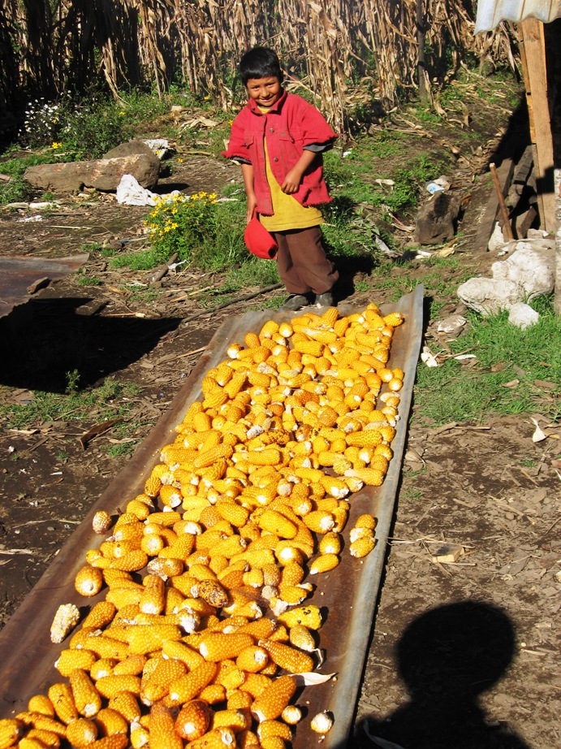
Corn harvest in Pulay



