Photographs of Project Field visit at Baap, Jodhpur

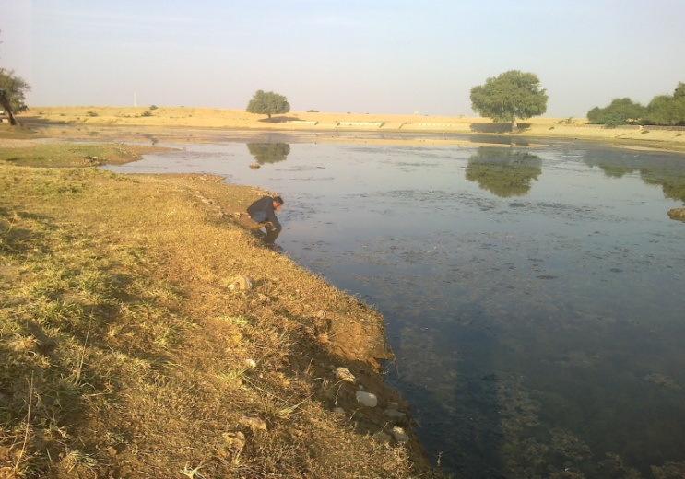  Village Naadi (Pond) at Bhartasar village | 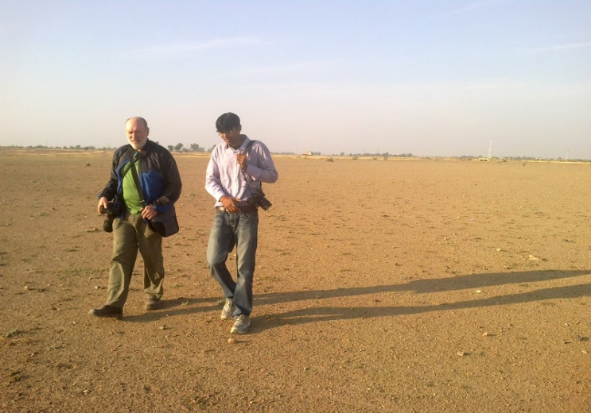  Observing the Naadi with large catchment area behind
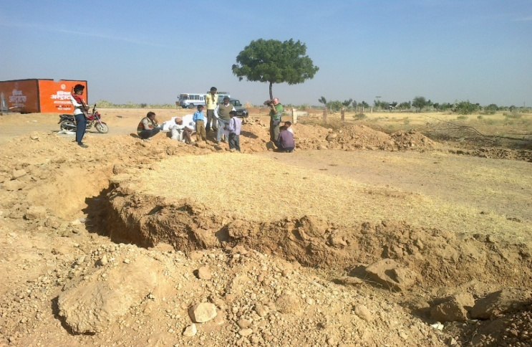  Discussion with the Team near the grinding mill | 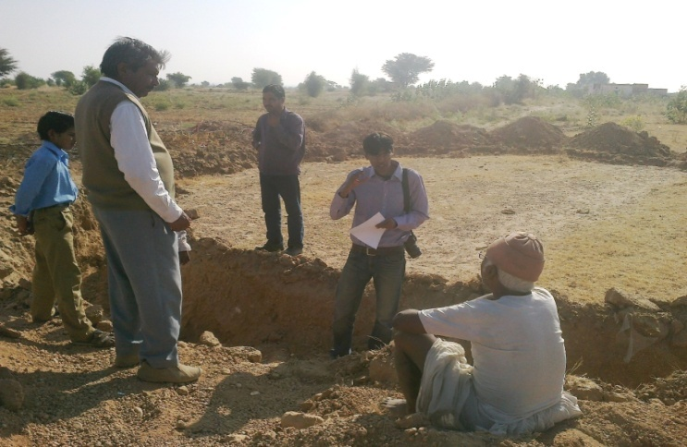  Shaurin discussing the process of grinding lime
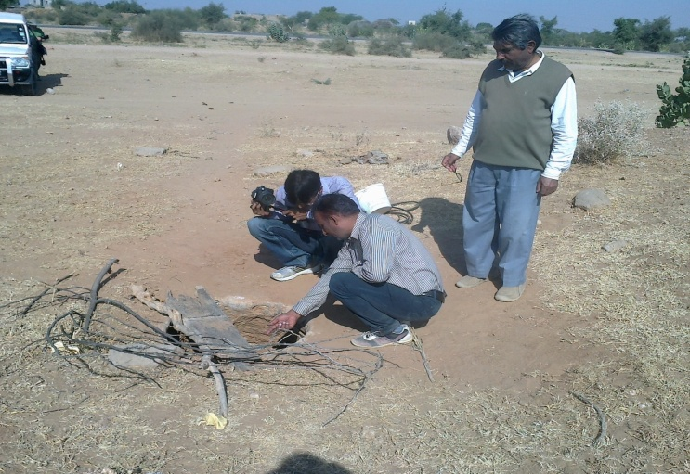  Observing the new Beri in Kishneri Village | 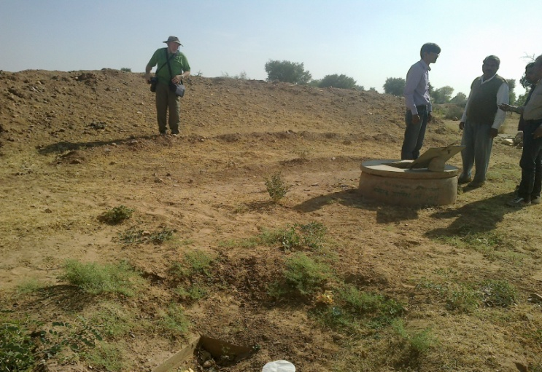  Observing the Beri with Cement Superstructure and silt catcher
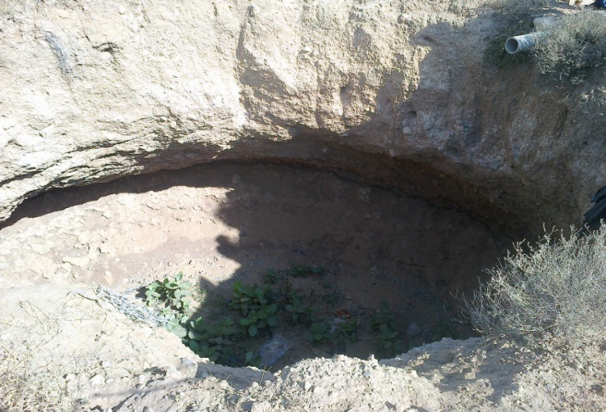  A collapsed Beri | 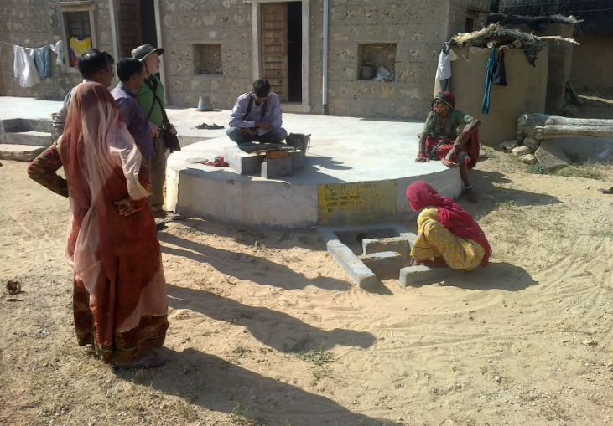  Observing the Taanka with catchment bed and silt trapper
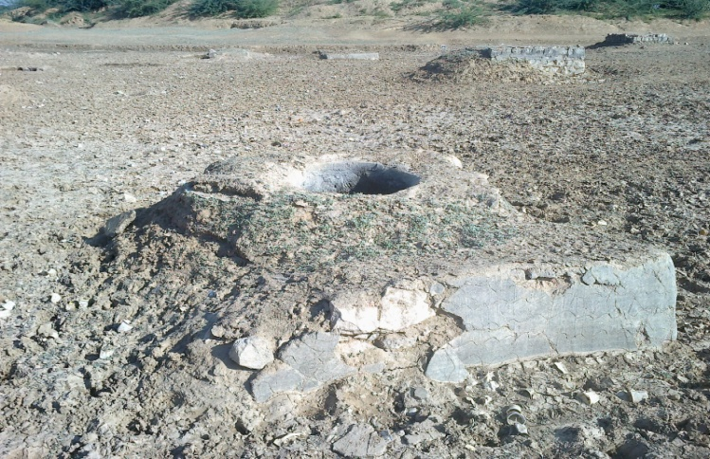  Open percolated Beri in the dried up Pond at Nokra | 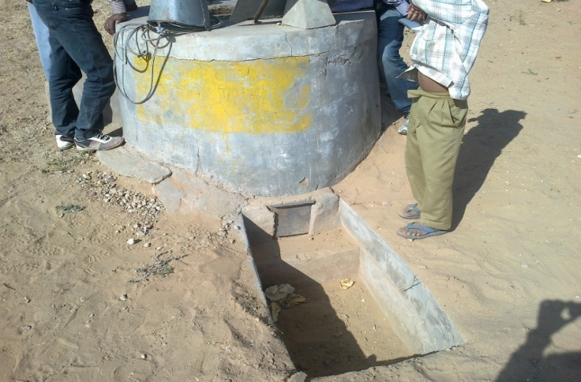  Rain water Harvesting Beri with super structure and silt trapper
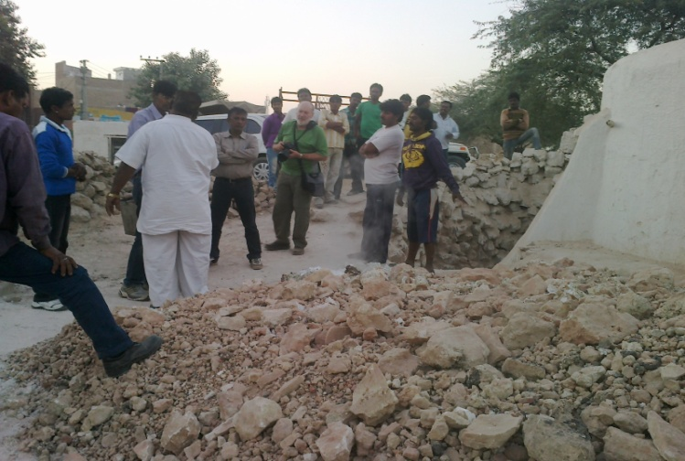  Understanding the process of lime preparation at Lime Bhatta in Bikaner | 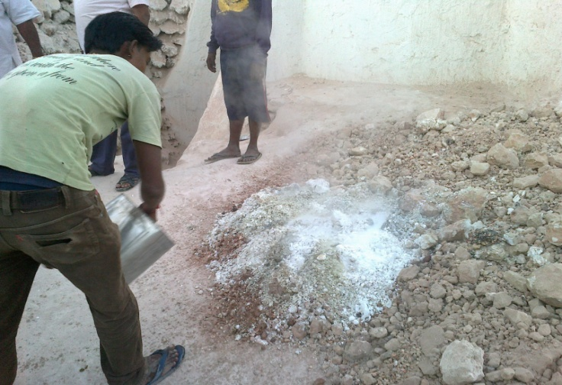  The limestone converting to lime powder after putting water on it
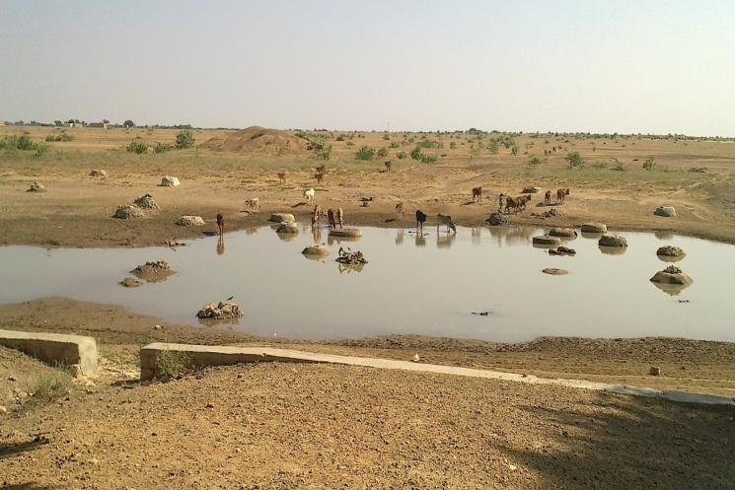  The Percolated Beries inside the Pond filled with water at Khetusar village | 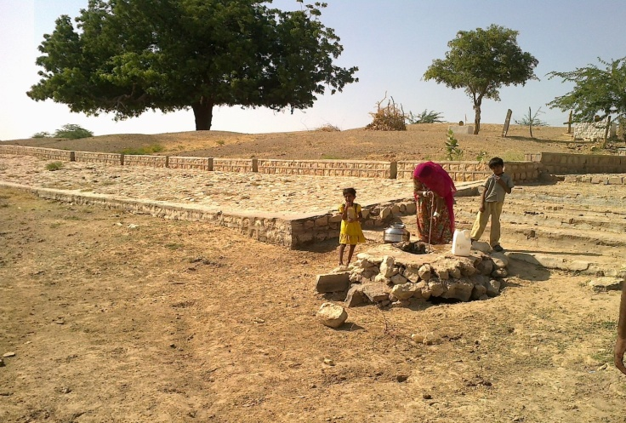  A women drawing water from semi structured Beri accessing water through steps built side of the Pond
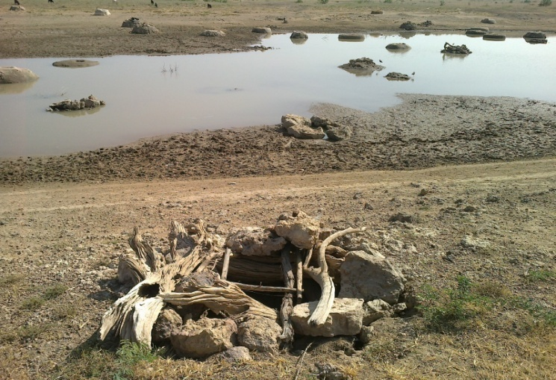  An uncovered Beri with numerous Beries in the pond bed | 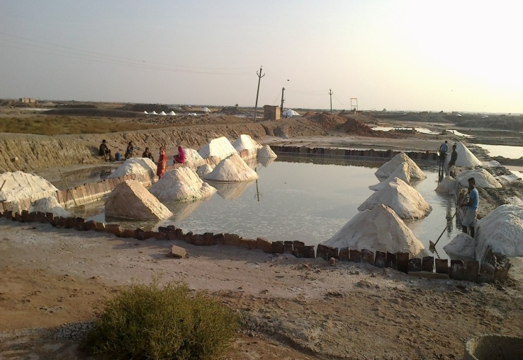  A Salt Mine at Reen village
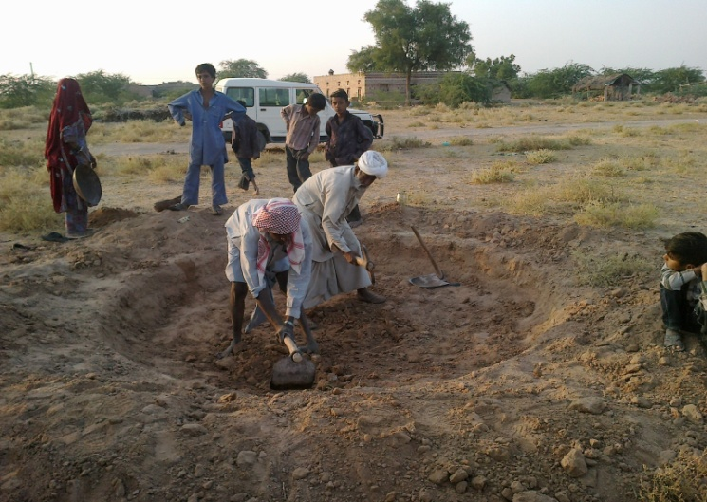  The pit digging for Taanka at Reen village | 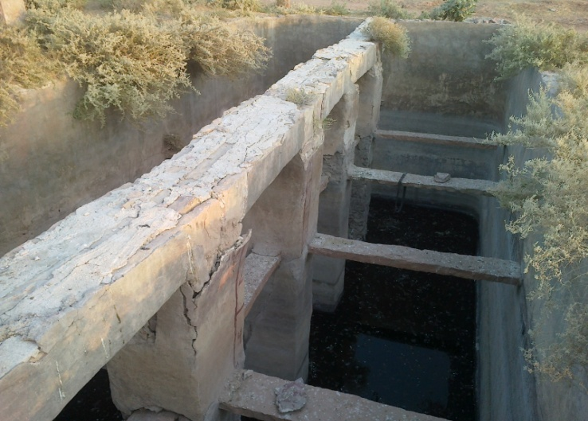  A disfunctional Taanka made of lime at Reen village

