Monitoring of water and sanitation programme:
Budusahi, January 2013

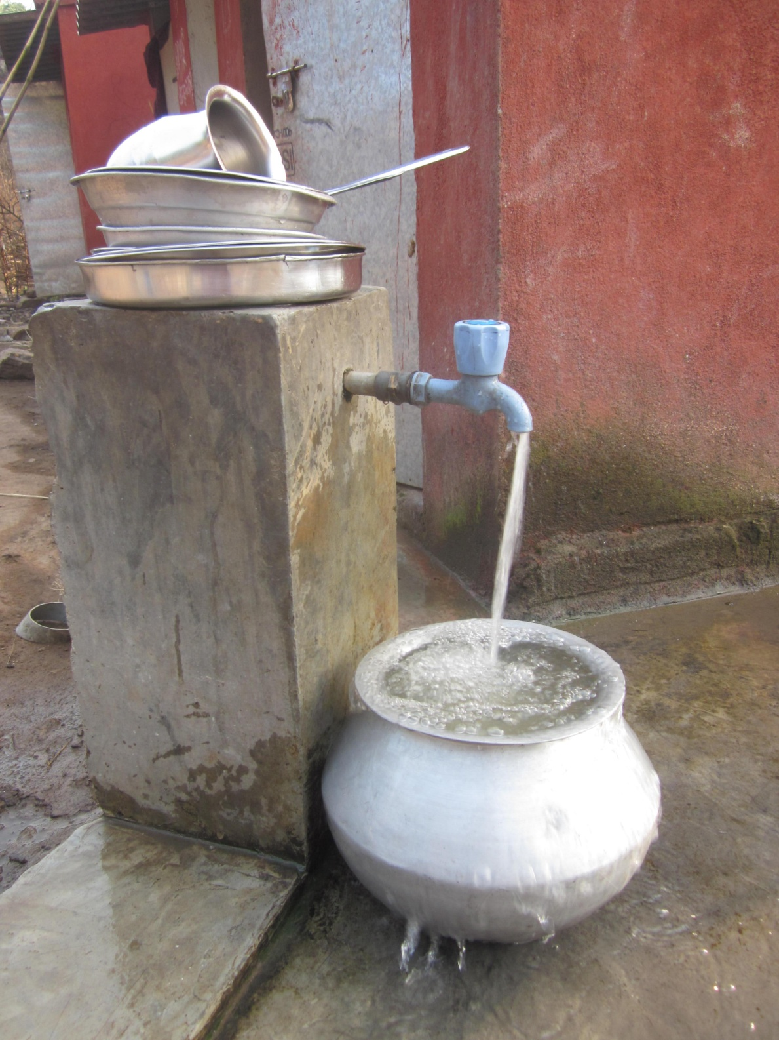
Table of contents:

- Village profile……………………………………………………………………3
- Process………………………………………………………………..................3
- Situation before and after project implementation……………………………...3
  - Water supply……………………………………………………………..3
  - Use and maintenance of facilities……………………………..................4
  - Benefits for women………………………………………………………4
  - Old customs: Restricting the scope for women to lead a life of dignity?..5

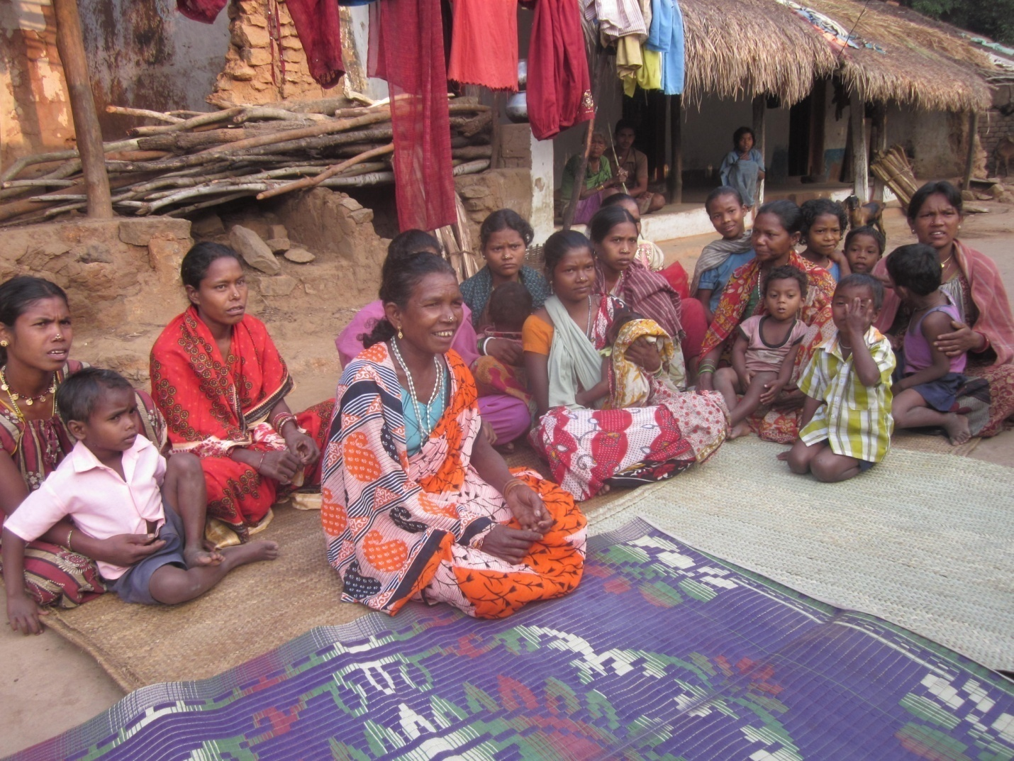
Above picture: Women of Budusahi

- Village Profile
The village of Budusahi is located in the Rayagada block of Gajapati district in Southern Orissa. It is a small village, composed of 25 households of Scheduled Tribe community. Of these 25 households, 4 are BPL (Below Poverty Line). It is a very remote village, located up in the hills of Gajapati. The inhabitants of this village mainly engage in shift cultivation and agriculture. Terraced rice fields shape the landscape, which is liberally dotted with palm and date tree, while enormous Tamarind trees encircle the village. The water supply work was completed here in August 2012. Prior to this, each household had completed the construction of their toilets and bathrooms. In order to monitor the situation in the village post implementation, a series of discussions were conducted with the residents of Budusahi. These tried to shed light on how the process has unfolded, and its impact on the lives of the community.
- Process
The residents of Budusahi recounted the acute water scarcity they used to face during the summer months. Due to the remote location of the community, they were barely able to access any government schemes to get over their situation. For these reasons, they were very interested in working with Gram Vikas to implement the water and sanitation programme. In order to further motivate the villagers regarding all aspects of the project, Gram Vikas staff took them on an exposure visit to a surrounding village named Munising where the project had already been implemented. The community of Budusahi soon reached a common understanding of the need for water and sanitation facilities after seeing the positive changes affected in the surrounding area.
Construction of toilet and bathing facilities began on 25.4.2011 and was completed on 18.2.2012. Peer Water Exchange supported financially towards the water supply system and Gram Vikas supported by giving cement, doors and toilet pans. Residents of Budusahi contributed their labour and construction materials to building these facilities.
- Situation before and after the implementation of the facilities

  - Water supply:
Before the implementation of the project, the community of Budusahi used to go to the nearest small stream, about 1km away, in order to wash, bathe and defecate. Due to the hilly terrain this was a grueling journey. There was an open well located in the village, from which the women would fetch water back and forth. Fetching water, on top of the journey to the stream to wash and bathe, used to consume between 2-3 hours out of their day. During the summer months, the well was prone to dry up. When this happened, the villagers would often have to wait 24 hours for it to recharge, leading to scarcity of water.
A water source was located 3km away in the nearby village of Taraling. Water is collected in a tank located on the upper side of the village using a gravity flow water supply system. This involves harnessing the natural topography of the landscape and the natural flow of water under gravity to fill the tank. There are two water tanks with a combined capacity of 10,000 Lts. The villagers have expressed an interest in making kitchen gardens now that they have a consistent water supply, but have not taken any action regarding this matter as of yet.
  - Use and maintenance of facilities:
Wandering around Budusahi, it was observed that the village was visibly clean and there were no signs of open-defecation. However, during the course of our discussion it was brought to our attention that many of the toilets were not being used. The facilities were mostly clean, but around 90% were either locked up or being used for other purposes such as collection of water or cleaning of pots and other utensils.
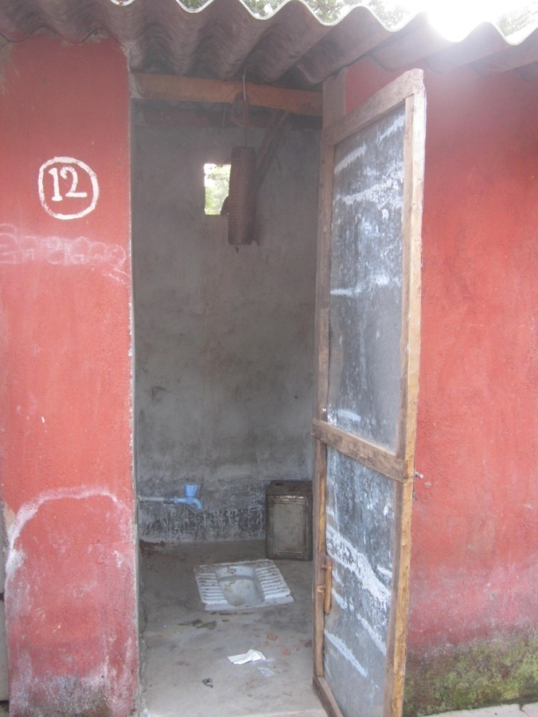
Pictured above: A toilet in Budusahi

Behavioral change takes time:
We later spoke with the Koinpur Project Coordinator, Mr. D. N. Mishra, who is responsible for the implementation of the project in this village. He explained that, as the project has only recently been implemented, the community is still adjusting to the facilities. Their main motivation in accepting the project was to gain a consistent water supply; toilet and bathing facilities were of secondary importance. Additionally, most of the population is engaged in agricultural pursuits to ensure their livelihood. The season began in July, just when the project was completed, and most of the men left for the village of Gondahati where they work in agricultural fields. There, as there were no toilet facilities, they continued to practice open-defecation. Now the season is over, they are returning to Budusahi, but have not had time to get used to the facilities. The construction of toilets and bathing facilities may be quick, but their use requires a behavioral change which can only be achieved in the long term. To address this issue, Gram Vikas plans to implement some motivational training programmes in the village in order to emphasize the importance of hygiene and sanitation practices.
  - Benefits for women
Privacy and dignity:
It was difficult to get the women of Budusahi to speak freely and open up to us. The meeting we tried to have with the female community was closely watched by the men. The older women expressed pleasure towards the running water supply, but appeared less enthusiastic about the toilet and bathing facilities. It was the younger generation who were the most enthusiastic. They expressed their appreciation of the new found privacy these facilities allow them to enjoy. As they used to bathe openly in the nearby river, being able to bathe in an enclosed space in the privacy of their own homes affords them a dignity previously denied to them. Now, when they visit the homes of their relatives who don’t have such facilities, they no longer feel comfortable defecating and bathing in the open.
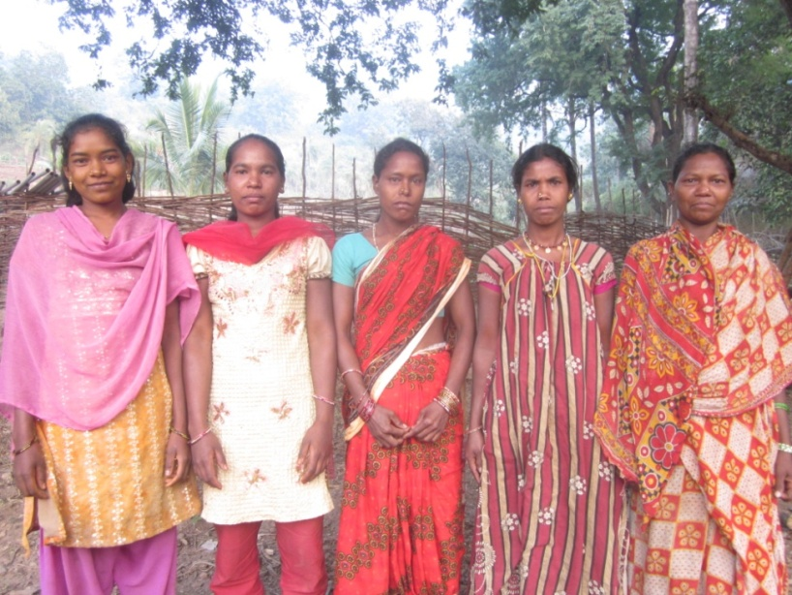
  - Ancient customs: Restricting the scope for women to lead a life of dignity?
Our attention was caught when we noticed an extension pipe leading from one of the bathrooms to an area outside of the village. We followed the pipe and found a woman bathing her new born baby under the cover of a large Tamarind tree. Our curiosity aroused, we wondered why the woman had come so far outside of the village to do this, especially at a time when both she and her baby were extremely sensitive.
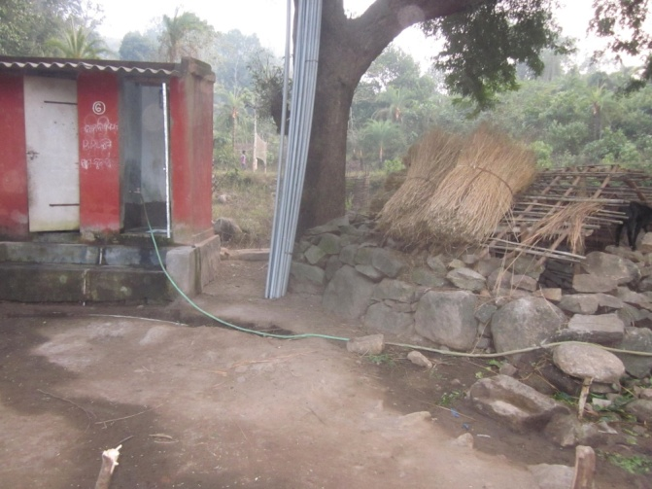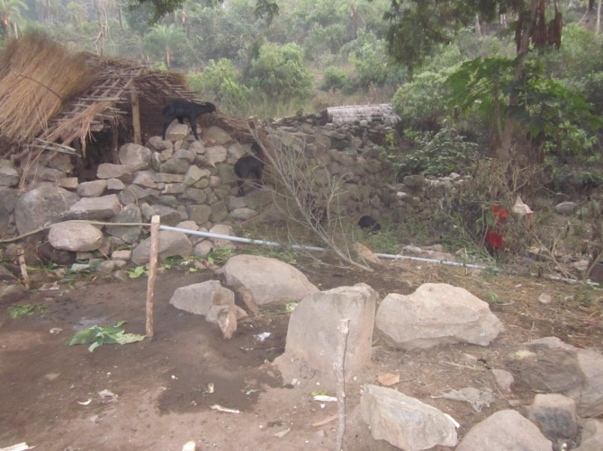
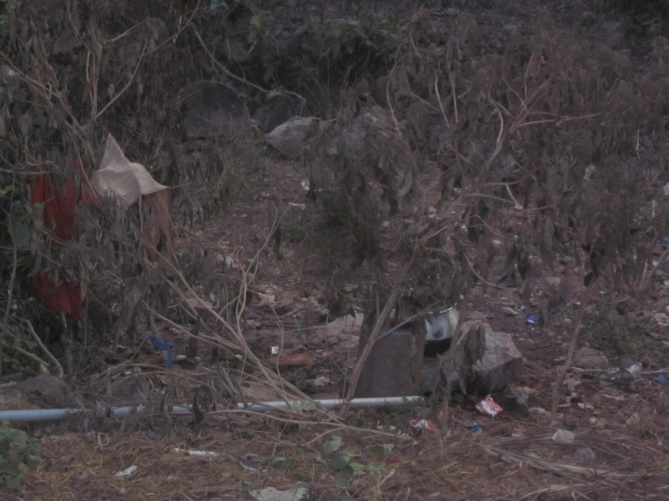
Above pictures: Extension pipe leading away towards bathing area outside of village
We spoke about this with some of the younger female members of Budusahi (pictured above). Dhano Moni (pictured first left) is 21 years old, and studied up to 6th. She explained that they do not use the toilet and bathing facilities up to 21 days after having given birth, nor when they are menstruating. It is their custom that women should not be in contact with men during this time. As these facilities are used by the men, they should not use them at that time. When asked whether this social rule bothered them, Dhano curtly replied, ‘This is our custom, we are happy to respect it. Our elders would scold us otherwise’.
As we left Budusahi, I reflected on the situation. Ultimately, the main beneficiaries of the water and sanitation programme should be the women. It is upon them that the task of water collection traditionally falls. It is they who must always wait until nightfall before they can relieve themselves if they are to avoid the preying eyes of men and preserve their dignity. The construction of toilets and bathing rooms should finally allow women the level of privacy they deserve. And yet when they are weak and most in need of such privacy – just after having given birth and during their menstruation – their customs deprive them of this right. From my own perspective, I felt a profound sense of injustice. Of course, I cannot apply my own belief system to theirs. Their customs and traditions are valid and should be respected. And yet, while building toilet and bathing facilities is certainly important, it seems self-defeating if the target beneficiaries are not gaining the full advantages. Perhaps, if the water and sanitation programme is to have a truly meaningful impact on the lives of rural women, more needs to be done to promote the softer part of development which targets such attitudes. Through training and capacity building, men and women could be educated about such issues as menstrual hygiene, and how sensitive a woman and her baby are, particularly in the first 21 days after birth. Changing belief systems which are so entrenched is a mammoth task, and a sensitive one, but my time spent in Budusahi convinced me that it is necessary if the water and sanitation programme is to deliver the full advantages to its target beneficiaries and achieve its full objectives.

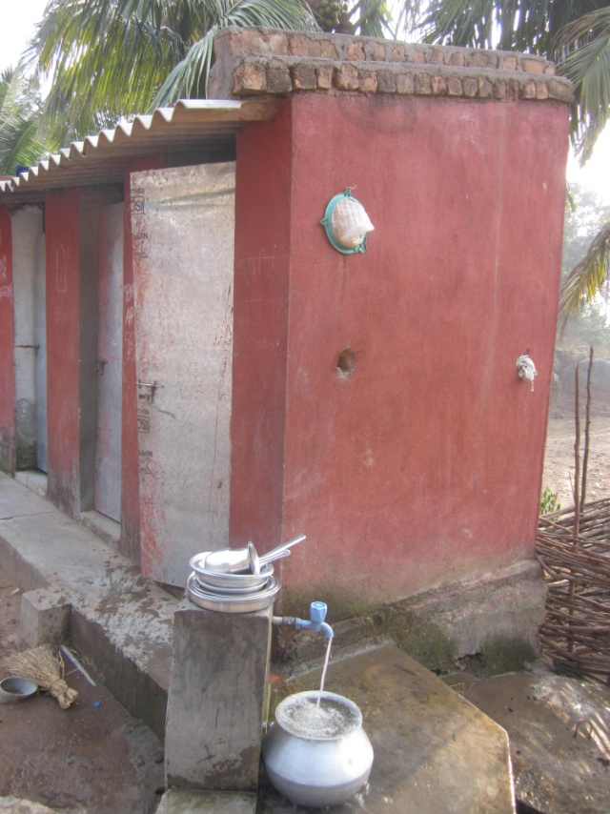
Above picture: Running water supply, Budusahi
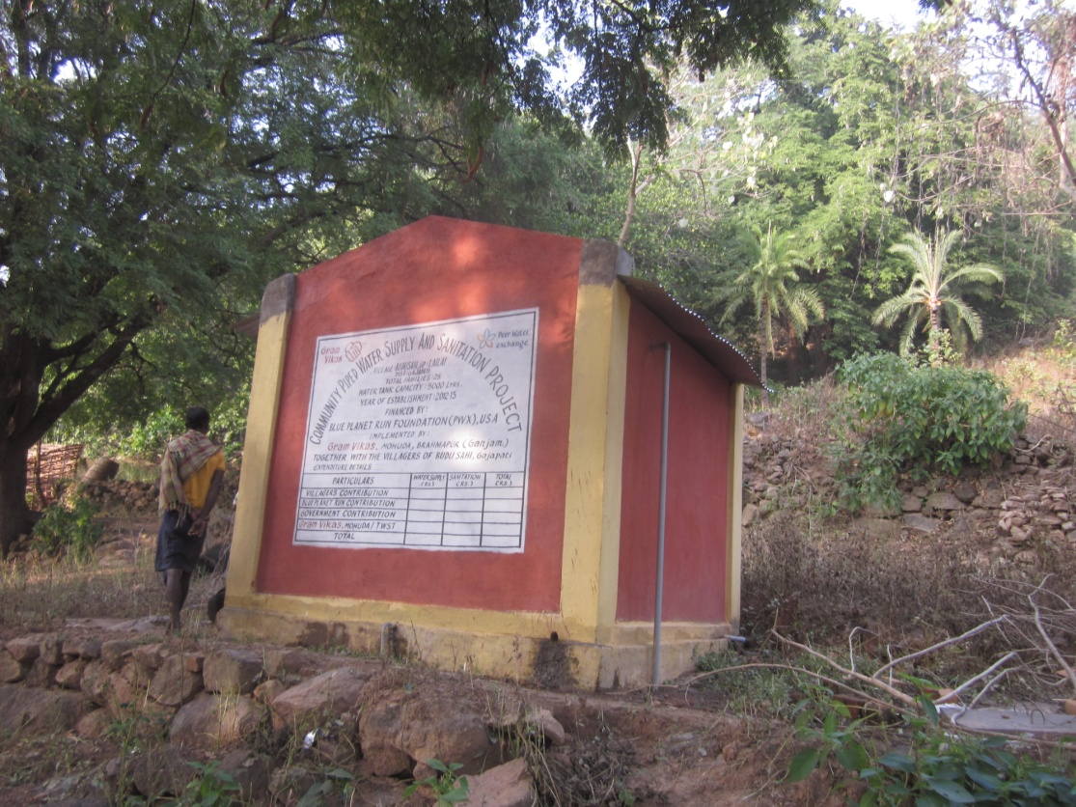
Above picture: Completed water tank with total capacity of 10,000 litres

